8 STAGES OF GENOCIDE = AMERICA NOW AT 6...7?
https://thecommonsenseshow.com/
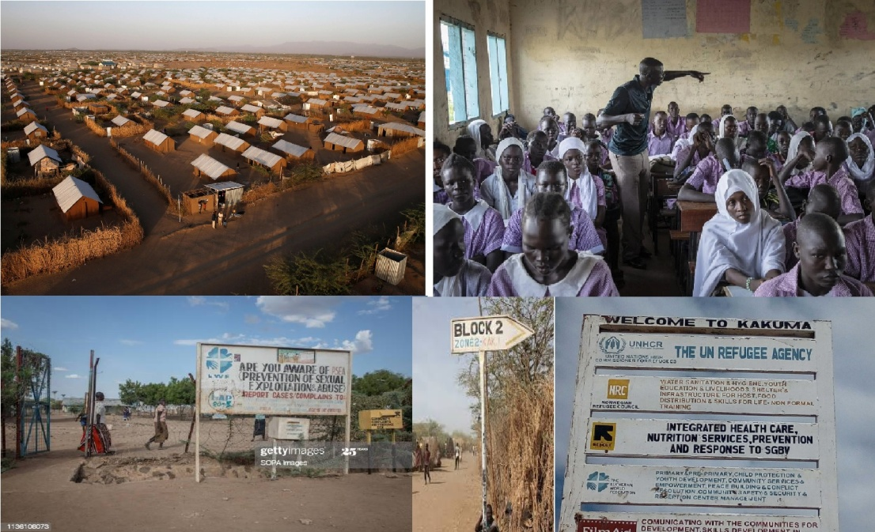
By. Gregory H. Stanton, President of Genocide Watch...Stanton identified 8 key stages related to the process of genocide? Summarized.
1.Classification 2. Symbolization 3. Dehumanization 4. Organization 5. Polarization 6. Preparation 7. Extermination 8. and Denial.
Stanton defines genocide as “A process that develops in eight stages that are predictable, but not inexorable...Logically, later stages must be preceded by earlier stages. But all stages continue to operate throughout the process. In other words, the processes and stages overlap and this is precisely what we see in modern day America.
In this article, I will review the 8 stages and comment with modern day examples of how these stages are being enacted, today. At the end of the analysis, I will present the results of a correlation analysis
In case your keeping score, stage 6 of the 8 Stanton stages have been fully achieved. The last two stages are clearly being acted upon by the Biden administration and its confederate allies that run so-called Blue states.

The 8 Stages With Comment
"CLASSIFICATION: All cultures have categories to distinguish people into “us and them” by ethnicity, race, religion, or nationality: German and Jew, Hutu and Tutsi. Bipolar societies that lack mixed categories, such as Rwanda and Burundi, are the most likely to have genocide."
If you are white and a nationalist, you are labeled a white nationalist or, or more commonly, today, a white supremacist (see below).
Today...anyone who supports Trump is also a racist. This has evolved into a mantra that is totally devoid of logic. If one supports the rule of law and the Constitution and decries the criminal behavior...The lockdowns have also provided a means to discriminate against Christians (note: believers are the main target).
It is no secret that the globalists are Satanists. As such, they fear Christ. Therefore they do not miss an opportunity to discriminate against Christians. In lockdowns, it was common to see strip clubs open, but not churches. White, nationalist, gun owner, constitutionalist, anti-abortion and Christian are the identifiable traits which will (justify) the modern day death camps.

"SYMBOLIZATION: We give names or other symbols to the classifications. We name people “Jews” or “Gypsies”, or distinguish them by colors or dress; and apply the symbols to members of groups. Classification and symbolization are universally human and do not necessarily result in genocide unless they lead to the next stage, dehumanization. When combined with hatred, symbols may be forced upon unwilling members of pariah groups: the yellow star for Jews under Nazi rule, the blue scarf for people from the Eastern Zone in Khmer Rouge Cambodia." And now we can add the Marxist organizations of BLM, Antifa and the Democratic Party.
Today, ...if one wants to get beat up today, just wear a MAGA hat in public, or show political support for Trump. Increasingly, all gun owners are mass murderers.
DEHUMANIZATION: "One group denies the humanity of the other group. Members of it are equated with animals, vermin, insects, (viruses) or diseases. Dehumanization overcomes the normal human revulsion against murder. At this stage, hate propaganda in print and on hate radios is used to vilify (means: speak ill of, slander, criticize, condemn and disprove of through analyzing, censure, and disagree with) the victim group. In combating this dehumanization, incitement to genocide should not be confused with protected speech."
ORGANIZATION: "Genocide is always organized, usually by the state, often using militias (not freedom loving) to provide deniability of state responsibility (the Janjaweed in Darfur.) Sometimes organization is informal (Hindu mobs led by local RSS militants) or decentralized (terrorist groups.) Special army units or militias (false flag groups that are not legit as citizen groups=anti-genocide) are often trained and armed."
The Democrats are in the midst of a communist revolution and have successfully executed a coup. Every action taken by the Democrats in the House and Senate was designed to remove Donald Trump from power. The Wuhan Flu was designed to bring about changes in our election system (e.g. ballot harvesting, untraceable fake absentee ballots, etc) brought about the biggest case of election fraud in world history. From there, they will have smooth sailing to a complete governmental takeover...America will soon hear a lot about Obama's OFS. They will make Antifa look like law-abiding citizens.
They are as brutal as the cartels. This strategy, being enacted by the Left is exemplified, but not limited to ANTIFA, Black Lives Matter, Open Society, etc., all George Soros groups. One should take note that that ANTIFA, like Hitler’s Brown Shirts, are now uniformed and are very well trained courtesy of the Communist Chinese, who also control a sizeable segment of Congress as well as local and state officials.
After stealing the 2020 election, the Democrats are not leaving Trump supporters alone. There is a stepped level of dangerous level of threats being leveled against non compliant people.

POLARIZATION: "Extremists drive the groups apart. Hate groups broadcast polarizing propaganda. Extremist terrorism targets moderates, intimidating and silencing the center. Moderates from the perpetrators’ own group are most able to stop genocide, so are the first to be arrested and killed."
Google and social media’s censorship and de-platforming of conservatives and in particular conservative Christians and even more pronounced, white conservatives, are being targeted. Jobs are being lost for being conservative and personal safety is in question. Senator Rand Paul was beaten and has required 2 surgeries related to the beating. Later Rand Paul and his wife, along with 4 DC policemen were chased to Rand Paul's hotel. Police officers are being attacked for carrying out the arrests of extreme Leftists as they are doused in water and urine with plastic bottles while the Democratic mayors of these cities do nothing. The ICE building in Portland was firebombed. Representative Maxine Waters, and others like her, have called for violence against Trump, as has Madonna and several others.

This concept of genocide is developing and evolving right before our eyes. Soon, nobody will be safe. Biden just declared war on 80-100 million Americans when he said that "Trump supporters are the dagger in the throat of Democracy." The unspoken meaning is apparent. A threat of this magnitude cannot be left unattended.

There is an extreme polarization of justice that cannot go unmentioned. Illegal immigrants have to neither wear masks or bee vaccinated and the companies that are firing their employees for not being vaccinated will hire these people right off the streets. In the greatest act of polarization, the same hospitals that are firing your doctors and nurses will treat these unvaccinated hordes without question.

Here is the frightening aspect of this stage: The hatred and prejudice against Trump supporters has grown to another group, the unvaccinated. Even though the opposite is true, the vaccinated are accused of "killing" the vaccinated because of their non-compliance. The ability to put food on one's table is being compromised if one does not submit to multiple kill shots. SEVERAL STATES ARE NOW PREPARING CONCENTRATION CAMPS, UNDER THE GUISE OF MEDICAL INTERVENTION, IN ORDER TO HOUSE DISSIDENTS WHO ARE FALSELY ACCUSED OF BEING A PUBLIC HEALTH THREAT.

PREPARATION: "Victims are identified and separated out because of their ethnic or religious identity. Death lists are drawn up. Members of victim groups are forced to wear identifying symbols. Their property is expropriated. They are often segregated into ghettoes, deported into concentration camps, or confined to a famine-struck region and starved.?
As Steve Quayle has repeatedly pointed out, there are Red Lists, etc., that will be used one day to lessen the number of Americans among us.

Don't forget that Michelle Obama, Kamala Harris, AOC and other democrats have threatened to place all conservatives on lists and make certain that the populist movement ever starts again.

The Social Credit System in China is an example of this process, where one’s right to housing, travel, employment and food is taken away for wrongful participation on the internet. That Google-designed system is now appearing in both Google and other social media algorithms being enacted against American conservatives. Dr. Malone, the ex-CEO of Pfizer and well known for his anti-Vax status has been removed from Twitter, Facebook and LinkedIn. As a sitting President, Trump was removed from social media as has a sitting Congresswoman, Majorie Taylor Greene.

False flag attacks add to the cause of preparation to exterminate. Look at January 6h, and as Doug Thornton has expressed, is the modern day Reichstag Fire. As Hitler used the Reichstag Fire false flag event to take over the government and eliminate all political opposition, the Democrats led by the Mafia Princess, Nancy Pelosi, is seeking to ban as many GOP from running for office, including Trump, for and remote connection to the J6 riots, which clearly was not a revolution or an insurrection. It was a false flag attack led by Nancy Pelosi organized forces that encouraged and let people into congressional buildings. This is why she won't release thousands of hours of video, because the false flag event would be exposed. We already have proof, from video played on Fox News, that Ray Epps, who encouraged all on January 5th to storm the Congressional building the next day as the aware patriots chanted "Fed" at Epps. Want proof of the false flag, Epps has not been prosecuted.

The Common Sense Show just made Google’s Black List of dangerous website as did Mike Adams’s site. The NSA has constructed, according to my insider sources, a “naughty and nice” list from their incessant surveillance. From Alexa to Google products, our entire lives are being stalked and profiled. The correlation in this variable, is not a perfect 1.0, but everything is in process. For example, under Obama we saw the development of the NDAA, arrests without due process for very undefined reasons. Also, we saw the leaking of FM 39.4, which is the organizational manual for FEMA Camps. So it is easy to conclude that when the Left had control of the government they are putting their “preparation stamp” upon America. To use a baseball term, Obama was the 8th inning set-up pitcher and Hillary was to be the 9th inning closer, but along came the rise of populism and Donald Trump. In all likelihood, Trump is just a speed bump that is slowing down the process.
Ask yourself why we have admitted members of MS-13. They are the hit men for the drug cartels. This fact, alone, legitimizes points #5 and #6.
The first 6 stages have been realized. As Hitler targeted the Jews, Gypsies, Homosexuals and homeless, this generation of genocidal maniacs have their targets and they are Unvaccinated who will not bend to the will of tyrants, Whites, Christians and people who support law and order. If you fit into one of these groups, you better begin to prepare to evade detection and arrest because when you go to the Covid extermination camps, you are not coming out!
"EXTERMINATION begins, and quickly becomes the mass killing legally called “genocide.” It is “extermination” to the killers because they do not believe their victims to be fully human. When it is sponsored by the state, the armed forces often work with militias to do the killing. Sometimes the genocide results in revenge killings by groups against each other, creating the downward whirlpool-like cycle of bilateral genocide (as in Burundi). At this stage, only rapid and overwhelming armed intervention can stop genocide."
There are elements of this concept in evidence. Have you ever asked yourself the question as to why school shootings and mass public shooting are practically unique to the United States? Narratives, like the El Paso shooting do not hold up to forensic scrutiny. This was clearly a false flag that was designed to force Congress to enact gun legislation that will prevent the populace from being able to effectively defend themselves against a tyrannical and deadly takeover.
According to the University of Hawaii Democide (NWO-Deep State in both parties worldwide GENOCIDE) Project, there were 16 genocides in the 20th century. Everyone of them was preceded by first enacting gun registration and later confiscation. There were no exceptions. This combined with Obama’s Executive Order 13603 which calls for labor camps, confiscation of any and all resources, etc, speaks to the fact that extermination is the goal that is being pursued by the extreme Left. For some of the readers of the CSS, the light just went on and there was just a collective awareness realized by readers who now know why I am exposing FEMA camps and genocidal legislation in recent writings. It is coming America, you better wake the hell up!
When one includes, vaccines, GMO’s, Chemtrails, and the still ongoing radiation from Fukushima, etc., it is clear that the slow-kill genocide is already underway. The vaccines and the camps will complete the task.

According to Stanton, if America is to survive, an armed counter-revolution is the only answer once the process has gone this far.
8. "DENIAL is the eighth stage that always follows genocide. It is among the surest indicators of further genocidal massacres. The perpetrators of genocide dig up the mass graves, burn the bodies, try to cover up the evidence and intimidate the witnesses. They deny that they committed any crimes, and often blame what happened on the victims. They block investigations of the crimes, and continue to govern until driven from power by force, when they flee into exile. There they remain with impunity,
The movie “The Hunt” is an example of this process of advocating for genocide. Epstein’s exploits in alliance with the participation of many of our elected elite and not elected elite speaks to how far the lawlessness has gone. Children were murdered in great numbers so that these groups could more fully enjoy the fruits of their murderous and perverted pleasures. This is the beginning of genocide against children, particularly blond-haired and blue-eyed children."
There are complete media cover-ups of the soft kill genocides being taken against our people. Chemtrails and GMO’s for example, are never discussed in the MSM, despite ample scientific evidence. Weather wars are being perpetrated against the people and are on the verge of creating mass starvation (e.g. Midwest). Vaccine deaths are covered up and as the Frontline Doctors have stated through their attorney, Tom Renz, the variants, which cannot be accurately tested for, are being used to cover-up vaccine deaths.
I previously predicted that when a regime change would take place in 2020, these soft kill strategies will give way to roundups and FEMA camp exterminations.

Data Analysis
I will not bore the reader with the extreme details of operationalizing variables and chi-square and the like, but I would like to share my data results of where America is at today with regard to these 8 stages of genocide. Last year, I ran a data analysis using my old SPSS statistical program
In my academic career, I have written two courses on statistics...Here is what I found.
In correlation research, any correlation ranging from .7-1.0 is very strong . A 1.0 correlation is a perfect correlation. The results were stunning.
In correlation research, any correlation ranging from .7-1.0 is very strong. A 1.0 correlation is a perfect correlation. One has to remember that correlation does not show causation, it shows a degree of relationship (i.e. factors that would go together).
I constructed a list of factors related to genocide using Stalin, Hitler and Mao

Here is what I found:

1. The likelihood of genocide in America is nearly guaranteed with a .95 correlation. THE ONLY FACTOR NOT IN COMMON WITH THESE 3 REGIMES WAS HIGH UNEMPLOYMENT AT THE TIME I RAN THE NUMBERS. NOW, WE HAVE HIGH UNEMPLOYMENT. This leads me to believe that the chances of an economic collapse is coming is very high because the Left needs pissed off people in the streets like ANTIFA, in large numbers, in multiple cities, to get the killing started. When the coup is successful, the roundups and exterminations will begin in earnest by the new government. The lockdowns certainly have fulfilled this aspect.
2 . The likelihood of genocide against identified groups like Christian's, Is harder to calculate. But with the best data possible, the correlation is .84 which is still quite high
3. Racial targeting of whites is trickier to calculate for a variety of reasons. The calculation is .86. If one were to include the increasing disappearance of Whites from TV commercials, the number would be much higher. Here are further results...

Comparative Correlation to the Stanton Stages:
Nazi Germany: 1.0
China: .97
Soviet Union: .96
In other words, Stanton’s eight stages are excellent predictors of genocide and the United States numbers are equivalent in this regard.

Summary
There are clear limitations to my data approach. But they are clearly indicative of the fact that previously identified segments of the American people are in grave danger. A better, and a much more time consuming approach would be to enact the use of multiple regression analysis. This would help to better account for the analysis of the overlap of the 8 factors that Stanton mentioned. However, even this elementary analysis, this analysis clearly demonstrates that America is very close to becoming the next Nazi Germany.
In summary, the United States is not quite to the point of these three genocidal societies from a statistical standpoint. However, it strongly appears that the US will match if not exceed these genocidal regimes, on the present course we have embarked upon. Further, if one considers the vaccines to be distinct threat to longevity, one would be able to successfully argue that the genocide has already started and the state-sponsored Covid detention camps will finish the job.
Can we turn this back at the ballot box? Stanton would argue that we cannot. Hodges would say no as well. As long as there are Dominion voting machines and absentee balloting, there will never be another free election which is another hallmark trait of a genocidal communist regime. Remember, it was the great genocidal promoting Stalin that once said "I do not care who votes, I only can who counts the votes."The recent 2020 election theft had speaks clearly to this point. There may never be another free election again.
What if the people miraculously stand up to this tyranny, believe that, under the Kigali Principles, the United Nations would attack the United States with member states. Remember, the United States, thanks to Obama (Anti-Christ/Gog) is a signatory to the Kigali Principals which allows the UN to enter a country, based on its own say so and take over that country by any means possible. In a case of civil disobedience or rebellion, there are 28 nations that would the US to end the rebellion. Either way, it appears that Stanton is likely correct, genocide is in our future in a worst case scenario. And in a best case scenario, civil war or World War III, or both, represents the best case scenario. And people think I am crazy when I talk about the importance of guns, ammo, gold, food, water, medicine and tools as well as neighborhood alliances.
So where is America at? The data is clear, we have completed Stage 6 and Stages 7 and 8 are developing. America is so close to genocide, but there are none so blind than those who refuse to see. I do not have a time frame. But with the rapidity of the events, this could all be over this year and most Americans will never know what hit them. The Covid lockdowns and subsequent Covid extermination camps, where euthanasia will soon be applied just like in New Zealand, have created a sense of martial law which is an excellent springboard to more nefarious agendas. The question is no longer if we can save our nation, but whether or not, individual survival is still possible. Have you tried praying to Jesus for salvation?

