Table of Contents
DAUGHTER OF ZION – REVELATION 1
GARDEN 2
SING 2
LIKE FIRE 3
BLOOD 3
GAZEBO-SMALL GARDEN CABIN AT LORDLAND PHOTO 2013-2016 5
DAUGHTER OF ZION LINKS: 6

TOPICS OF THE LORD: Jasper Café’ Druids, Adam and Eve, small box he hides in, plays in, Pollux and Castor, siamese twins, wife, 12 trash bags, each side of the road, warm, wife, roots, grape vine, kidney, rocks dirt, new planet earth,

DAUGHTER OF ZION – REVELATION
Heb 13:14 For here have we no continuing city, but we seek one to come (New Jerusalem – People).” (1 Peter 2:9 (Exodus 19:6), cf. Exodus 19:5; Acts 9:13, 32, 41; Acts 26:10; Romans 1:7; Romans 8:27; Romans 12:13; Romans 16:15; 1 Corinthians 6:1, 2; Philippians 4:21; Colossians 1:12;)
New Jerusalem is our eternal destination, and this city of God a holy city is made up of Gods people who are paired (144,000) specifically. These are the be the immortal bodies, and unions prepared by God for him to walk with, in and by. The city to come is also related to Gods original plan and this is where God began a redemption plan that involved Me and Gabriel, leading to the attacks, and much more on him and I, in different environments, individually and as a whole.
These unions are related to God who sees male and female as together as his seat of authority and dwelling place in covenant between the Adam and Eve (Male and Female, 144,000 plus), and a covenant between them and God, also harvest workers and tabernacle; the New Jerusalem of God.
In 2018 approximately I was betrothed to Gabriel this person that was the object of others who wanted me to be out of the way, and then began the long educational process of why? What was going on? And in the future over time I came to understand more.
Lam 2:4 He hath bent his bow like an enemy: he stood with his right hand as an adversary, and slew all that were pleasant (H4261 object of affection, desire) to the eye (H5869 Jehovah is the eye of man, sight, He has his eyes fixed upon man-face, appearance, form, well, a fountain of gardens, the fountain of habitation Ps 83:11-of judgment, a fountain of the spy, the eye a fountin to flow out looking, askance [to one side, slanting, indirect, sidelong], envious=tears) in the tabernacle (H168/H166 tent, covering, dwelling, of the covenant, moveable, portable, house of David, root shinning vibrating appearance-to be bright) of the daughter (H1323 apple of the eye, branch to build a house, establish a family, build a foundation of a house [New Jerusalem] a son of God, son of a womb-born of the same womb), of Zion: he poured out his fury LIKE FIRE.
GARDEN H1588 gan- enclosed garden (fig. of a bride)- Sng 4:12 KJV - 12 A garden (H1588) inclosed is my sister, my spouse; a spring shut up, a fountain sealed, of a wing, fig of a chaste woman. H1598 to hedge about, i.e. (generally) protect:—defend.

SINGING
Singing H7440 ringing cry, of entreaty appeal, plea, request, petition, supplication, in proclamation edict, declaration, public statement, announcement, assertion, sound bite, triumph, joy, praise, shout for joy or grief, sorrow, heartache, mourning, bereavement for lack of respect or value.

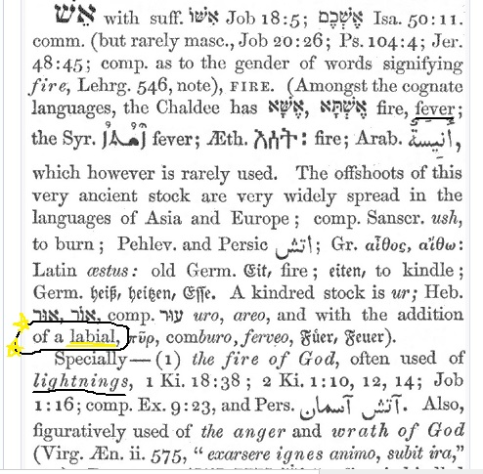
FIRE - Labial=Hebrew 784 altar fire=LABIA – lips producing speech, or sound, pipe, movement of air across a sharp edge, fever inflammation from God’s Wrath or anger. To be kindled to BURN (sequential)
Those who are being ‘V’ are being judged from within, the vials of vaccine are causing Gods anger and wrath to be felt by those vaccinated, and not by those who have not been. The daughter of Zion seems to be one vessel used by God for this purpose. Gabriel also is a vessel of Gods anger and like 5G God has his weapons against his or our enemies as well.

BLOOD
Heb 13:11 “For the bodies of those beasts, whose blood (G129 haîma a body temperature that is unusually high, usually caused by bacterial or viral infections, seat of life, slay, murder) is brought into the sanctuary (G39 the temple, holy place; transferred to Christians, as those whom God has selected ἐκ τοῦ κόσμου John 17:14, 16, that under the influence of the Holy Spirit they may be rendered, through holiness, partakers of salvation in the kingdom of God) by the high priest for sin, are burned without the camp Wherefore Jesus also, that he might sanctify the people with his own blood, suffered outside (cast out, strange, from the V forward) the gate (access or entrance)....

GAZEBO-SMALL GARDEN CABIN AT LORDLAND PHOTO 2013-2016
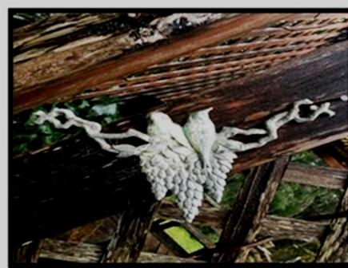
The photo above was during a sabbatical type trip, and in the garden was this image I took a picture because God had begun to send me angelic visitors for a few years, and other things prophetically were happening. I snapped this picture and my interpretation of this originally was two birds facing in opposite directions sitting on top of what I viewed as a womb, and ovaries.
Also, it has three grape clusters below and during this trip one night I had a dream all night of Jesus on my right side, with outstretched hand wearing a white robe, crown, and blue sash said over and over again to me “I am going to begin working IN and THROUGH you.” I believe currently as of May 2022 that this was an indicator of what God would do in the future regarding the woman bringing forth the manchild/male, Rev 12 taking place on Sept 23, 2017 and travailing to bring forth the children (represented by the cluster of grapes).
Micah 4:10 Be in pain, and labour to bring forth, O daughter of Zion, like a woman in travail (Rev 12 Manchild=MALE): for now shalt you go forth out of the city, and you shalt dwell, lodge, lay, abide, lie down, sleep, destroyed, pour out a vessel, in the field (Medford prison to homelessness, field, soil, land, not tents or homes), and you shalt go even to Babylon (H894 confusion [by mixing] male and female genders, confuse self on account of shape shifting, their wasting strength, fodder/feed animals); there shalt you be delivered; there (H8033 from that time-“they have transgressed the covenant therein they have rebelled against me”) the LORD shall redeem thee Daughter of Zion from the hand of thine enemies.
I believe that I am this daughter of Zion, and the daughters of Babylon who were the bloodline of Israel and Judah along with others (males) had me arrested, but first they surrounded me and plotted to take me for over a month. Once they had I was put into prison, and after about 14-15 days let out into the field, no coat, transportation, phone, food ($97.00) and was followed and attacked in many places, not physically but with words.
My Mother, my Sister, and a gal named Jordan/Nancy/Giza also were involved, my daughter, along with many others, including men who were trying to remove me, and carry on their plot. Why? I explain this in other documents because this bringing forth the manchild involved me, and his removing where they had intended to have him for themselves, and I was not a part of the plan.
Why? Because God and Gabriel began a plan that in some way did not work in their favour, which was regarding Gabriel. This plan truly originated with God in the beginning, a plan of the ages to be performed in this time during the 7 year tribulation (w/Great Tribulation) and Mark of the Beast the ‘V’. This plan was to take him and I, use as a teaching tool about his plan, and reveal mysteries along the way.
I had encounters with the Lord in this journey, also many angelic meetings which were not planned by me. They brought many prophetic insights, confirmations, and understandings to what was taking place, and this process that had begun. All of this is related to the redemption, the 144,000 elect sealing, the 12 Tribes of Israel which they are those either helping or in opposition (War), however, not of my choosing, but it has happened anyway.
During a period of 2017 – 2022 during Trumps presidency who is also Gabriel was about the Messiah (Trump=Man/Male) who was in the Revelation 12 sign in the sky that took place Sept 23, 2017. We began to come together and a grand process began. So did the attacks, these attacks came from those who hold positions of power worldwide.
Their goal right now is to put me away if possible when I go to trial, because they have not stopped attacking, and trying to find ways to delegitimize me, slander, or whatever they can concoct.
In 2017-18 bringing forth this manchild (family-Trump, I knew him as Gabriel) who was a man coming out of Babylon, Egypt, and Illuminati. This bringing forth is about leaving that life he lived prior being, and believing in a promise of God that involved me. I actually have court coming up, and many are involved corruptly I might add because they are in power in the justice system.
Zech 2:10 Sing and rejoice, O daughter of Zion: for, lo, I come (The Lord), and I will dwell (H7931 by transmission, lodging, tabernacle, abide, inhabit, remain= H7901 to lie (of sexual relations-to be lain with used of a woman) in the midst of thee, saith the LORD.
Zec 9:9 Rejoice greatly, O daughter of Zion; shout, O daughter of Jerusalem: behold, thy King (the Lord and Gabriel?) cometh unto thee: he is just, and having salvation; lowly, and riding (H7392 chariot, sit, horseback, vehicle, to be carried Jehovah, upon the clouds, a horseman, upon the wings of Cherubim Ps 18:11, Deut 33:26, a place, the hand-on the wings of the wind) upon above, over, in addition, together with her Zion, an ass (H2543/2560 a heap, to boil, foam, foam up, to be red, my bowels are in ferment, redness, in turmoil Lam 1:20= Job 16:16 my face is reddened from weeping), and upon a colt (H5895 bearing a burden, raising a He-ass a young ass (as just broken to a load; from its swift ardent running-opening the eyes, to awaken, to arouse ones strength, “as a eagle stirs up her nest, hovers over her young” to watch, against anyone) the foal (H112/29 son, male child, member of a guild, class, Babylon, Egypt, a young bullock [All Gabriel and family] the Kings Son, Sons of the Ethiopians, Jews, Levites, son of DEATH or one doomed to die to rebuild a house and establish a family, restored exiles) of an ass (H860/386 sense of patients a She-ass=ME, a female donkey and the Son is to be strong, perpetual, constancy=fidelity, faithfulness, loyal, dependability, single-mindedness, enduring “with continual war in his bones” “a mighty nation” the potent-the both to continue enduring).
The above verse is related to where God sits in Zion (Me, and Gabriel conjoined). This is an example of the Ark or rather throne of God which is in the body temple of God where in the future New Jerusalem he will dwell in, with, between upon his throne in covenant and marriage. Also, God moves through the air, atmosphere, through the wind.
Zech 2:7 Deliver yourself, O Zion, that dwells with the daughter of Babylon. King David’s Daughter, and His anointed.
(Jer 6:2, Ps 50:2, 129:5, Babylon dislike her Ps 48:12, Micah 4:7-8, 10, Isa 40:9, Isa 52:1, Prov 31:26, Rev 12:1, Jer 8:19 the Lord in Zion, 97:8, Ps 99:2, 45:13, Zeph 3:14; also Mother I have been told Gal 4:1)
Note: She (daughter of ZION) is an oracle (to prophesy, forewarning, prediction, seer, vision, trumpet and voice of God) a temple for the Lord to speak. Jeremiah was her friend, and Isaiah.

DAUGHTER OF ZION LINKS:
By Zion’s Princess
1. https://youtu.be/0SwDw_sTnac Daughters Of Jerusalem And Daughters of Zion Judgments & Envy Against Queen Zion &Prophetic Word!
2. https://youtu.be/df1hPKoXPEY Daughters of Jerusalem And Daughters of Zion And Envy Against Queen Zion PT2
Note: She (daughter of ZION) is an oracle (to prophesy, forewarning, prediction, seer, vision, trumpet and voice of God) a temple for the Lord to speak. Jeremiah was her friend, and Isaiah.

