Contents
OCT 25, 2021, and Earlier in Medford Oregon 1
JESUS MY ATONEMENT – PRAYER SHAWL – ARK – CLOUD Oct 25, 2021 4
SHIN is Messiah linked to Q 6
DRUIDS 7
AUG 12, 2018 (Elul New Year the 12th) 7
“The King is in the Field” 7
Rev 16:13 the dragon, beast and false prophet 11

Encounters with Jesus the Lord YAH “As is”

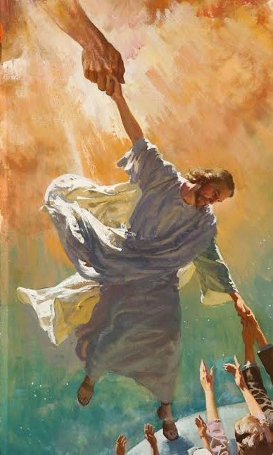
OCT 25, 2021, and Earlier in Medford Oregon
www.yourawake.weebly.com (More research on many topics-Research and prophetic revelation or unveiling)
Before reading, remember when Jesus came onto the scene the leaders of the day did not receive him because of the things he said and his teachings. It seemed contrary to what they had been teaching for centuries. However, Jesus is the Word they taught and if he wants to do a new thing in the earth he will. He is, and many who are participating in the Covid times should understand what is going on.
The ROE in the Zohar 700 year old prophecy that I downloaded about 2017-2018 approximately revealed the Messiah who was to have a seven year time span from the 66th to the 73rd (2015-2021 approx), but also the Roe which had been revealed to me as Me.
The Roe would be visited by the Lord and he would find that there was no one righteous that would help her, that there was no help for her. I was that Roe, and what came about in Medford was that visit by the Lord Jesus.
ENCOUNTER: “The Lord God who is Jesus the Word visited me when I was basically without any help, except him of course and a few others I do not know that helped later.
I had just been let out of a place that I had been betrayed to by my former Mother, and I had not even a coat, no blanket, no money, no ID, and was left on my own. Not only that I had a stalker that was chasing me around everywhere.
I finally went to St. Vincent DePaul and was sitting out front after getting a few clothing items, and He the Lord approached me crouched down and said “Well, Duck, Duck!” He had two diamond crowns on his hat, and actually was riding a white bike. He said something about ‘AYE’, and I thought he meant like a pirate, but I now believe it stood for ‘Adam Branch and Eve.’
Later that day I was alone at a Café’ that was called “Jasper Café’” and Jesus came there, he asked if he could share the space basically, and I said yes which was vacant, closed, and quiet accept for some road warriors. I knew it was him, and we began to talk, it was evening, and I was tired, also hungry at the time. He spoke of many things and I will just list what he said basically, some I wrote down in my journal and the rest I have stored as memory.”
Heb 2:6 but there is a place where someone has testified: “What is man that you are mindful of him, the son of man that you care/visit for him? 7 You made him a little lower than the angels; you crowned him with glory and honor.
“He, the Lord spoke of many things, and as hard as I tried to listen I only caught the following revelations:
“He said he was thinking he would ‘End it All November 19’ and ‘That was His/My Birthday’ and he glanced up at me to see my reaction or what I thought. I believe this is possibly the time of Jacobs Troubles and the Wrath of God as I was given in 2016 timeline.
“Gabe, aka Trump and I are a CO OP (Co-operative) that we were “Siamese Twins” of which I was told we were by the Gemini prophecy, other words of prophecy or revelation.
“The Lord Jesus asked ‘Do you know who I AM?’ and I said ‘I think so, believing he was the Lord God.”
He said a few times that we were before Adam and Eve, and were called DRUIDS; He said some were bad/evil, and that we or I was good. I have information I will put at the bottom about the Druids that were before Adam and Eve. He mentioned that there was destruction that took place during that time.
“He said that He was sending as “You are going to Canada” and then looked up at me again, and I said “Wherever you think!”
“He said twice “You deserve to be made Beautiful!” (Ornamentation, giftings, and all the rest).
“He said that Oregon has “Restored his faith in humanity” and was not happy about the state of the world or America so it seemed.
“He also said something about Gabe and I being the original Adam and Eve. Now I know what he has been saying in my number symbolism about restoring his original plan that was under the curse in the Garden, and now being redeemed once again.
“The Lord said that I am Gabes Wife, and no longer betrothed any longer.
“He also mentioned the Revelation 12 sign that took place Sept 23, 2017, which was about him and me as well. Relating to the King Planet, King Star, and the Woman that brings forth (into the world, in view, out, onward, promote, encourages, or supports) the male child. (I.e. Trump/Gabe etc).
“He mentioned that originally there were Two Sons, and one died. I was not, sure if he meant Suns, but I think Sons.
“Yes” to Pollux and Castor as representing Gabe and I, Pollux and Castor, the Bridegroom and Bride in the Constellation of Gemini “Twins” 6-25-2021. He Jesus “Venus” lined up; connected, linked, teamed, gathered together, and get ready with Pollux and Castor on that date in the heavens, a sign.”
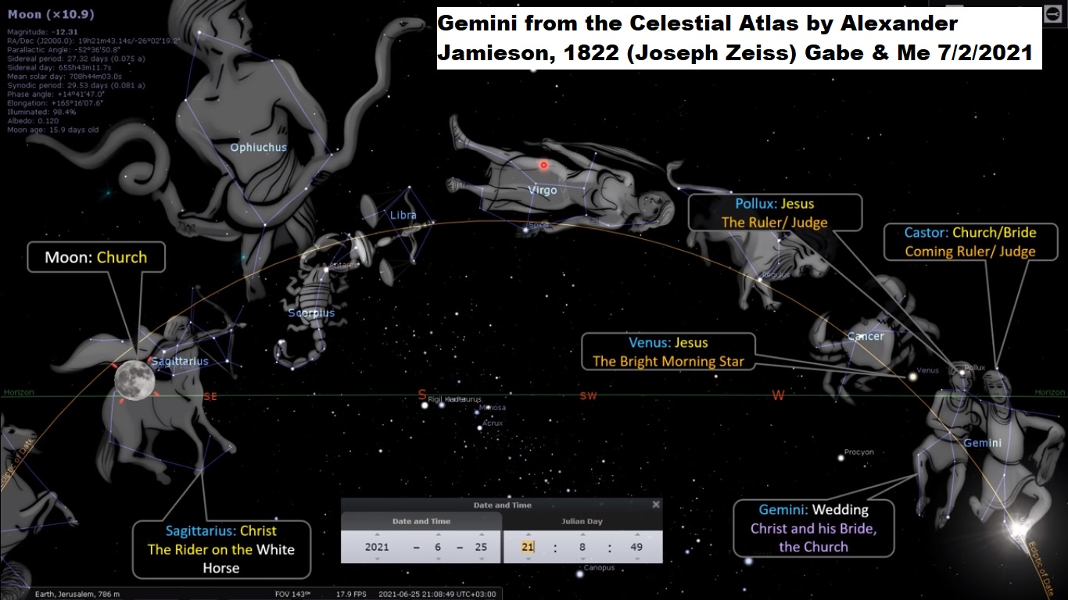
June 25, 2021 this prophecy was given to me and was written in 1822 about the “Twins” (G&Me) the Bridegroom/Christ, i.e. Messiah and the Bride, we are a type and example.

JESUS MY ATONEMENT – PRAYER SHAWL – ARK – CLOUD Oct 25, 2021
Oct 25, 2021 around 4:30 pm, I drove by Jesus the Lord once again, and he looked up at me like he does, when I noticed that he was sitting and covered over his head was a white prayer shawl with three royal blue embroidered lines, and fringe. It went over his head and shoulders down past his hips. I wanted to stop, but was not sure if I should. He also revealed that we were to be made spirit, smoke or vapour symbolically.
When I wrote in my journal what had happened, a team trucking warrior went by and revealed “Rabbi” which is what they used to call him.
I decided to contemplate what the shawl meant, and the word that came to me is that he had his head COVERED. This led me to Exodus 25:17 covering represented him as the ATONEMENT under the Ark of the Covenant.
I know that Jesus fulfills the three last feasts of the Lord and we are currently in the Feast of Atonement but also entering in very soon the Feast of Tabernacles/Sukkot.
The next scripture that I was led to regarding covering was Ex. 33:22 (good numbers): “I will put you in the cleft of the ROCK, and cover you with my hand” this was to MOSES.
In December 2020 I had an encounter with an Angel that told me that JESUS jumped into a ROCK. Now Trump also represents the Rock of Offence, or stumbling block/stone, and cornerstone. I spoke to this Angel about Trump and he said that Trump had 72, and I knew that in the Zohar the Messiah had 73 years total, and that Dec 2020 was his 6th year and starting his 7th (73rd) year or Sabbath.
The last scripture that I was led to regarding the COVERING was Lev 16:2 “the Lord appears in a cloud over the Atonement Cover. Jesus is the blood atonement on the Ark, etc.
G3509 Nephos a throng, a large dense multitude, a cloud in the sky.
H6051 Cloud a covering a veil over heaven, a morning cloud, image of something transient, observer of times, to make appear, produce, act covertly, magical arts. G3507-3509 a cloud which lead Israelites, same as above 3508-9 definite masses of vapor (H5387 mist, smoke, prince, captain, ruler, governor) with some form or shape, to be lifted up, exalted, to be carried, aided, assist, be swept away, to take, to receive, to lift up the hand in swearing, H5375 nasa
Matt 17:5, While he yet spake, behold, a bright cloud G3507 overshadowed them: and behold a voice out of the cloud, G3507 which said, this is my beloved Son, in whom I am well pleased; hear ye him. Same as above. (Said of Trump by Prophet in Las Vegas International Church).
Gabriel told me that I was surrounded by a CLOUD (In front of Rays Market), Gabe asked how I did that, and that it was hiding or protecting us, or me. I do not fully remember the exact words as to hiding or protecting.
Lev 16:2 The LORD said to Moses: “Tell your brother Aaron not to come whenever he chooses into the Most Holy Place behind the curtain in front of the atonement cover on the ark, or else he will die, because I appear in the cloud over the atonement cover. (This scripture is actually related to the Day of Atonement)
Note: Gabe mentioned that I was surrounded by a cloud, and I think he asked me about it, but I do not remember my response.
Ps 32:3-7 Then I (David) acknowledged my sin to you and did not cover up my iniquity. I said, “I will confess my transgressions to the LORD”— and you forgave the guilt of my sin.
Note: Gabe is a son of David to sit on a throne as a king (President and the New Earth/Kingdom)
CORNERSTONE Carving in a 700 year old church in England that also led me to the Zohar prophecy regarding the 66-73rd years of Messiah and the Roe as I spoke of above.
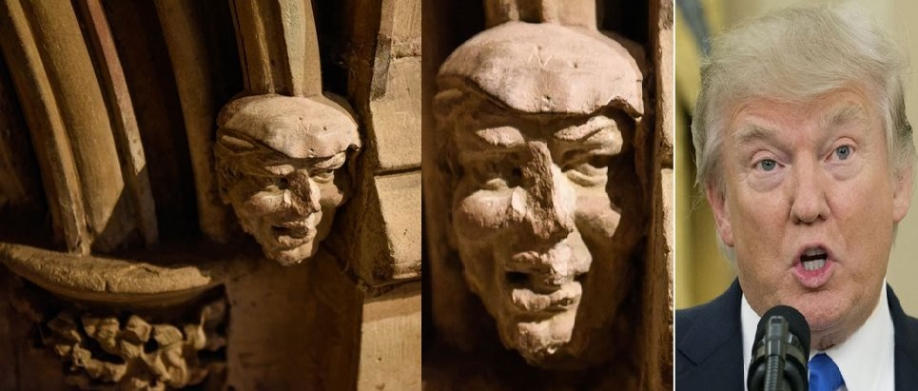
Q posts during the time of Trump presidency, represented Trump Team, and some researcher revealed that in numerology “Q” represents Messiah.

SHIN is Messiah linked to Q
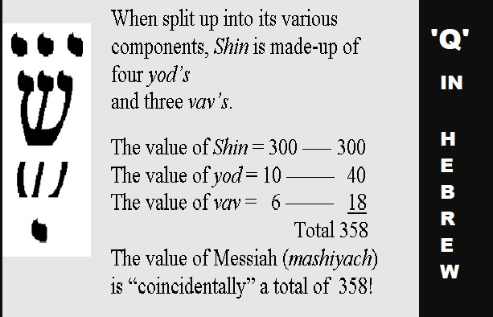
I think it interesting to note the 3 prong letter which could represent the Father, Son and Holy Spirit, three in One God. Mashiyach/Messiah means “Anointed One” like David, or Deliver, and Savior as Jesus or Moses, etc.
Gabe and I are examples, symbolic, and a Type of expression of the Lord Jesus who is the Atonement for our Sins, Ark of the Testimony/Covenant, Old and New Testament. We have been anointed by the Holy Spirit which is the Messiah Spirit to represent, and teach about him.

DRUIDS
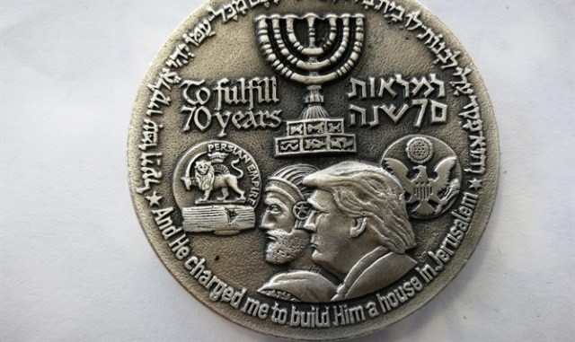
TEMPLE COIN OF TRUMP AS CYRUS AND THE 70 YEARS OF CAPTIVITY
On YouTube there was a guy who was teaching about the Druids, Celtic and Irish Myths, and here is what I found:
Doyw = Druid = “SEER” a Wiseman of weeds, tree, solid, steadfast, to know, and Oak, related to N. American Indians, Ancient India, Brittan.
Thought to be a religious group, classes, noble men, knights, teachers, and were judges. Levite type, warrior Queens, Priest in white robes who dressed and carried a rod or staff, Royal heir cast, royal rulers, linked possibly to Atlantis, also gets into DNA link and super ancestors.

AUG 12, 2018 (Elul New Year the 12th)
“The King is in the Field” START FRESH!!!
Everyone says/declares “the King is in the Field!” He has come down to our level, the King goes to the field and sets up his ‘ROYAL TENT’ (body/literal tent) near a town (Selma) only one month each year. The normal people have access to God.
AARON who is also Gabriel (Trump) had a Tent (silk) set up outside of Selma – he said with Hebrew writing on the inside.
He told me that the 7 7 7 represented the “ARK OF THE COVENANT”
Which he said was on the front (adjoin=connect, look onto)of the ARK, his head forehead (777) = 12 = #3 my number (also on the front of the hat was Me). He the KING surprises me/us with his presence, His being there, company, crowd, audience, existence, aura, authority, spirit, happening, event, episode and manifestation. Song of Solomon 6:3 is connected and Elul is the first letter—It is a Season of Haven, sanctuary, safe place, shelter, camouflage and refuge.
The Priest prepares and readies self by cleansing and repentance. Me? God has appointed mercy from his hand/Jesus, and is related to the constellations of “Virgo” or Virgin. Our Relationship is intimacy with the Lord, he and we are to be mothering-nurturing to others...END 2018 Info
Note Oct 27, 2021: The above information was written and included in a eBook I uploaded to my website, and Amazon regarding the Ark of the Covenant.
However recent information that I have been given I want to include here to document the unveiling/revelation. 777 also is 21 years, and Trump mentioned in a recent speech (Oct 2021) that we had 21 years and will not be doing that again.
Recently around June or July in California I was introduced to the concept that Gabe aka Aaron and Me were a physical/spiritual representation of the Ark of the Covenant. The bringing together those who were Jews or the bloodline; where He has lived and existed for much of his life. The grace in the New Testament, the Mercy Seat of the Ark and Jesus whose blood atones for our sin on the seat.
Also, in scripture in Leviticus 16 it says that the Lord God appears in a CLOUD over the Atonement seat (Mercy Seat of the Ark) which is also called the Mercy Seat. Representing Jesus as our Atonement for sin.
This bringing together of Gabe who is Aaron above, and I represent the need for both. One, complete, and it also relates to the covenants both needing each other to be the completion of Gods eternal redemption.
I also was told that I was made for Gabe, aka Aaron like Adam and Eve, Twins conjoined inseparable. The Lord Jesus Yeshua when he visited me said that we were the Adam and Eve, and that we were Siamese twins, and that we represent the Bride and Bridegroom, Christ/Jesus and the Church/Ecclesia (all Gods people) Jew and Gentile, and those who are believers in Jesus the Messiah.
In the Spring of 2014-15 I had a dream all night, where the Lord Jesus in a white linen robe, with a royal blue sash, and wearing a gold crown on his head. Jesus had his hand outstretched over me all night on my bed, and said to me over and over: “I Am going to begin to work in and through you” My daughter Terina was there and I told her about it.
I already belonged to the Lord so I wondered what he meant, and I believe I now know.
When I was supernaturally anointed by God I was also told by Benjamin who I am not sure exactly who He was, but I believed that He may have been the Lord, but also could be Gabriel/Aaron who is Trump. He said that incredible things were happening to him, and that He was fulfilling scripture in Revelation and Daniel specifically 7-11 regarding the 70th week of Daniel, and more.
Basically, He and I were symbolic visual and literal expressions setting forth the Lord Jesus, the two covenants into one, the Law, Grace and Atonement. This was Gods teaching tool Gabe/Trump and I to help those in his bloodline who were worshiping world idols, Baal, and the rest to on the whole teach by a visual symbolic example and Gods word, etc. Genius Lord!
Here is the email that I received and I had three phone conversations with him where He said to me: “You could not talk to me unless you were one of the 144,000” and I wrote many things down that he had spoken.
EMAIL:
BENJAMIN IS?
Oct 20, 2018 IP
Name
Benjamin S
Email
(...)@aol.com
Comment
I would like to ask you questions about the Messiah to come. I didn't read your books yet but you nailed it with your wisdom. I think you want to speak with me so i can fill you in on missing wisdom. I was never religious till 1/20/17 Trump inauguration day. There been crazy things happening to me since that day that I can't explain. All I can say every time I take a pictures or videos there rainbows around me with faces looking down upon me. If you're serious about Trump who I believe has a biblical link to me let's speak,asap. My email is (deleted) My grammar isn't good so hard for my to express my points by emails. I'm 50yrs old now but wasn't till turn 48yrs old that Holy Spirit had filled my soul with knowledge of the scripture. The book of Revelation is my life. The scriptures are talking about me. Everything in the first 4-chapters is about me and what happening to me last 2-yrs also book of Daniel from chapter 7 to 11 is me. Let me prove to you who I'am and if i don't hear from you then I know the holy spirit will not allowed you to contact me. Please reach out to me and I won't disappoint you. Thanks Benjamin, Rev 4:2-3 talks about a person sitting on the throne appearance of Jasper(which is stone of Benjamin)then is mentions about rainbow encircled the throne shone like Emerald.(Emerald means tribe of Judah,also stone for Month of May,also stone for Gemini. I'm born on May 26,1968,70-week of Daniel,which started the day Trump sworn into office bc Trump was 70 yrs,7-months and 7-days old on Jan 20,2017 in Hebrew yr 5777. The 70-weeks is about atonement to end sins for the Messiah which would end on last day his turns 49 yrs old. Do the math 70th week of Trump's presidency was Friday May 25th 2018. The next day I turned 50 and that's when all of sudden the pictures inside my phone,I saw these heavenly lights around me. I would love to speak to you bc I have no one who can understand me about this. Btw,my mother was 16yrs of age when she conceived me and was virgin and not married yet. She was married by the time of my birth. I hope to hear from you this is my cell phone number (DELETED) End of Email
My Note: The flow or punctuation etc is like Woody Cambel who gave me info about Trump for the book I wrote called “Donald the Last Trump of God” and “Donald Messiah Trump” Also, Woody seemed to claim to be God (revealed in another email prior to Trumps election).

Rev 16:13 the dragon, beast and false prophet
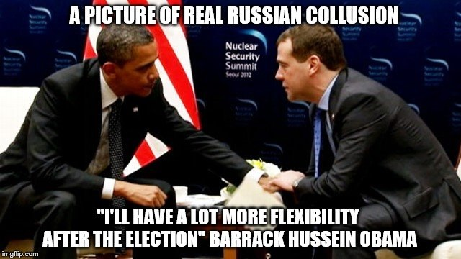
The Anti-Christ Army being gathered are preparing destruction for mankind who are not part of the beast system, and who are not submitting to the Medical Tyranny that is being used to Mark the whole world into Satan’s army or Gods.
Rev 16:13 Then I saw three evil spirits that looked like frogs; they came out of the mouth of the dragon, out of the mouth of the beast and out of the mouth of the false prophet. 14 They are spirits of demons performing (working) miraculous signs, and they go out to the kings of the whole world, to gather them for the battle on the great day of God Almighty.
Obama is Gog and Anti-Christ who took power December 2020 who represents the Son of perdition and the dragon Satan the Devil on earth. The following research reveals what comes out of the mouth, of the dragon, beast and false prophet, and He is gathering his army for the final battle. The election was stolen, and Trump did have the election in a landslide, but on Gods timeline it was time for the Great Tribulation to begin and the Beast System came into power.
Three evil spirits come out of the MOUTH or people of the dragon, beast, and false prophets to gather them together as Satan’s army against Gods. This is those who are compromised and those who are not with the “V.”
MOUTH Greek 4750 stoma: from the soul or heart the thoughts, crying and bewailing G5114 part of the body, to cut, stroke, with repeated blows. I believe this body is people in is army currently being gathered partly through the Mark/Vax.
DRAGON G 1404: Name for Satan, the serpent, figurative a description of the Devil, symbolic, representative, ornate and emblem. Event (Covid), object, account of a person, class of people, sort, species, kind, character, mold (fashion, pattern, to produce), stamp, or SEAL. Corona is a crown, and seal, just as God seals us, and so does Satan.
BEAST Greek 2343, 2339 therion: bestial man, savage, living creature preparing destruction for men. We are in the Beast System where everything now is related to the deified COVID Beast system, the mask the “Eikon” symbol fashioned an “image” of the beast.
FALSE PROPHET G5578: acting the part, utters falsehoods under the name of divine prophecies, G5571 = liar, deceitful, untrue, erroneous, wicked. G5574 means to speak deliberate falsehoods in an attempt to deceive, cheat, against one.
WORKING MIRACLES G4160/G5492: name of things made, construct, fashion, the cause, to prepare, execute, to practice, and transgress the law. A sign, token, or mark to distinguish others, a thing, or person. Ceremonially transcending the common course of nature, G4591 = to signify, to give a sign.
In H1968 crown or (Corona) garland, wreath, resembling a solar corona related to the Sun, Halo which means to know or “Know apart” (from another), “together” (pipto “I Fall”) to happen. Crown H6963 – head, part most bowed, to bow down, to stoop, to contract, in deference (submission, judgment, yielding to will of another (i.e. Satan, or?) to his wishes, worship and captivity (Isa 46:2).
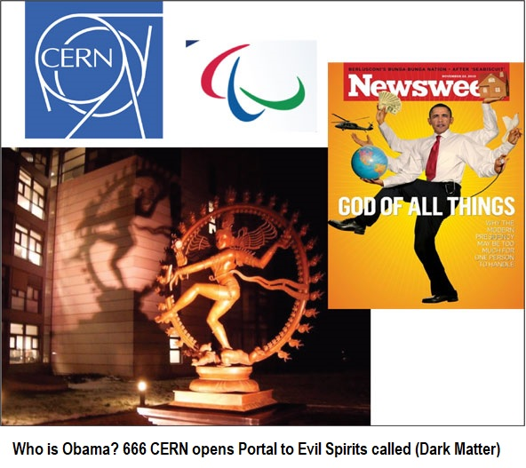
Stoop H7164: bow down, touch forehead to worship reverence and fall down in homage to false gods as superior. (In Islam they bow the body and touch forehead to ground), and Obama represents Islam. They bow to the East towards the Sun. Obama is linked to the god of destruction, see CERN 666. He is also Gog of War, and Anti-Christ, and the mask is the Burka symbol of ISLAM (the religion, Allah, and Baal among other names.
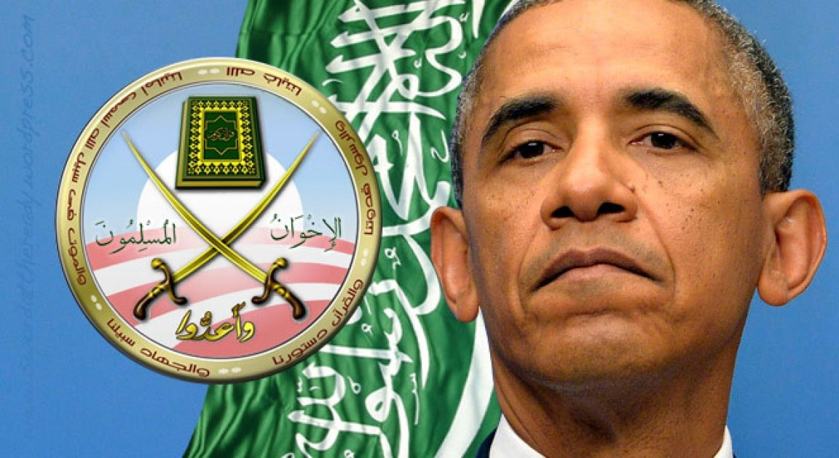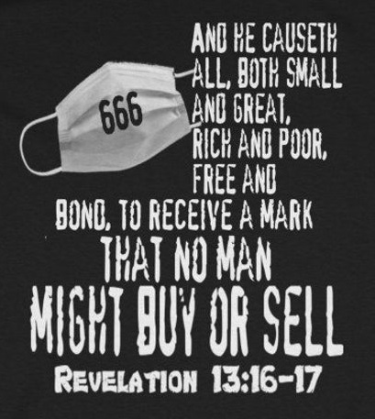
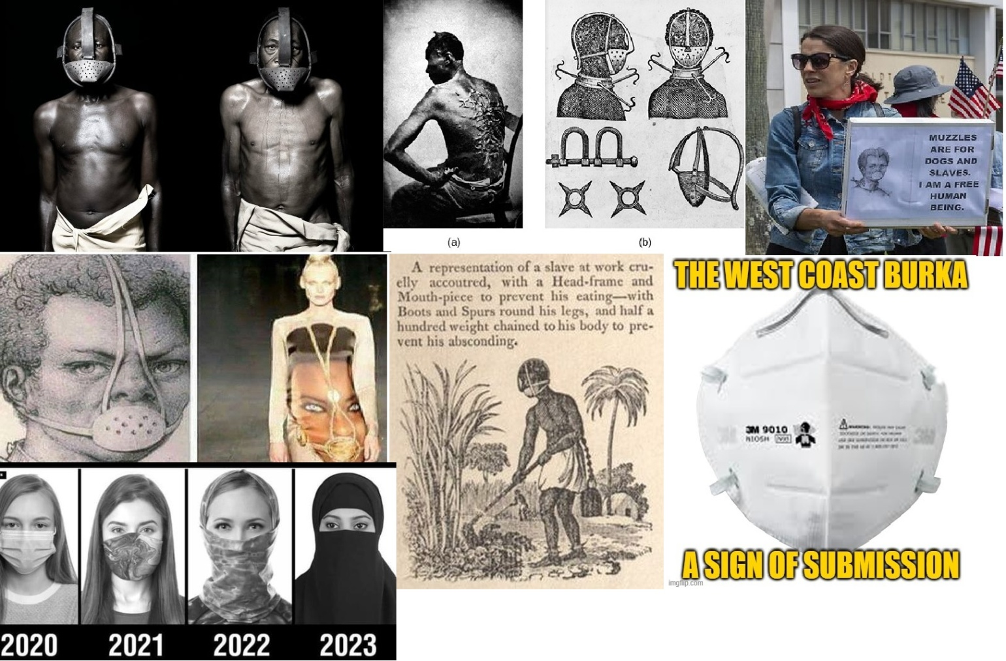
The Mask is the image of the Beast as in “Eikon” or “I Con” and represents Islam and the Star of Communism and Allah the representation of the Moon God, and originally many gods.
In order to be part of Gods Army you have to be sealed by him by the Holy Spirit which seals you into his redemption and salvation. The “V” seals you into the Dragons army, but there are only two camps, and places that people will go after it is all over. Choose wisely. Jesus and his future, or Satan’s and his.
Jesus says that you/we are the temple of God and he dwells in us, so we must ask him in believe in him and his sacrifice on the cross and resurrection on the 3rd day.
Since my meeting with the Lord in Medford around June 2021 to my best recollection all of scripture is being fulfilled. The things happening to Gabriel and Me are all pointing to Jesus the Atonement, the Fall Feasts of the Lord that have been and will be fulfilled. Jesus is coming for his children who are also are called his bride. Gabe and I were a way that others could wake up to this final harvest that is the finale’, closing of the books, and end of sin, and prophecy fulfilled.
Jesus has been showing up a lot lately and time is up! Soon he may begin the ending of all just as it is prophesied in Daniel 9-11, Revelation and all the OT prophetic books. Are you ready to go home to your father who is the word, and Jesus coming to take his kids home? Do not be left behind, and you have to seek him first in your life above all else.
Call on Jesus and he says he will save you, and then keep his commandments and be holy for he is holy. Blessings

