False flag - Wikipedia

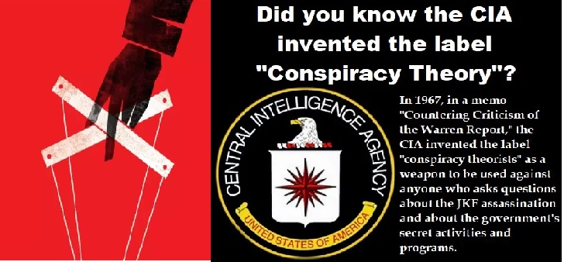
TRUMP supporters storm Wash DC Capital? Nope they were let in, and were BLM and Antifa all planned!
Notes are my input into the Wikipedia entries which explain different ways a False Flag is used, however the bottom line for a false flag to be consider there must be corruption in that group or party of any kind, who feel the need to misrepresent in some form for a particular agenda.
A false flag operation is an act committed with the intent of disguising the actual source of responsibility and pinning blame on a second party. The term is popular amongst conspiracy theory promoters in referring to covert operations of various governments and cabals.
The term "false flag" originated in the 16th century as a purely figurative expression to mean "a deliberate misrepresentation of someone’s affiliation or motives".^{[2]} It was later used to describe a ruse in naval warfare whereby a vessel flew the flag of a neutral or enemy country in order to hide its true identity. The tactic was originally used by pirates and privateers to deceive other ships into allowing them to move closer before attacking them. It later was deemed an acceptable practice during naval warfare according to international maritime laws, provided the attacking vessel displayed their true flag once an attack had begun.^{[3][4][5][6]}
The term today extends to include countries that organize attacks on themselves and make the attacks appear to be by enemy (Government, etc) nations or terrorists, thus giving the nation that was supposedly attacked a pretext for domestic repression and foreign military aggression.^{[7]}
Operations carried out during peacetime by civilian organizations, as well as covert government agencies, can (by extension) also are called false flag operations if they seek to hide the real organization behind an operation.
While false flag operations originate in warfare and government, they also can occur in civilian settings among certain factions, such as businesses, special interest groups, religions, political ideologies and campaigns for office.
Current Application: Business ready to close, or part of a deep state operation to first open a business in attempted dissention regarding shut downs and masks and then officials coming in as organized to shut them down. Or one business or restaurant bar that was already closed for renovations, officials closed a month later, but it was already closed, and used its closing to promote fear when they took away the license (so said) others feared to remain open. However, there can be bribes in place or cover for existing crime like a money laundering facility. So many options of false flags all deception by the deep state to keep people in fear, and then use it, make it go viral to cause fear among others. Like the George Floyd murder by cops this was a false flag.

Political campaigning
Political campaigning has a long history of this tactic in various forms, including in person, print media and electronically in recent years. This can involve when supporters of one candidate pose as supporters of another, or act as "straw men" for their preferred candidate to debate against. This can happen with or without the candidate's knowledge.
In 2006, individuals practicing false flag behavior were discovered and "outed" in New Hampshire and New Jersey after blog comments claiming to be from supporters of a political candidate were traced to the IP address of paid staffers for that candidate's opponent.
If you could employ an associate who pretends to be sympathetic to the unions' or any other cause to physically attack you (or even use a firearm against you), you could discredit the unions ... Employing a false flag operation would assist in undercutting any support that the media (mass, group or meeting, together with the people involved in their production), may be creating in favor of the unions.
Conservative commenter Lou Dobbs suggested that pipe bombs that were sent to prominent Democrats prior to the 2018 mid-term elections were part of a false flag effort to discredit Republicans and supporters of President Trump. This was demonstrated to be wrong when the pipe bombs were traced to a Florida man with strongly declared right-wing affiliation.
(The potential false flag was that it was a right wing individual; maybe not right wing at all, but a Democrat hiding as a right wing individual?)
On the internet, a concern troll is a false flag pseudonym created by a user whose actual point of view is opposed to the one that the troll claims to hold. The concern troll posts in web forums devoted to its declared point of view and attempts to sway the group's actions or opinions while claiming to share their goals, but with professed "concerns". The goal is to sow fear, uncertainty, and doubt within the group often by appealing to outrage culture. This is a particular case of sockpuppeting and safe-baiting.

Ideological
Proponents of political or religious ideologies will sometimes use false flag tactics (Note: only if they are corrupt would this be true in my estimation). This can be done to discredit or implicate rival groups, create the appearance of enemies when none exist, or create the illusion of organized and directed persecution. This can be used to gain attention and sympathy from outsiders, in particular the media, or to convince others within the group that their beliefs are under attack and in need of protection.
Note: On the other hand it could be exactly that implicating rival groups and the enemies do exist and any attention is necessary to bring forth truth, otherwise the enemies stay covert and operate as they please. It is when there is dishonesty in any group or party that a false flag would be used, corrupting the truth on any level.
In retaliation for writing The Scandal of Scientology, some members of the Church of Scientology stole stationery from author Paulette Cooper's home and then used that stationery to forge bomb threats and have them mailed to a Scientology office. The Guardian's Office also had a plan for further operations to discredit Cooper known as Operation Freak-out, but several Scientology operatives were arrested in a separate investigation and the plan was exposed.
Note: False Flags exist because someone is trying to hurt another, discredit another, and all of things are not of God, but some form of twisted beliefs that claim to represent God.

Psychology
False flag attacking is a kind of psychological warfare. The motivations and effects have been analyzed within the framework of regality theory, which is a branch of evolutionary psychology. People will develop authoritarian, intolerant, and xenophobic attitudes when they perceive that their social group is under attack, according to this theory. This is called a regal psychological reaction. An attack that is successfully blamed on outsiders will lead to such a regal reaction. The result is that people will be more likely to support their own government and military. A collection of historical examples of the fabrication of collective danger by false flag attacks and other kinds of deception has identified the following motives:^{[54]}
- To create psychological support for a planned war (on Freedom/Patriots/dissenters like those who refuse to shut down or wear masks)
- To pave the way for a transition to a less democratic form of government
- To consolidate (strengthen, fuse, ad secure) a government when its power is dwindling
- To defame an enemy by blaming an attack on them
The effect may be the opposite if the deception is disclosed and the attack is blamed on an internal elite rather than on the alleged outgroup. (Us vs. Them, Good vs. Evil, Satan vs. God)

Conspiracy theories
Because false flag operations would, by their nature, fail to produce the desired outcome should they be exposed, the perpetrators of such tactics have a vested interest in concealing their actions. As such, conspiracy theories abound with regards to events that have shaped public opinion in a significant way. By claiming that an event was orchestrated by an internal actor, these conspiracy theories cast doubt on the legitimacy of actions taken in response to such events. However, when such claims are made, especially without substantial evidence, they can contribute to misinformation about the events in question (or clarify). The intentional dissemination of this kind of disinformation (not to be confused with misinformation: disinformation is false or misleading claims spread deliberately to deceive the target audience) can be seen in and of itself as an act of information warfare.
For example, some conspiracy theorists in the United States frequently claim attacks such as the Orlando nightclub shooting and the Sandy Hook Elementary School shooting, as well as the attacks of 9/11, are false flag operations staged by conspirators, usually government or corporate forces, in order to achieve some goal such as expansion of government surveillance, disarmament of the population, or military action against blamed nations or groups. Crisis actors are sometimes claimed in this context to play the part of bystanders or witnesses, emergency response personnel, and (with the aid of stage makeup) wounded victims of the attack.^{[55]}
These recent examples exist in the context of a history of conspiracy theories regarding past events, such as the well-known conspiracy theories surrounding the JFK assassination, some of which postulate that the CIA or other government actors orchestrated out the assassination, with a variety of motives having been proposed. Another notable historical example is the case of the USS Maine incident, which led to the outbreak of the Spanish-American war. At the time, American and Spanish sources reported different conclusions for what had caused the incident, with the official view in Cuba and Spain being that the sinking was carried out intentionally by American forces as a pretext for war, a view which is reflected on the Monument to the Victims of the USS Maine in Havana.

