Table of Contents
GREEN DEAL and Paris Climate Peace Accord (Environmental-UNFCCC) 1
Trump said: “The Green New Deal Hoax is the next criminal CON job.” 1
TRUMP INTERVIEW TODAY 4/1/2021 1
President TRUMPS Full Speech at Right side Broadcasting – Video removed 2
New Green Deal Linked to The Great Reset 3
Abomination of Desolation? Obama-nation=Anti-Christ 8
Mask is the main “Image” of the Beast (System) 8
BENJAMIN TEXT Nov 21, 2019 – 3:34 pm (Messenger of God) 11
Stone Cairns / Stone Balancing / Stone Stacking 13

GREEN DEAL and Paris Climate Peace Accord (Environmental-UNFCCC)
According to Trumps speech in Ohio June 2021 the next big deception is the Green Deal=Paris Climate Peace Accord. Deception as in he says that it sounds all fluffy and good, but indicates it is not and a deception like the COVID mask, Plandemic, vaccination and the rest. He spoke many things relating to biblical prophecy, in code, and we need to understand what he is telling us.
I believe under all of the smooth talk and open representation is genocide and population or rather human extinction level policies. Satan taking souls on the way.
The Green Deal is Linked to Sustainability – growth strategy (line of attack and plan) – Net ZERO emissions—
Trump said: “The Green New Deal Hoax is the next criminal CON job.”

TRUMP INTERVIEW TODAY 4/1/2021
Quote: “I think there is ROOM for something, and I bring allot of people WITH ME” part of a questioned by Laura Trump regarding getting the news out there and new platform...he never answered it but with the final quote above.
Room: G5253 the highest part of a house, upper chamber, above, for ones sake, beyond, over, chiefest apostles, to pierce through the other side. (Joel 2:16) Chamber: Joe 2:16 “Gather the people, sanctify the congregation, assemble the elders, gather the children, and those that suck the breasts: let the bridegroom go forth of his chamber, and the bride out of her closet. H2315 inner, most inward parts (inner man), private chambers, enclosed, surrounded (flesh-body)

President TRUMPS Full Speech at Right side Broadcasting – Video removed
Ohio and this was 1:41:51 min. on YouTube. What was and always of interest is that Trump is speaking in code. Here are the excerpts from the speech and some interpretation of the code undertone.
Trump said these prophetic words that reveal what WILL happen in America and what to think or do about it for us. Much happening right now and in the future.
- Forced indoctrination camps on military...Inflation is skyrocketing our Nation WILL be Destroyed.
- He wants to send J. Bid, Fake News – (where?) there going down the tubes...trump said he is going to take back the HOUSE (Gods?), AMERICA and the Senate (administration, governing body, council, ruling body-Gemini Atlas Info) soon.
- A FLOOD of migrants invited in from all over the world – we can’t have it (redemption, deliverance, to smoke occupants-to chain, shut in- force, in a good or a bad sense), millions coming in. (gone up 976% in 5-6 months)
- Border Patrol (Ice) – tough people – run into pack of MS13 swinging hard and they win. (Code)
- We have to shut down (deliver up-imprison - break in pieces-crushed) lawless Biden’s Agenda. (2 Thess 2:7)
- They are gonna take our Guns.
- 21 years is enough (777-2021) – Gov’t wouldn’t last – while were there – were not gonna stay 21 years. Were gonna bring back our troops. 2 Armies (our troops in the middle) were gonna bring them home. “I started the process all the troops are coming back home” They (Gov’t) couldn’t stop the process – troops protect their own borders for 3 years, nothing happened.
- The Iran deal which is gonna destroy Israel (Gods people specifically America) or going to be a BIG War most likely.
- Next month (July 2021) our Oil Independence will be GONE.
- We entered the Paris Accord – Devastate Ohio Oil and Gas – this will CLOSE Countries. America kicks in – Tax hike is Devastating.
- They are weaponizing Law enforcement to go after Republicans (Also mentions the voting fraud investigation is to find those who voted for Trump not to change the election)
- Socialist Democrats.
- Our enemies are watching and laughing at America and us.
- Gov’t run schools – we must be able to opt out – Trump says get back to school- the public schools are Horrible, Horrible... (Note: we must home school),
- We just can’t have what the Democrats will do.
- 2024 were not gonna have a country left. Maybe by 2020.
- Green New Deal Hoax is the next criminal Con Job. They will say and do anything to destroy the MAGA movement. Note: Strongs H3173 MEGAS means-Only Begotten Son, beloved, the LIFE – Mega G5598 means O’Mega=Omega the ending/last (Rev 16:14 final judgment and Great day of the Lord [HOT]
He is telling us what is going to happen, he did through Q 2017 until the election was stolen and the Anti-Christ took power Dec 2020. ‘Q’ who is Trump team ended Nov 8 after 2020 election. In the Q drops it revealed so many prophetic happenings and they are still to happen. Also, he is saying we can’t have what they are going to do. I believe he is taking out his children. He has been gathering his last day’s army (Troops) to himself, and taking us out. This is in scripture, and the War Scroll revealing God is going to Rapture out his people who are the ‘Army of God’ aka the Troops!

New Green Deal Linked to The Great Reset
Talked about by National and World leaders. It is another name for the New World Order, New Green Deal, ID2020, Agenda 2021-30 (Orig. Jade Helm 15), and is not good for most people.
Linked to the Vax, Chip, Body Sensor by Injection of Covid 19 immunization filled with all kinds of things like Nano Bots, computer chips, DNA enhancers/changers and much more. Here is what I came up with when typing in the “Great Reset” seeing it as a type of computer linked system. (Richard Florida at Economic Forum says it is the New World Order)

Related to the binary entering into a state-clearing errors (moral/political-even the mind/soul) in a controlled manner when the current is found undesirable – a reboot signal to the software (inner man/human soul/psyche) which then sets the original software (host body/persons mind, etc) to a new pre-determined state.
In a series – a virtual Machine Model = software running on top of a host one.

Chuck Missler said: The hardware of a computer is the body, and the software is the actual soul or inner person, aka host.

A new host/demon evil spirit possession can “run on top” of you, overriding you; likely through the vaccination internal Body Sensor (666 Mark of the Beast - COVID-New God of America =Socialist Communist Satan Beast system).

Other applications like ID papers, card and the like are stepping stones to further requirements and oppressions.

There is a RESET “Line” – which is a circuit or loop by a conductor terminal to other devises.
Another troubling part of this is related to the CDC Zombie Preparedness (Zombie Preparedness | CDC ) and in theory once a person dies, in some cases catches this so called virus they become a Zombie. The reality is that when the person dies they are taken over by evil spirits, but TV and the New World Order along with Hollywood have been brainwashing people to believe it is not possession, but a virus of some kind. How convenient to cover the reality of Satan and a spiritual world.

(Note: CERN is letting them out of the Abyss and these evil entities they call DARK MATTER)
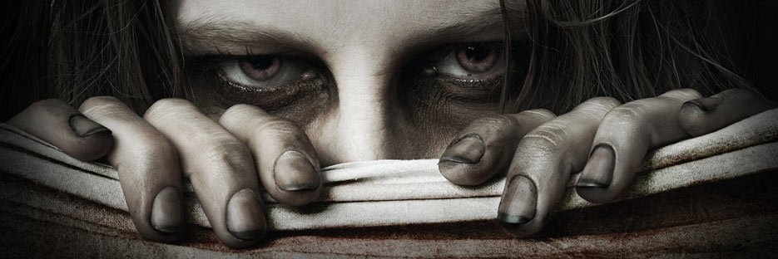
Which may be related to the software death (aka power loss), where the body and computer body sensor via vaccination can then remotely be possessed known as “out-of-band management.”
Image above is from CDC website.

Each individual has a Carbon footprint and debt or requirement. CO2 emissions must be maintained, and that means that some CO2 footprints of some will be eliminated (You). If you do not go along with their entire plan because you believe in freedom, the constitution, individual God given rights and so much more you will be delegitimized, vilified and then blamed (i.e. death camps, executions, slave labor or starvation, etc). After being blamed for the earthly problems (the Lies) they will oft you to a camp, and forget about you, work you to death, starve you, or just pull the plug. If you been vaccinated that will be one way you will be killed. Without the vaccination and all other requirements they will hunt you down (nicely), and nicely cancel you out.

Note: They are not gonna tell you their plan to kill off mankind while taking souls along the way. Satan’s hybrids are in power over the entire planet, and they hate humans Gods Children and creation. The bible says that as in the days of Noah so shall it be in the days of the Son of Man, Trump. The days of Noah means Fallen Angel hybrid children are in control. This was told me by the Lord himself! (Mat 24:37 “But as the days of Noe/Noah were, so shall also the coming of the Son of man be.”)

One View of Human Footprint: “In a typical day, you might drive to work, do a load of laundry, or watch TV in an air-conditioned room. Every one of those actions comes with a price that extends beyond the one measured in dollars and cents withdrawn from a bank—this price comes in the form of natural resources withdrawn from the Earth.”
Ok so you cannot pay for it with money; so how do you pay for living? You do not! they decide how much you get, and then decide if you should get anything based on the critical factor that they promote (BS). Under Trump there were no problems, and yes the climate is hot, cold, and extreme, but not as they have distorted for years. He Trump said they were pumping 90% of drinking water into the oceans, but why? To sell the lie.
.....................................................................................................................................................................
Note: The most recent was the COVID CON, and the mask in Greek actually means Eikon=I CON!
Quote: David Harnsanyi: “It is not hyperbole to contend that GND (Green New Deal) is likely the most ridiculous and un-American plan that’s ever been presented by an elected official to voters. Not merely because it would necessitate a communist strongman to institute, but also because the societal costs are unfathomable.”
Net zero emissions? Since the Earth already reacts strongly to small changes in the amount of CO₂, methane and other greenhouse gases in the atmosphere, emissions of these gases must be reduced until the whole system is back in balance again. Net zero emission means that all man-​made greenhouse gas emissions must be removed from the atmosphere through reduction measures, thus reducing the Earth’s net climate balance, after removal via natural and artificial sink, (see: What are negative emissions?), to zero. This way humankind would be carbon neutral and global temperature would stabilize...
...the "Kyoto Protocol", the first document with legally binding obligations for limits and reductions, was adopted by the ratified countries. The period of applicability was set for the years 2008 to 2012 (1. obligation period) and 2013 to 2020 obligation period)
However, it should be noted: The later this goal is reached, the higher the negative emissions need to be. You can find out more in the article on Negative emissions or about your own CO₂ budget.
CO2 budget? SFO, U of Geneva, and FOEN: Since this budget has already been exceeded for several years, this means that the CO₂ budget for the future is effectively even lower (than net zero emissions). Basically this means: The later the target of net zero emissions are reached, the higher the negative emissions will need to be later/NOW.
The ecological footprint can be calculated at all levels, be it for selected activities, individuals, companies, communities, cities or countries. Unlike the CO₂ footprint, the ecological footprint considers other environmental influences in addition (PLUS +) to CO₂ emissions.
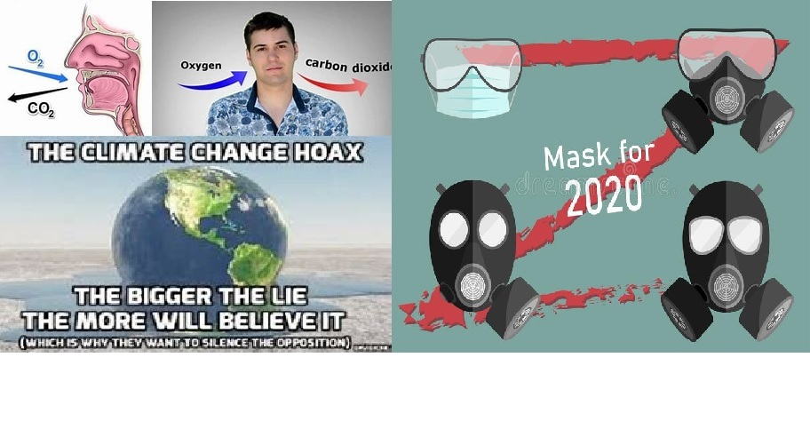
HELSINKI PRINCIPLES
https://www.cape4financeministry.org/sites/cape/files/inline-files/Explanatory%20Note%20-final.pdf (Climate Action Coalition principles)
HELSINKI PRINCIPLES We, as Finance Ministers from around the world: Cognizant, mindful, and aware that climate change poses a significant threat to our economies, societies, and environments, including risks to economic growth and macroeconomic stability, and that there is an urgent need to accelerate action; Recognizing that climate change is also an opportunity, and that taking action can generate substantial benefits for our societies by stimulating technological innovation, improving human well-being, and accelerating economic growth;
Noting our unique position as Finance Ministers to help accelerate a just transition to a low-carbon and climateresilient economy through macroeconomic and fiscal policy, public financial management and, where applicable, financial regulation; Acknowledging that such policies and actions will support global collective action on climate change under the Paris Agreement; Cognizant that Finance Ministers have a common purpose, and can benefit from a forum for sharing experiences and facilitating the adoption of best practices and policies for low-carbon and climate-resilient growth; and Supported by technical assistance from development partners. Hereby establish a Coalition of Finance Ministers to demonstrate our leadership in the response to climate change, wherein we will operate within our national framework, competencies, and mandate to support the following principles:
- Align our policies and practices with the Paris Agreement commitments;
- Share our experience and expertise with each other in order to provide mutual encouragement and promote collective understanding of policies and practices for climate action;
- Work towards measures that result in effective carbon pricing;
- Take climate change into account in macroeconomic policy, fiscal planning, budgeting, public investment management, and procurement practices;
- Mobilize private sources of climate finance by facilitating investments and the development of a financial sector which supports climate mitigation and adaptation;
- Engage actively in the domestic preparation and implementation of Nationally Determined Contributions (NDCs) submitted under the Paris Agreement.
(The Principles mention the support of technical assistance from development partners. The World Bank has relevant programs such as CAPE and the NDC Support Facility. Other institutions like the International Monetary Fund (IMF), the Organization for Economic Cooperation and Development (OECD), UNFCCC Secretariat, UN Development Programme (UNDP) and other UN agencies, and the NDC Partnership also provide technical assistance and analytical support to countries and have been following the Coalition as observers.)... Principle 1. ‘Align our policies and practices with the Paris Agreement commitments
‘Carbon pricing’ refers to measures which put a price on the emissions of carbon dioxide or other greenhouse gases. Such measures provide incentives for emitters to reduce emissions—
>>the Warsaw International Mechanism (What?) All related to EARTH DAY...Satan is the prince of this world and earth worship and the worship of the creation/created, is not worship of God, but in reality Satan and his replacement idols and confiscated materials.
CARING FOR THE EARTH: “The successor to the World Conservation Strategy published in 1980, this global strategy for a sustainable society, is intended to restate current thinking about conservation and development in an informative and encouraging way, and is orientated towards practical action. It sets targets for the changes in our lives that will move us towards a sustainable society and urges a concerted effort to make this ethic a global force in personal, national and international relations.” (All of this is related to the NGD-Paris Accord-Earth Worship GAIA, who is Satan and so forth)
UNFCCC (Road to Glasgow) and Vaccine Participation – all related to the New Green Deal (Accord)
Note: All this above will come into play with the Vaccine, Body Sensor internal nano bots, crystals, and linked to bitcoin or some banking payroll system. In other words you will get so much let’s say EARTH CURRENCY allowing you to live up to the amount dedicated to you based on criteria they install. For instance you convert your home; you maintain vaccinations, wear masks, follow all the regulations put forth. You get X amount once that is out you have to refill your account but if you cannot you get nothing, no food, water, gas, etc. If you are not vaccinated you get to go to these reeducation camps, possibly forcing you to get vaccinated, or using family and food to make you submit. It is a nice little CON to genocide the people and save the planet????? Just a fairy tale and fake news.
Satan has a strategy to take your soul, kill all God’s children (You and I) and cause those to worship him that will, and those that won’t will be without the basics to live, and then die. It will be impossible to transition to this sustainable society because the cost is genocide of mankind. Satan is in power, and will reveal his Son, the Son of Perdition, and Lawless one who I understand to be OBAMA.
He will be destroyed, but he knows that he has a short time and is going to take as many with him as possible. If this next CON as Trump said is being implemented now then it will be one more tool that will be used to take the ignorant and those vaccinated etc into the next phase of their destruction of mankind.
Bright note is that God is not going to let him take out his people. God himself is gonna rescue his people out of here and his Wrath is being stored right now to be unleashed on Satan and the wicked. Those who take the 666 mark of the beast, i.e. the vaccinations, mask which is image or symbol (Eikon) and worship this world system of Satan are losing their eternal souls.
Rev 14:11 And the smoke of their torment ascendeth up forever and ever: and they have no rest day nor night, who WIRSGUO the beast and his image (Eikon-Con-Mask), and whosoever receives the mark (Vaccination) of his name (title, term, alias, category, depiction, sketch, kind=Covid everything) Covid real name is CORONA virus and means CROWN (of Satan or God), the virus means (error, mistake, problem, fault spiritually).
In God’s word it states that you cannot buy and sell without the mark (i.e. Vaccination), the mask was the image and precursor to the mark like a stepping stone.
Rev 13:17 “And that no man might buy or sell, save he that had the mark, or the name of the beast, or the number of his name.” (Transitory from image to mark the goal)
Worship means many things and these are a few of them: respect, venerate, devotion, respect, high opinion, value, price, charge, and worth, usefulness, worth, use, consequence, help, attach importance to, quantity, estimate, appraise, judge, and consider. Relate all of those words to the mask, and how it was more important than the Constitution or individual rights and freedoms. Apply it to how people think you must wear it, and never take it off, so much.

Abomination of Desolation? Obama-nation=Anti-Christ
Dan 11:27 ...the end shall be at the time appointed. Vs 31 and arms (Political/Military) shall stand on his (dishonor/violate) the sanctuary of strength (palace, consecrated place, building or Mountain [White House/Wash DC?], to separate, bestowing favors, WAR and inaugurate rites)
...and shall take away the daily sacrifice, and they shall place (H5414-give, put on, assign and bestow) the abomination (idol/garment, i.e. MASK) that maketh desolate (causes ruin=devastate, impair, prejudice and weaken Our Economy in America-Shut downs, etc).
Take away: depart, remove, take off, turn aside, abolish from God. To be contrary, turn aside from Gods laws, from anyone ruling; daily – to STRETCH (mask) continually (at employment, shopping, eating, and living), undefined extensions (think COVID shut downs).
Note: The MASK is the abomination that maketh desolate, however it is more than one thing it is many. These represent Satan’s Beast System of 666. Obama is the Anti-Christ, and he is the lawless Son of Perdition. Biden is his representation.
The Holy Covenant is either the “Abraham Christians or Patriots to mention a few. Restricting religious and other freedoms (the TARGET).

Mask is the main “Image” of the Beast (System)
I WILL NOT GIVE RESEARCH, AND ALL THE INFO RELATED BUT I AM GOING TO SUMMARIZE THE REALITY OF THE IMAGE OF THE BEAST AND MARK.
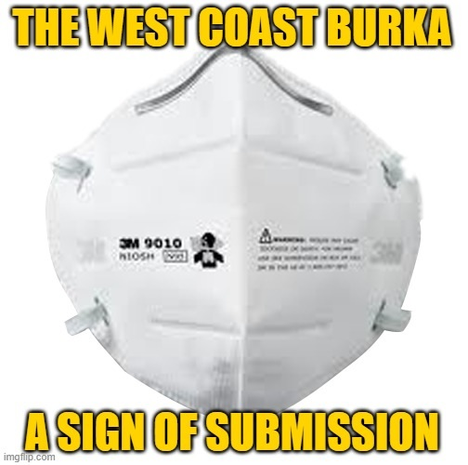
What is the ‘Burka’ mean for Americans? What is an Idol? How do we worship a “god(s)?” What does the bible say about any or all of these questions?
Burka garment: Face ‘Veil’ like a bride of someone, or a scarf as Trump spoke about. Burka is a religious requirement by most Islamic scholars, past or present. I was told that our battle was against Islam by the Lord in 2016. A scarf is also considered a ‘Veil’
Reality: The MASK is the worshiping of Satan, aka Alah, and many other ‘gods’ Fallen Angels. It is the Greek “Eikon/I CON” like fraud, deception, prisoner, mislead, entrap and draw us in. They tricked you/us.
The virus was a deception to get the world ready for the Beast System, Image (Mask) and Mark (Vaccine) of the Beast. The Anti-Christ is Obama, and Satan is his God that they and now many worship by wearing the mask, and getting vaccinated.
BIBLICAL INTERPRETATION (Scriptures: Rev 13-15; Rom 2, Jeremiah 10, Dan 11, 12; Isa 28; 2 Thess, Jer 4 just a few)
Rev 15 –7 last PLAGUES = a calamity: stripe, wound (-ed), to pound, deprived of light (insight, understanding and knowledge), to strike or smite (Trump said we got HIT=strike); shrouded in DARKNESS (Thesaurus: Ignorance, lack of knowledge, unawareness, uniformed, naïve, or unacquainted, not in possession of the FACTS)
Rev 13:4 ...they worshipped the dragon (Satan) that gave power to the beast (System: Mask, Vaccine, 6’ dividing, where all our systems are affected worldwide) allowed to exercise authority for 3.5 years. Beast System and Anti-Christ Obama took power Dec 2020.
Trump said the COVID-19 had many names, at least 20, and one was Plague, Scourge, China virus, etc.
Roman 2:23 And changed the glory (credit, admiration, warmth, happiness) of the uncorruptible God into an image made like (G3666 representation-to become similar=Mask-Identity-Muslim god Allah/Satan) to corruptible man, and to birds, and four footed beasts, and creeping things.
Jer 10:14 Every man is brutish in his knowledge: every founder is confounded by the graven image: for his molten image is falsehood, and there is no breath in them. 51:17 Every man is brutish by his knowledge; every founder is confounded by the graven image: for his molten image is falsehood, and there is no breath in them.
Isa 28, 2 Thess, Jer 4 Read these.
Deu 4:23 Take heed (notice attention, examine, and perceive) unto yourselves, should you forget the covenant of the LORD your God, which he made with you, and you make a graven image, or the likeness of anything, which the LORD thy God hath forbidden you. (mask/other)
Graven Image H6456 Carved, Idol, Mask (curse), to shape new, to cut, to form H6459 pesel-to hew (cut, sculpt, model, style, mold, mock-up, reproduction) into shape.

BENJAMIN TEXT Nov 21, 2019 – 3:34 pm (Messenger of God)
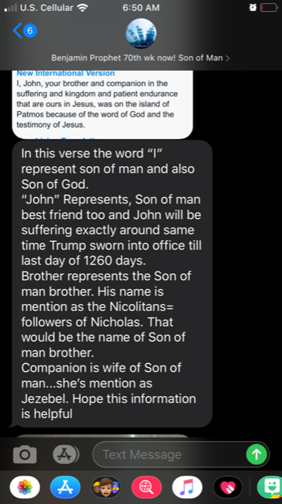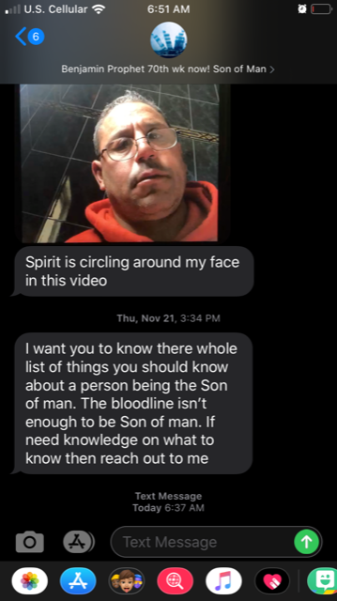

Stone Cairns / Stone Balancing / Stone Stacking
I was at the ocean and these were being built on the beach nearby where I was camping, I began to knock them down while a witch doctor was building more. I felt I was tearing down the altars of Baal spiritually. I told bystanders that that was what I was doing that these were portals for spirits to come into and be present on the beach. They said they looked into it and that what I said was not true. They were either part of it, lying or did not research it properly. It is everywhere and information is historic.
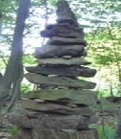
The first “Sacred Space” building technique that you can use is building stone cairns, also known as stone stacking, stone building, or stone balancing.
The art of balancing stones has origins in many cultures. In many parts of Asia, stones are balanced and stacked as a sign of prayer and meditation. In North America, native Americans used stone cairns to watch over animals and forests while humans were not present. As druids, we often meet among stacked stones (such as the OBOD events at Stonehenge each year-Stonehenge may be a portal for the fallen to come through) or in stone circles (i.e. Satanist Circle). When we balance stones, we connect the depths of our souls to the depths of the earth and create something of beauty and harmony. What do the stacked stones convey? Ask them, and you may find out.
Note: Nigel Mortimer is convinced that up until 1779, a ring of “rude” standing stones formed a now concealed and obscured “portal.”
“Thor’s Gate” Style Cairn, complete with spiral drawn in clay
Stone balancing is a very simple, yet profound activity. Stone balancing allows you, at its core, to connect with the ancient energies of the earth. As you stack stones, you can enter a deep communion with the land, a kind of movement meditation.
For example, a stone cairn I maintain every day is my “Shrine to the Fallen” (fallen angels and Thor is one)
which sits on top of a white pine tree stump from a tree that was cut before we moved here. This shrine...

