Mystery of God is Finished
APRIL 28, 2022 Thursday
Rev 10:7 ...the voice of the seventh angel (Trumpet), when he shall begin to sound, the mystery of God should be finished, as he the Lord God=Jesus Christ hath declared to his servants the prophets. (To do something a hidden thing, secret will, establish his will, of Christ, his kingdom, of godliness)
***Warning this is a HOLY topic and should be treated as such; this mystery is not for this earth, but for when God takes redeems his people, this corruption puts on incorruption, and mortal must put on immortality, it is for the new planet also called New Earth. This does not apply to marriages now, or relationships now, the flesh must be redeemed from the fleshly corruption because flesh and blood cannot inherit the kingdom of God which is within.(Lk 17:21, 1 Cor 15:53-54, 15:42-50)
Isa 44:28 That says of Cyrus (D. Trump 2017), He is my shepherd, and shall perform all my pleasure: even saying to Jerusalem, Thou shalt be built; and to the temple, Thy your/relating to you foundation shall be laid (New Jerusalem, 144,000, bloodline Judah and Israel the foundation-Gods people).
Now I will present what God has shown me regarding the hidden thing of God; the mystery that was not revealed until this time where we are in the midst of the Great Tribulation, mark of the Beast, the fulfillment of Scriptures, closing of the books, and the end of SIN. (Dan 9:24 to finish the transgression, and to make an end of sins, and to make reconciliation for iniquity, and to bring in everlasting righteousness, and to seal up make an end of and stop the vision and prophecy, and to anoint the most Holy).
The two Cherubim and witnesses or testimonies next to the ARK represent this covenant, dwelling place of Gods Holy Spirit and throne with the temple, joined to the body of saints, elect, and believers, etc. become his house, the New Jerusalem the measure of a man.
The representation of the Ark is the actual rendering that was given after the physical ark was found, and the Ark appears to be a throne, chair or seat. The Angels look towards each other and down at the covenant between them, which then represents their commitment to God to be One in covenant and holiness.
Their wings or feathers touch in the middle three on each side 33 (Jesus age at crucifixion-blood on the mercy seat). Feathers H2623/5133/3671 saints, holy one, godly one, faithful ones, flying, burnt offering, covering, wings of the morning, edge, extremity, the skirts of a garment.
This touching represents their connection to each other and the throne or back of the seat Ark. Priest hats, and staffs=rods in hand. The look down and across at what is inside the Ark representing covenant (personal, to the Lord, and not defiling their temple)
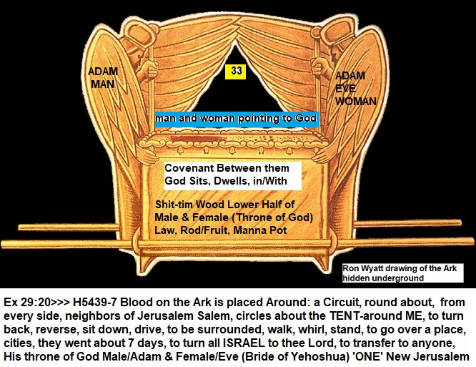
Noah’s Ark, Moses Ark reed boat, Ark of the Covenant, Tabernacle skin covering, to Jesus his body the Temple, and pointing to us the Temple of God. The mystery of the redemption of the Bride (male and female) returning back to the original plan of God. Marriage supper is union, fellowship where Jesus by the Holy Spirit called the comforter comes into this earthly temple and we sup with him, fellowship. The mystery is the final redemptive purpose of Gods dwelling in the midst of us, male and female 2 by 2 as at the first.
Adam and Eve who walked with God in the Garden of Eden (H5729/H5727 Pleasure, to delight oneself)-However, because of sin the covenant was broken between all of them, and their temple was polluted with the serpent braking the union and covenant with God, just as the fallen angels sin was going into the daughters of men (sexual) and defiling them, their blood and covenant with God.
Gen 3:7 And the eyes (Spiritual and Sexual) of them both were opened, and they knew that they were naked...defiled
Redemption is Gods original mystery and secret plan of the ages is about New Jerusalem, the measure of a man, a bride adorned for her husband (God), not a temple made by man, but a temple of God, an immortal dwelling. Remember, God took part of man and made woman, together they are ‘One’ a temple where Gods holy spirit would dwell in part, and in the future, New Jerusalem, New Heaven and New Earth, this body temple would be ONE again walking, with God in the future redemption. God in the Son Jesus, we in Jesus and in the Father one body as the scriptures say. I will include them below.
John 14:10 Believe you not that I am in the Father, and the Father in me? The words that I speak unto you I speak not of myself: but the Father that dwells in me, he does the works. 11 Believe me that I am in the Father, and the Father in me: or else believe me for the very works' sake.
John 14:23 Jesus answered and said to him, “If anyone loves me, he will keep My word; and My Father will love him, and We will (Father and Son) come to him and make Our home with him (Those who love him).
The Temple and what it is made of represent our bodies, also representing the Lords Body and New Jerusalem, the materials all have a meaning pointing to the 144,000, Elders, Army, Priests, Witnesses, patterns in every way.
Mar 14:58 We heard him say, I will destroy this temple (Jerusalem building) that is made with hands, and within three days (Jesus Resurrection) I will build another made without hands.
God’s desire was to make a Holy Tabernacle by teaching us over time through many resources, rituals, and symbolism his latter application which is no longer just an earthly example, but now will become the plan of the ages enacted by God himself. Those prepared those vessels that are set apart to God right now. To translate into eternity and his final purpose to dwell among, in the midst, and walk with us a marriage (Marriage Supper of the Lamb) a union just as many have united with Mystery Babylon the V, the union with the Beast system through the Image, Mark 666, number #6 of man, and name COVID.
Scripture Reference: Gen 3:8 walking in garden, Gen 3:21 God made coats of Skin, 1 Thess 4:4 vessels/body, Matt 26:61, John 2:19-21 his body temple, Rev 21:17 New Jerusalem-measure of a man-12 tribes, etc.
G3485 Temple/naos: to dwell, sanctuary, entire consecrated enclosure, Holy place, Holy of Holies
2Co 6:16 “And what agreement hath the temple of God with idols? for you are the temple of the living God; as God hath said, I will dwell in them, and walk in them; and I will be their God, and they shall be my people. (The lord walked originally in the garden with Adam and Eve until the covenant breach)
Rev 21:1...And I saw a new heaven and a new earth...2 And I John saw the holy city, new Jerusalem, coming down from God out of heaven, prepared (G2090 to make the necessary preparations, get everything ready, to prepare the minds of men to give the Messiah a fit reception, to receive one coming), as a bride (male and female) adorned (G2885 to embellish with honor, garnish, proper order) for her husband (God).
Rod H2415/G4464 = a branch, scepter used on a journey, a royal scepter, stick, cast out from thy sepulchre, to not join, a snake (type or symbol of the male reproductive member lower part of Ark covenant body; Ex 7:9-12), H5221 smite with the palm of (one's) hand; beat, scourge, clap, applaud, give a thrust, conquer, subjugate to ravage in battle.
The pagan world worships the phallic symbol which is the member (male rod/female) in covenant between men, women, and their creator God. The phallic symbol has many names including Holywood. (Spelled that way on purpose)
Manna = Jesus is the manna, body, life, light, Word of God, which is each male and female, his spirit, called the bread of life.
Ten Commandments/Law = He writes his laws in our hearts and minds (Heb 10:16) this is in us the Ark
God wants to be with us fully, but in sinless redeemed temples, Man now whole with woman in covenant together as one with the Lord Father God and Jesus Yehoshua. Originally, we were in him as spirit children, came to earth to grow up, learn and be prepared for his finale purpose of every age to dwell with his people, and be their God. We in him, he in us, one body, temple, house, on the New planet Earth, and New Heavens.
God is pairing male and female, not here, but after the redemption, and many have seen dreams or visions revealing some of this. This is called Revelation. This has to do with the elect, harvest workers, aka 144,000 and the rest. In Eph 5 God reveals the plan of earthly marriage as Jesus who is God and the Ecclesia, aka Church or congregation of all the saints and it has many great examples many need to be explained, but not today.
www.yourawake.weebly.com (All research and confirmations with links to dreams, visions, other prophet sites for your learning and confirmation)
TIME IS UP! AND IT IS JUST THE BEGINNING...The 7th Trumpet is sounding the books are closing, sin will end, and prophecy will cease. Get Ready! Repent and call on Jesus your redeemer, and Lamb that was sacrificed and covers us like skin of the temple. This is a spiritual reality, and even though we take on flesh (spiritual) for now we are being prepared, the BRIDE of Jesus Christ soon to leave this Earth behind.

