The Lord God Communication – Daughter of Zion – Anti-Christ OBAMA 5/5/2022
This image is about CERN, the god of destruction related to Obama on the Newsweek cover during his Presidency
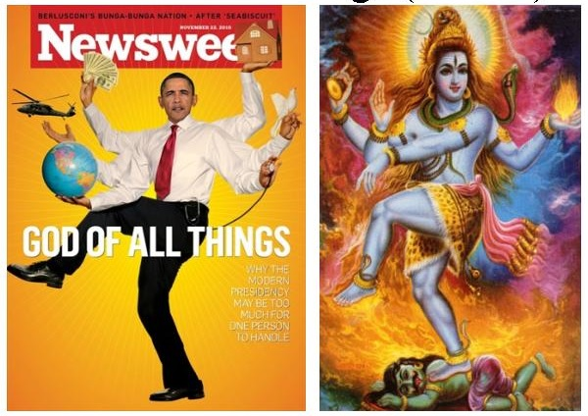
Contents
The Lord God Communication – Daughter of Zion – Anti-Christ OBAMA 5/5/2022 1
CONVERSATION WITH THE LORD GOD IN PERSON 3
1st Conversation: 3
2nd Conversation: 3
3rd Conversation: 4
4th Conversation 5
5th Conversation: 5
Scripture Related Hail, Fire and Brimstone, Waters turn to blood (Red Sea): 7
This Cataclysmic event 8
RAPTURE VIDEO LINKS #3: 8
HAND IMAGE OF SINWAR/OBAMA - REPRESENTS THE 666 10
GOG – ANTI-CHRIST (REPLACEMENT OF YHVH) 10
YAHYAH SINWAR CHIEF OF HAMAS (IRAN) 14
DAUGHTER OF ZION – REVELATION 18
GARDEN 19
SINGING, Song, Psalm 19
The Glory of God in Zion 19
JEREMIAH 33 20
The information below is related to altar of fire, the blood is the waters; and the anger of the Lord as designated at the time. 22
BLOOD 22
FORSAKE ALL IN COMING OUT OF EGYPT, SODOM, AND BABYLON 23
FORSOOK 23
TO LIVE BY EVERY WORD OF GOD 24
GAZEBO-SMALL GARDEN CABIN AT LORDLAND PHOTO 2013-2016 25
LINKS - DAUGHTER OF ZION: 28

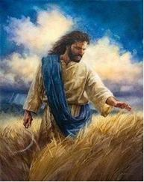
CONVERSATION WITH THE LORD GOD IN PERSON
My first known conversation was in 2016 and documented in one of my eBooks called “Donald the Last Trump”. I was given much revelation and prophetic insight regarding the times we have been in.
On earth he does not appear as in the photo left, it would be too obvious, but like the shape shifters he has appeared in camoflauge wearing optional images of himself.
The following conversations are only the ones I was sure of and they began in Sept 2021 through to May 2022.

1st Conversation:
He the Lord said “Do you know who I AM? And I said “I think I do” at the Jasper Café’ he insinuated that I and Gabriel were Druids, and he said that they were before Adam and Eve.
He said he and the angels have filled up bottles with tears and he showed me one, it seemed to sparkle and was thick. He truly is heartbroken regarding those who reject him, or are doing evil and refuse to repent and turn back to him.
Yes that we Gabriel and I were Adam and Eve; He looked inside a small wooden box, and then he looked at me and said he hides in it, and plays inside, or used too. I know now it is was related to his holy spirit and “manna” related, me and G.
He mentioned Pollux and Castor as “siamese twins” which means conjoined like the Ark of the Covenant which I know now is Gods plan for eternity to pair male and female with him like the Gemini sign I was given.
He said I was no longer betrothed but now the wife, at the time I thought me with Gabriel, but I now realize it was Jesus (Holy Spirit) with Gabriel and I—when the Heavenly constellation and sign in the heavens in Gemini “Twins” took place 6/25/2021 where Jesus (Venus=Morning Star) lined up with Castor and Pollux (Us).
He gave me a flashlight from a bike it was round and had two bulbs ‘lights’ inside. He did a sign at the time about the shittim wood in a white box, but I will not elaborate what.
He wore a hat with two diamond crowns on it and I thought it was about us (G & I), he had a bike and said it needed some upgrades but it was a nice bike and he liked it. He said “You deserve to be made beautiful” he said “Relationships” and we discussed them.

2nd Conversation:
He had his arms full of roots, and one grape vine, also he was carrying different sizes rocks and dirt, and said that they were really heavy, he said he is looking for rocks and mentioned gemstones. He said something about his wife were sometimes male or female, I think I understand but not saying right here (Adam and Eve=male and female). He called me his wife, and as he left he said “I Love You”
He mentioned a beach and ocean, and that it was a desert, and that there is another planet with mountains and rivers that was good. He said people could of grown vines (grape) producing fruit, and wine (Holy Spirit) instead they F**ked it up, because of the ‘V’ they are committing fornication with Satan and weeds are now growing where the holy spirit could have.
Scripture: Jonah 2:5 “The waters mayim compassed me about, even to the soul: the depth closed me round about, the weeds sup were wrapped about my head.”
Note: My mom said the weeds are growing so fast she cannot keep up with pulling them, I looked around and the area was fine, and I later understood that these were spiritual evil spirits, and internet controlled “One Mind” or hive mind.
Jon 2:5 “The waters compassed me about, even to the soul: the depth closed me round surround about, the weeds were wrapped about my head.” (weeds: H5488 Red Sea, reeds, sea weed, a rush; blow, gale, current [electric?], blast; from the nile/Egypt-wild plant-to train, groom, make ready, guide, in sequence, progression and series, as in more vax, and internatl awakening)
These plants are not of God but of the beast system, and Satan the RED DRAGON.
Another person, an acquaintance said regarding weeds, that there were entities [creatures, beings, things, organism, insect, living thing, life form, unit] inside of her and they were getting bigger, and that she was doing spiritual warfare? So he confirmed what happened to those who took the ‘V’- Mark666.
Mayim: water; figuratively, juice; by euphemism, urine, semen (seed of Satan=DNA of everything=including Nephalim):— piss, wasting, watering, course, flood, spring.
Weeds: Bitter Lakes, shallow and marshy, whence reeds (probably also reddish colour-Red Sea
He the Lord Jesus who is God, and He talked about a place, another planet with rivers and mountains that was prepared, and I knew it was the New Earth. He talked about a 12 inch loaf of bread, and said something about reaching under the chair and getting one.
Now mind you this is my interpretation of some of the things said and not exactly, but I tell it from that point of view.

3rd Conversation:
He said he filled up 12 trash bags (related and refering to the 12 Tribes of Israel who were not redeemed), each side of the road about a ¼ of a mile he said was trash, warm, He asked if I was the wife in a round about way waiting for my response and I said “I believe so, yes”, roots, grape vine, kidney, rocks dirt, new planet earth, He said he likes to rest there at Coffee Heaven (symbolic of rest in Heaven to come).
He mentioned about someone a woman being rich and having 7 or more mansions or homes, and millions; so, I am thinking this is refering to souls and riches in heaven. I could not keep up with all he was saying.
He offered up that Texas was cold, real cold (not friendly to him), and that California was cold as well and he does not like either. I knew he meant people or individuals.
He said he was resting there all but his mind and that He thinks non-stop, also he said something about his hair being down his back (long), but I knew he was talking about me, because many times he speaks in reference to random or himself, and when I repeat it; it is about me. There are many things said I do not remember.
He God was sitting across from me on a bench, and he asked me about bread about 12” long, he reached down under the bench and said you just pull it out or something like that. Also, he mentioned when it gets too warm he moves to one side into the shade.

4th Conversation
Those ducks had four children, where are they now? He was glad he was not in the Army anymore, and that he is taking the money and running. He was fishing because he needed something to do. Said he was maybe going to stay in a Teepee tonight, and hoped it had a bed, he went and checked and it was 80.00 a night. (He pointed in the direction that would be NE.
He said it was beautiful, and he went and brought me back a Coca Cola, He said he bought a burger and French fries, and he wanted to know if I wanted one. In his vehicle he played “Respect” by Aretha Franklin. It made me sad. He gets very little respect from his children who all the people on the earth, he sheds tears (if only they knew, or understood?) this is how I saw him that day. This is the creator God who also became a man, and this is the man, not the one who will be our Judge. To me He was beautiful, kind, caring, grace, love, and ‘Holy’ good.
When he gave me the Coca Cola he asked if I was fishing. I do not remember my response. This was because I was speaking to the Atmosphere about respect, God, and why people don’t get it, pride, game playing, and competition for the wrong things. (Why you join the club? What are you fighting for?) Kind of like that.

5th Conversation:
The last conversation as I left was that the Sephardic Jews (African) were the first, and the Ashkenazi were later. This was related to the four sons that he told me about previously three other times I believe, and I think he wanted me to understand this that they were mine and Gabriel who was King Solomon, and these sons were related to Queen of Sheba whom not known by me, or forgotten were our sons. Donald John Trump who is Gabriel and King Solomon was the builder of the Temple of God, which makes sense because Trump built many buildings and structures through time. (1Ki 10:1–13 )
2Ch 9:1And when the queen (Esther 24x, king, royal or royal sanctuary, feast, mowing) of Sheba (“seven” or oath) heard of the fame of Solomon, she came to prove Solomon with hard questions at Jerusalem, with a very great company, and camels that bare spices, and gold in abundance, and precious stones: and when she was come to Solomon, she communed (to lead, and guide flocks, and she was speaking in her heart, a promise, when she shall be spoken for, she shall be asked in marriage, she made war upon them because of the plot to waylay and destroy, and they spoke deceitfully as before; “they have spoken against Jehovah and against me/him”) with him of all that was in her heart (to love with the whole heart, soul, life or breast, the soul life to be refreshed).
Manna=H3823: Songs 4:9 (twice in verse) thou hast encouraged me, thou hast encouraged me with one of thine eyes, I understand this to be what has taken place in these last year’s which launched our journey.
2Ch 9:2 And Solomon (Gabriel/Trump) told her all her questions: and there was nothing hid from Solomon which he told her not. 3 And when the queen of Sheba had seen the wisdom of Solomon, and the house that he had built, 4 And the meat of his table, and the sitting of his servants, and the attendance of his ministers, and their apparel; his cupbearers also, and their apparel; and his ascent by which he went up into the house of the LORD; there was no more spirit in her.
2Ch 9:5 And she (Queen Sheba) said to the king, It was a true report which I heard in mine own land of thine acts, and of thy wisdom: 6 Howbeit I believed not their words, until I came, and mine eyes had seen it: and, behold, the one half of the greatness of thy wisdom was not told me: for thou exceeds the fame that I heard. 7 Happy are thy men, and happy are these your servants, which stand continually before thee, and hear thy wisdom.
2Ch 9:8 Blessed be the LORD thy God, which delighted in thee to set thee on his throne, to be king for the LORD thy God: because thy God loved Israel, to establish them forever, therefore made he thee king over them, to do judgment and justice.
Related to Sheba and the end of days which is now; regarding the daughter of Zion:
Isa 60:14 The sons also of them that afflicted thee shall come bending unto thee; and all they that despised thee shall bow themselves down at the soles of thy feet; and they shall call thee, The city of the LORD, The Zion of the Holy One of Israel.
There are DNA studies that link Adam to the middle east, Asia, Europe, but specifically to Africa, as a matter of fact they link it directly to Adam as an African.
After the Cataclysmic – sudden and violent upheaval turmoil, confusion, disruption mayhem or disaster tragedy, calamity, failure, misfortune, and mess that causes great changes, alter, transform, modify, variation, convert, altercation in society, devastating, after the CATACLYSMIC event, is 10 days the grid goes down causing those with the ‘V’ great pain, part of the solution is have people move into 5G cities and ultimately Elon Musk (Anti-Christ, meaning replacement, alternate, substitute), and Bill Gates (False Prophet), and Bizos Cavello (Multiple applications related, medical and Biosciences) will have the solution and it will be related to technological upgrades, etc.
Bizos Biosciences: a science that studies structures, functions, interactions, or other aspects of living organisms (DNA mixing GMO related), e.g. biology, ecology, physiology, or molecular (nuclear, elemental and indivisible of similar parts) biology
Scripture: Mat 24:24 “For false christs – Anti-Christ (Elon Musk) and false prophets (Gates) will rise and show great signs and wonders (a prodigy, portent-miracle: performed by any one) to deceive, if possible, even the elect.
The ‘V’ is organic living organisms the smallest particles there are; they want all ‘V’ to control them.

Scripture Related Hail, Fire and Brimstone, Waters turn to blood (Red Sea):
Rev 8:7 The first angel sounded, and there followed hail to lower into a void, to strike down, gulf fixed, torment, (Lk 16) no water, parched land, bay of the sea; he mentioned Ocean, and fire mingled with blood, and they were cast upon the earth: and the third 1/3 part of trees (G5464 Matt 13:32 oaks, birds lodge/fallen host, seeds growing to shape and size of a tree = people –weeds, a corrupt tree brings forth evil fruit/seed/children-the Tares) was burnt up (Devils and demons, or evil spirits flowed down from their head-Euroclydon=a tempestuous wind) and ALL green grass was burnt up. (‘V’ related, and could apply in multiple ways)
He told me that we (regarding the Hail-internal judgment-they have died spiritually forever/the slain; Lazarus related in HELL-Lk 16:23) had to go to the sea, ocean, and we must wear waterproof wool, bosom of a garment (Garments of Life), Jesus side was pierced and out came water and blood signifying the baptism, washing, and those who took the ‘V’ cannot cross over back to the Lord.
If you want to look further you can do word studies in the www.blueletterbible.org to aid in further understanding the judgment through the V.a.x.
They cannot quench their thirst or even hunger, related to Jesus being the water of life, and the bread of life where we will never hunger or thirst again. This is related to the first trumpet sound and the Corona ‘V’ mark of the beast, image, number 6’ and the name Corona/COVID.
Another think He told me is that they glow RED and Florescent GREEN by a THERMO signature, only the V.a.x do this and can be traced anywhere, but those without the ‘V’ can hide behind a glass and not be seen. That is why they want everyone taking the V, as well as it is going to take you SOUL.
God will not let them perform their full agenda towards his people whom will be taken before the true final Wrath of God commences, and Jacobs troubles begin. Many leaders, rich, and perceived important will go underground into bunkers worldwide to hide from the Lord because Satan knows his time is short he is deceiving them and they are deceived. and government facilities, and fake a coming by aliens who are actually fallen angel or their hybrid children, Elon will present himself as the savior with some technology or new Vax upgrade that will solve their pain and sickness problems.
This Cataclysmic event as far as I am thinking may be the removing of the restrainer, the catching away, known as the Rapture or Harpazo (2 Thess 2:6-7), and has other names like ascend up, rise up, go up of Gods people which cause the total disruption and mayhem in society population, the public, humanity, the world, civilization, culture, and social order, also association, union, circle, group, friendship, relationships, organizations, memory, remembrances, nostalgia, homesickness, indistinctness, negligence, insensitivity, disregard, abandon of all alliances.
There will be laws and rules for us, which will be oppressive, unequally administered, but they will not be held accountable, and that means those in power, or even those of your own family.
He the Lord mentioned that first the homeless will be blamed, then the immigrants than everyone will fight each other. They want this to happen and will promote division because they want the population to be either converted, killed (All), and chaos. For those not taking the V they will starve, and be hunted.
One is that those needing food, water, gas, or medication, etc will have to be ‘V’ – He the Lord mentioned those who have the ‘V’ can be tracked by thermo technology making them glow red and florescent green or green. Those who do not have the ‘V’ yet and possibly left behind can hide behind glass and will not be detected.
Elon Musk is the Anti-Christ, and Bill Gates the false prophet, also Obama and Biden are Burger Kings, as in puppets. One think that even those planning to use advanced technology of space craft to deceive the people, and cause them to worship Elon is spacecraft that like a rocket can land sideways on the ground. Elon, Bizo’s and Gates along with others will go underground and pretend that they came from outer space, or something along that line of deception. The fallen angels, AI may even take over and those with the V will go along with them like slaves.

RAPTURE VIDEO LINKS #3:
https://youtu.be/tQM7FXmevks Rapture
https://youtu.be/4NAgZzQcfvM Rapture clips of Chaos
https://youtu.be/BK20jKSO3B8 Rapture – disbelief clip

HAND IMAGE OF SINWAR/OBAMA - REPRESENTS THE 666
This image has been seen in similar form in Pet Goat and George W. Bush was the one doing this with his hand.
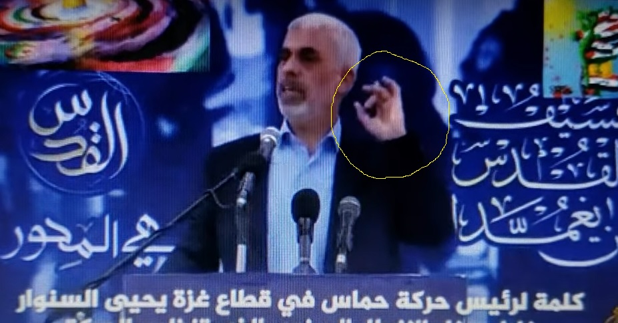
PET GOAT GEORGE BUSH-NWO RELATED
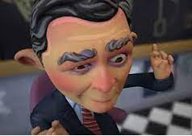

GOG – ANTI-CHRIST (REPLACEMENT OF YHVH)
YAHYAH SINWAR Chief of Hamas in IRAN, aka OBAMA who is a Fallen Angel-shape shifter: He, YahYah Sinwar changes himself (shifts) as described in the book of Enoch.
Video of SPEECH (Who is this?) https://youtu.be/ZJ_sOVQcbi4
“Night SEASON” Link (Pagan information) https://youtu.be/59I-t50ZEhs
Iranian Leader (Obama-Fallen Angel called Aliens) 5/5/2022 Partial speech from video of Mk Allison
“Harming the Al-Aqsa Mosque and JerUSAlem means a religious war (Jihad)
“When it comes to our religion and our holy places (hand over heart=in their body the temple of the beast/satan/evil spirits and fallen angel control or possession)
“We will spare nothing and will not hesitate to make the decision (hand slicing R to L “Carate” 3 times)
“If this entity continues its policies (pointing left-direction?)
“Take it from me: (hand on heart) It will change the shape of planet Earth, because a regional religious war will leave Earth Scorched.
“The world has a chance to act in order to prevent this great war, and to avoid starting processes that only ‘A’ knows how they will end. (lies)
“But we, as Palestinians and Arabs and Muslims, who are part of the Jerusalem axis and coalition (Jerusalem also is America, aka Israel/Ephraim, so is Selma, Shalem, Jerusalem)
“We say clearly that we are completely ready to defend the Al-Aqsa Mosque. A few days ago 5/ ?/2022 that we have prepared a first salvo of 1,111 rockets.
“For when we have to defend the Al-Aqsa Mosque (pointing symbol the hand to screen behind Muslims Jihad-related to West bank)
“Why 1,111? Because this number is made of two “11” figures. (DJTrump & Me)
“It commemorates the martyrdom of the eternal leader Abu Ammar (Yasser Arafat-Obama is adopted Son)
“This salvo will be named the “Martyr Abu Ammar” salvo (offensive, onslaught, blitz, attack, harass, show aggression, badger).
“Our people under occupation inside (Israel, ‘V’ related-these names represent in code other things below listed) in Negev, the Triangle region (Ark of covenant between G & Me and God see photo the triangle area/region), the Galilee, Haifa, Jaffa, Acre, and Lod”
“Whoever has a gun should prepare it, and whoever does not have a gun, should prepare his cleaver, axe, or knife.” (Obama/Iran leader speech; there was more, but this all I had)END
Word Meanings:
Negev - parched, So. country
The Triangle Region – area, section, locality, borough, spot-catch a glimpse, see, place, part, quarter, part, element, branch, component, related to the Ark
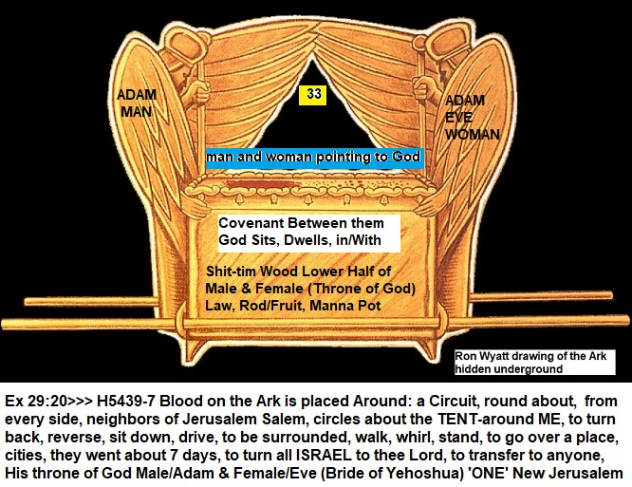
The TRIANGLE that Yahya spoke of was that between God and Man/Woman related to the Ark of the covenant. The throne of God where he dwells in a cloud above the mercy seat. The wings touch and the mathmaticl geometric shape is triangular.
The Galilee – mouth of the well, stone, roll, circuit, dist, valve, round; Haifa – well=drinking, to furnish a potion-to be drunk (for good or evil), fat pasture, slender, little, delicate
Jaffa – Port City (Tel Aviv), west central (beautiful), Jewish families.; Acre H6776 semed - 66 by 660 ft. one chain, land, couple two together, yoke a team=pair (male and female), a pair of horseman, a pair of riders,
Lod – H8289 Plain of Sharon; Song 2; yasar East of Jordan, fertility, around Gilead to go straight or right (Gender?-justice-in the eyes of a woman- let thine eyelids look straight before you) – transportation (moving, carrying, delivery, ship=vessel/body, hub) Ark, and the lower region of the Triangle is where the manna, spot is located on the lower half.
BLOOD MOON 11:11 (rockets) related to Obama who is Anti-Christ (YahYah Sinwar) He claims to be God, but is a Fallen Angel, and the Dragon is the force behind the man and religion of Islam among others.
YASSER ARAFAT ADOPTED CHILDREN, GAZA CITY, Gaza (The youth is Obama as a shapeshifter; my adopted Grandson from Ethiopia)
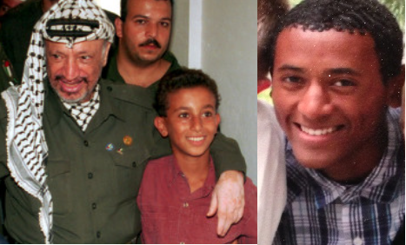
My Grandson, Obama who is YahYah Sinwar (Yahyah Sinwar=Worshiper of the Moon God & War), that is why in his speech he dedicated this salvo to Arafat because he believed that the Jews assassinated Yasser his father through adoption.
ONE ANTI-CHRIST (opposed to Gods Anointed, defiant, challenging, opposing, the true deliverer Trump – Who is Gods Chosen One/Messiah) AND SON OF PERDITION HAS BEEN REVEALED – AKA GOG -Photo
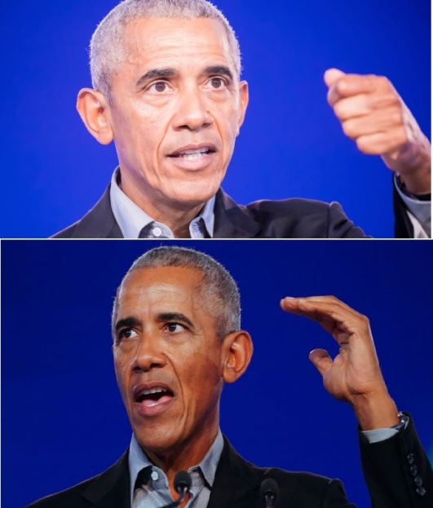

YAHYAH SINWAR CHIEF OF HAMAS (IRAN)
OBAMA GOG/ANTI-CHRIST AS I WAS TOLD IS ELON MUSK AND THE FALSE PROPHET IS BILL GATES-Photo
The Peace signs or symbolic representations of the TWO FIGURES spoken of in his speech. This relates to Gabriel (Donald Trump) and Me (Daughter of Zion). I have done other studies regarding the Ark of the Covenant which we also represent, and how this applies to Gods plan of eternity.
It appears that he is just one of the most likely 10 kings or 7 Heads of Countries that are part of this Anti Gods Chosen, and Gods people.
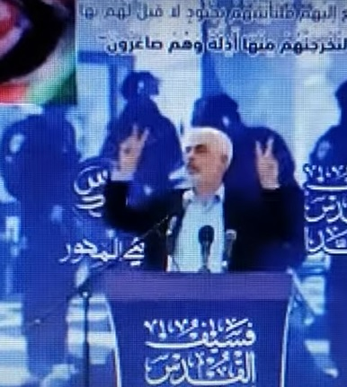
YAHYA SINWAR = OBAMA (IRAN CHIEF OF HAMAS)
Al-Aqsa - "the Farthest Mosque", and then up to Heaven on a heavenly creature called al-Burāq (magical flying horse) ash-Sharīf; located in the Old City of Jerusalem = (Arabic: ٱلْإِسْـرَاء), "The Night Journey"; ascension from Jerusalem to the heavens) temple mount plaza (court, cube, four-sided figure, rectangle/Ark?)
Moon = “Ruler of the Night” Moon God = Nanna (Sin) linked to Bulls head Deut 17:2-5 worship of the stars, planets, etc is punishable by death.
Mosque - Muslim place of worship = [masdʒid]; literally "place of ritual prostration" also called masjid, is a place of worship for Muslims. Any act of worship that follows the Islamic rules of prayer can be said to create a mosque, whether or not it takes place in a special building.
Prayer is in the heart, also openly so this applies to the seat of Satan. I believe predominately that he is refering to the ‘V’ and their place of worship is inside them like we are the temple of God, now Satan through technology has a place where he sits, their bodies.
2Th 2:3 Let no one deceive you by any means; for that Day will not come unless the falling away comes first, and the man of sin[fn] is revealed (He has), the son of perdition, 4 who opposes and exalts himself above all that is called God or that is worshiped, so that he sits as God[fn] in the temple (Peoples Bodies Gods Creation) of God, showing himself that he is God.
Note: This is worldwide COVID, masks, number ‘6’ and Mark (666) which is the Vax and nano technology (dust). Now weeds instead of wine/the vine is overtaking them, evil spirits, and hive mind hoocked up to the worldwide web, 5G, iphones and the rest.
“NIGHT JOURNEY” means: At the Lote tree of the utmost boundary near it is the Garden of refuges. Eyes (Ayin=Omicron, small ‘g’ or gods, related to the ‘V’) did not go beyond the mark” (which one the ‘V’ 666?). “donkey or ass/mule-pure white lightening”(God said that nothing defiled would come any more to him). YAHYA SPEECH IN CODE
Lote H7513/G2208 raft, to spread, bench or stool to trample, prostrate, submit self; one burning with zeal, a zealot to defend and uphold a thing, vehemently contending for a thing (zealous for) to be heated, anger, in a good sense to be zealous in the pursuit of good, to desire one earnestly, to be full of zeal for good, punitive zeal.
Tree H6086/G3586 staff, building materials wood, sticks for fuel, post, stake, shittim wood (Gen 2:9) pot (manna in Ark); a sextarius a vessel for measuring liquids, holding about a pint (.5 litre) a wooden pitcher or ewer (container, bowl, pot, basin) from which water or wine is poured. https://www.britannica.com/science/sextarius
9/11 Scripture related to Obama leader in IRAN
Isa 10:5 “O Assyrian (a step-Ancient Babylon-Iran), the rod of mine anger, and the staff in their hand is mine indignation. 6 “I will send him against a hypocritical nation (America/Ephraim, aka Jerusalem=Selma area), and against the people of my wrath will I give him a charge, to take the spoil, and to take the prey, and to tread them down like the mire of the streets.”
ASSYRIAN Eze 31:3...Behold, the Assyrian (Serpent, Obama) was a cedar in Lebanon with fair branches 8...The cedars in the garden of God could not hide him...9 I have made him (Assyrian) fair by the multitude of his branches: so that all the...18 thou shalt lie in the midst of the uncircumcised with them that be slain by the sword. This is Pharaoh and all his multitude, saith the Lord GOD.
The Rod of my anger refers to God the one wheeling Him, Obama but he thinks that he is doing these things, and God in Isaiah says He I s the one giving him this power to fulfill Gods written word.
Isa 10:5 “Woe to Assyria, the rod of My anger And the staff in whose hand is My (YHVH Gods) indignation.
Isa 10:12 “Therefore it shall come to pass, when the Lord has performed all His work on Mount Zion and on Jerusalem that He will say, “I will punish the fruit of the arrogant heart of the king (Obama and Satan) of Assyria, and the glory of his haughty looks.”
Isa 10:13 “For he King of Assyria says: “By the strength of my hand I have done it, And by my wisdom, for I am prudent...”
Isa 10:24 Therefore thus says the Lord GOD of hosts: “O My people, who dwell in Zion (literal City as in the place), do not be afraid of the Assyrian. He shall strike you with a rod and lift up his staff against you, in the manner of Egypt.
Isa 10:25 “For yet a very little while and the indignation fury, anger, provocation, frustration and displeasure will cease, as will My anger (wrath) in their destruction.”
So the Assyrian who is the king (Chief of Hamas/Iran=Obama), is the one that Natan 15 prophet said hits two cities with the ‘A’ bomb. This Assyrian, Gog, who is Sinwar/Obama is to be destroyed and his fruit/seed/children which can be linked to the evil spirits and hybrid children, because he is a fallen angel in a skin suit, who also shape shifts. Always behind the kings of the earth is Satan or YHVH.
These children of the Assyrian; the evil spirits which come bia the ‘V’ (Apollyon, CERN, opened abyss) some were let out and have gone into the whole earth to gather them together for the battle that started in 2015, and has continued to this day until the Lord is finished with his worl.
In the name of ‘Al...” related to the Mark of the Beast, snake, sabers, and even the Badge=image or mask (Qu’ran Tirmuthi 26:39; 27:82)
Assyrian H804 assur: “a step” successful, people and territory, name of god, Persian, to go straight in understanding, lead the oppressor right.

I believe this is the temple of the ‘V’ a temple/ of the He-Goat, Satan, and Son of Perdition is Anti-Christ Obama who is also Gog and brings this WW3 to the world, is bringing this war now.
NOTE: Natan 15 yr old Atheist Died and went to heaven and hell, said Obama is Gog of the land of Magog. Now Gog is a fallen angelic prince, mountain, locust king, or Satan himself either possessing Obama, or will fully posses him at some future point.

DAUGHTER OF ZION – REVELATION
I am documenting who the daughter of Zion is, and those who want to research this further can. I am not going to argue it, and it is the reality. Someone is, and all evidence points to me, but also it is linked to Gabriel as part of the Ark of the Covenant, both representing a particular part of Gods latter day plan which is now.
Heb 13:14 For here have we no continuing city, but we seek one to come (New Jerusalem – People).” (1 Peter 2:9 (Exodus 19:6), cf. Exodus 19:5; Acts 9:13, 32, 41; Acts 26:10; Romans 1:7; Romans 8:27; Romans 12:13; Romans 16:15; 1 Corinthians 6:1, 2; Philippians 4:21; Colossians 1:12;)
New Jerusalem is our eternal destination, and this city of God a holy city is made up of Gods people who are paired (144,000) specifically. These are the be the immortal bodies, and unions prepared by God for him to walk with, in and by. The city to come is also related to Gods original plan and this is where God began a redemption plan that involved Me and Gabriel, leading to the attacks, and much more on him and I, in different environments, individually and as a whole.
These unions are related to God who sees male and female as together as his seat of authority and dwelling place in covenant between the Adam and Eve (Male and Female, 144,000 plus), and a covenant between them and God, also harvest workers and tabernacle; the New Jerusalem of God.
In 2018 approximately I was betrothed to Gabriel this person that was the object of others who wanted me to be out of the way, and then began the long educational process of why? What was going on? And in the future over time I came to understand more. The Lord told me in 2021 at the Jasper Café’ that I was His wife now. This is a heavenly union and not of man.
Also, I was the wife to the Lord God, and anyone who knows about the Shulamite in the Song of Songs and the others ISRAEL who is his wife, and also the Bridegroom. He has asked me if I understood this, and I said: “I believe so.”
Lam 2:4 He (God) hath bent his bow like an enemy: he stood with his right hand as an adversary, and slew all that were pleasant (H4261 object of affection, desire) to the eye (H5869 Jehovah is the eye of man, sight, He has his eyes fixed upon man-face, appearance, form, well, a fountain of gardens, the fountain of habitation Ps 83:11-of judgment, a fountain of the spy, the eye a fountin to flow out looking, askance [to one side, slanting, indirect, sidelong], envious=tears) in the tabernacle (H168/H166 tent, covering, dwelling, of the covenant, moveable, portable, house of David, root shinning vibrating appearance-to be bright) of the daughter (H1323 apple of the eye, branch to build a house, establish a family, build a foundation of a house [New Jerusalem] a son of God, son of a womb-born of the same womb), of Zion: he poured out his fury LIKE FIRE.
GARDEN H1588 gan- enclosed garden (fig. of a bride) Song 4:12; 12 A garden (H1588) inclosed is my sister, my spouse; a spring shut up, a fountain sealed, of a wing, fig of a chaste woman. H1598 to hedge about, i.e. (generally) protect:—defend.

SINGING, Song, Psalm
Singing H7440 ringing cry, of entreaty appeal, plea, request, petition, supplication, in proclamation edict, declaration, public statement, announcement, assertion, sound bite, triumph, joy, praise, shout for joy or grief, sorrow, heartache, mourning, bereavement for lack of respect or value.
Psa 48:12 “Walk about Zion (Her), And go all around her. Count her towers; 13 Mark well her bulwarks; Consider her palaces; That you may tell it to the generation following. 14 For this is God, Our God forever and ever; He will be our guide, Even to death.”
Walk about Zion sawbab Ps 141:3 There are so many scriptures that point to me being specifically the daughter of Zion. Those who are following my website, and documents are aware of some of what is going on, especially if God is showing them revelation about these end time happenings, including this daughter of ZION.

The Glory of God in Zion
Psa 48:1 A Song. A Psalm of the sons of Korah. Great is the LORD, and greatly to be praised, In the city of our God, In His holy mountain.2 Beautiful in elevation, The joy of the whole earth, Is Mount Zion on the sides of the north, The city of the great King.3 God is in her palaces; He is known as her refuge.4 For behold, the kings assembled, They passed by together.5 They saw it, and so they marveled; They were troubled, they hastened away.
6 Fear took hold of them there, And pain, as of a woman in birth pangs (Rev 12)7 As when You break the ships of Tarshish, With an east wind.8 As we have heard, So we have seen, In the city of the LORD of hosts, In the city of our God: God will establish it forever. Selah9 We have thought, O God, on Your loving kindness, In the midst of Your temple.10 According to Your name, O God, So is Your praise to the ends of the earth; Your right hand is full of righteousness.11 Let Mount Zion (Moriah-Ark of the Covenant resides there) rejoice, Let the daughters of Judah be glad, Because of Your judgments.
All of this information, prophetic insight and revealing of these things is all about Gods end time harvest and redemption through his chosen vessels which are Gabriel and I among all of those involved with this Journey and the end of time, and all things as we knew them. He is here overseeing his last harvest of his children Israel, the 12 Tribes, and the bloodline.
It is of Epic Biblical proportions and those who are involved some understand what is happening, some cannot, and others are in between. The Lord Father God in human form with the heavenly host are overseeing all of this, bringing revelation in a sequential unfolding. It is all about his word (Him) which he is performing.
Written before creation, and now being consummated fully, sin is going to end, the fulfillment of all prophecy is happening, and the closing of the books #66 (I am 66 years old this year 2022) in number. Some others not included like Enoch should be, but I have used them as historical witnesses. The information below is about Zion and Mt. Moriah where the Ark of the Covenant was kept. In our case between Gabriel and me, the manna is to one side.
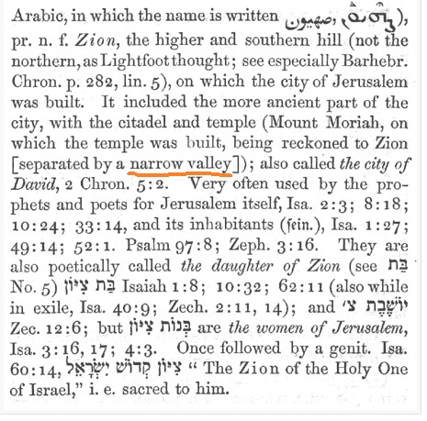

JEREMIAH 33
Jeremiah means: "whom Jehovah has appointed"יָד עַל כֵּס יָהּ = hand to the throne of Yah, the rhythmical movement, related to the throne, manna, Ark, Yah is HIS name. Yehovah “the Existing One” to be done, come into being, of a star, to lodge, dwell, as desiring Zion for dwelling-place.
Jer 33:1 Moreover the word of the LORD came unto Jeremiah the second time, while he was yet shut up in the court of the prison, saying, 2Thus saith the LORD the maker thereof, the LORD that formed it, to establish it; the LORD is his name; 3 Call unto me, and I will answer thee, and shew thee great and mighty things, which thou knowest not.
God has revealed many secrets, and revelations in these last times, and because the Lord God gave me this specific chapter related to prison, and letting me know ahead of time what he was going to do that would be confirmation that he does reveals things to us before he does them.
These scriptures are very prophetic of what has happened to me, and how God has revealed mysteries, and secret hidden things, and people including ancient history regarding family, sons, bloodline, and other mysteries.
God gave me this scriptures when I was locked in the prayer cabin at Lords Land, and Gabriel and I are linked to them, together we were anointed, twins like the Ark of the Covenant, two pieces together the man, and woman in UNION with the Lord God for his purposes and here are the rest of the scriptures related to the daughter of ZION, the branch, roots, and foundation of New Jerusalem. He, we build God, God builds him a House and many scripture has been given over the past years regarding these things.
SCRIPTURE:
Jer 33:15 In those days, and at that time, will I cause the Branch of righteousness to grow up unto David; and he shall execute judgment and righteousness in the land.16 In those days shall Judah be saved, and Jerusalem shall dwell safely: and this is the name wherewith she ZION shall be called, The LORD our righteousness. 17 For thus saith the LORD; David shall never want a man to sit upon the throne of the house of Israel;
Jer 33:18 Neither shall the priests the Levites want a man before me to offer burnt offerings, and to kindle meat offerings, and to do sacrifice continually.19 And the word of the LORD came unto Jeremiah, saying, 20 Thus saith the LORD; If ye can break my covenant of the day, and my covenant of the night, and that there should not be day and night in their season; 21 Then may also my covenant be broken with David my servant, that he (David) should not have a son to reign upon his throne; and with the Levites the priests, my ministers.
22As the host of heaven cannot be numbered, neither the sand of the sea (race) measured: so will I multiply the seed of David my servant, and the Levites that minister unto me (the LORD).
Jer 33:23 Moreover the word of the LORD came to Jeremiah, saying, 24Considerest thou not what this people have spoken, saying, The two families which the LORD hath chosen, he hath even cast them off? thus they have despised my people, that they should be no more a nation before them.
Jer 33:25Thus saith the LORD; If my covenant be not with day and night, and if I have not appointed the ordinances of heaven and earth; 26Then will I cast away the seed of Jacob, and David my servant, so that I will not take any of his seed to be rulers over the seed of Abraham, Isaac, and Jacob: for I will cause their captivity to return (overturned), and have mercy on them.
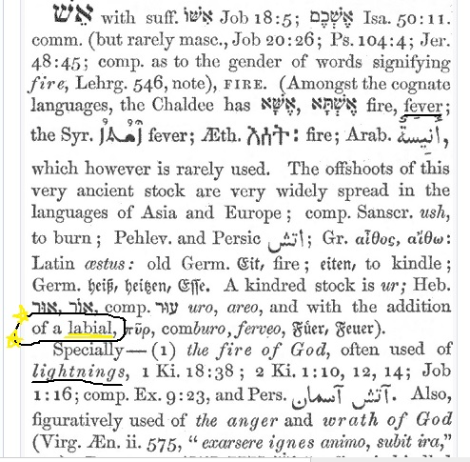
FIRE – Labial = Hebrew 784 altar fire=LABIA – lips producing speech, or sound, pipe, movement of air across a sharp edge, fever inflammation from God’s Wrath or anger. To be kindled to BURN (sequential)
Those who are being ‘V’ are being judged from within, the vials of vaccine are causing Gods anger and wrath to be felt by those vaccinated, and not by those who have not been. These are in union (like a marriage) with the beast and Satan, fornication & adultery from their father God.
The daughter of Zion seems to be one vessel used by God for this purpose. Gabriel also is a vessel of Gods anger and like 5G God has his weapons against his or our enemies as well.
The information below is related to altar of fire, the blood is the waters; and the anger of the Lord as designated at the time.

BLOOD
Heb 13:11 “For the bodies of those beasts, whose blood (G129 haîma a body temperature that is unusually high, usually caused by bacterial or viral infections, seat of life, slay, murder) is brought into the sanctuary (G39 the temple, holy place; transferred to Christians, as those whom God has selected ἐκ τοῦ κόσμου John 17:14, 16, that under the influence of the Holy Spirit they may be rendered, through holiness, partakers of salvation in the kingdom of God) by the high priest for sin, are burned without the camp Wherefore Jesus also, that he might sanctify the people with his own blood, suffered outside (cast out, strange, from the V forward) the gate (access or entrance)....

FORSAKE ALL IN COMING OUT OF EGYPT, SODOM, AND BABYLON
Phl 3:13 Brethren, I count not myself to have apprehended: but this one thing I do, forgetting those things which are behind, and reaching forth unto those things which are before, 14 I press toward the mark for the prize of the high calling of God in Christ Jesus.
INTERPRETATION
Phl 3:13 Brethren, I count not myself to have apprehended, held: but this one thing I do,
Forgetting (G1590 no longer caring for, neglecting, given over to oblivion invalid, annulled, canceled, null and void, out of mind, un cared for-G2990 to be hidden from one, secretly)
those things (G3588 this one, that one, he, she, it, the son, these and others omitted-those begat children)
which are behind (G3693 with what was before-of source; from the rear/behind [as a secure aspect], to look at, to stare, send her away= to see, i.e. become acquainted with by experience, to experience, know), and reaching forth unto those things which are
before, (ahead of, later on, next, resulting, consequential, follow-on, significant, far-reaching, and important, extensive)
14 I press (G1377 to make to run or flee, put to flight, drive away; without the idea of hostility, (do or do not) to run after, follow after: someone, or to persecute others, molest one which is faithless, cowards, or fearful, to give way under persecutions and apostatize-to renounce moral allegiance=loyalty, duty, constancy, fidelity to God and others (to run on errands; compare G1377); an attendant, i.e. (genitive case) a waiter (at table or in other menial, basic, tedious duties); specially, a Christian teacher and pastor, a deacon or deaconess):—deacon, minister, servant; who executes the commands of another, esp. of a master, someone in control or influencing events or things, in games, high level of achievement, who control feelings or behavior (button pushers) a servant, attendant, minister, the servant of a king)
Towards the mark (an observer, a watchman, the distant mark looked at, the goal or end one has in view-dig deep and laid the foundation on a rock, RAINMENT, heavenly immortality)
for the prize (the award to the victor in the games, a prize, metaph. of the heavenly reward for Christian character-of the high calling invitation to a feast, of the divine invitation to embrace salvation... i.e. to bear a name or title (among men) of God in Christ Jesus.
Luke 5:11 and when they (Disciples to be) had brought their ships to land, they FORSOOK ALL, and followed him (fishers of men).
FORSOOK – cry, suffer, and yield up, to send away, to bid going away or depart, of a husband divorcing his wife, to send forth, yield up, to let go, let alone, to disregard, to leave, not to discuss now, (a topic) of teachers, writers and speakers, to omit, neglect, give up a debt (obligation, duty, responsibility, liability, money owing), forgive, keep no longer, to permit, allow, not to hinder, to give up a thing to a person, to leave, go way from one, in order to go to another place, to depart from any one, to depart from one and leave him to himself so that all mutual claims are abandoned, to desert wrongfully, to go away leaving something behind, to leave one by not taking him as a companion, to leave on dying, leave behind one, to leave so that what is left may remain, leave remaining abandon, leave destitute.
ALL – G537/G3956 All things, everyone, the whole, altogether, of union, all parts of this dominion, the whole multitude, sense of privation=the beginning and the ending of all things/everyone, all men, all manner (behavior, approach, conduct, activities, actions, performance, routine, recital, presentation, concert, show, production, appearance, lecture, talk, seminar, giving, management) of, whosoever, anything, daily, always, all means (income, resources, funds, way, methods, process, wealth, earnings, channel, waterway, control, conduct, control, guide, leaders, escort, director, guidebooks, focus, concentrate, hub (feeling, affection, concern, sympathy, empathy, tenderness), center of attention, come together, focal point, spotlight, gathering place, foundation, meeting point, axis, alliance, affiliation, alignment, position, grouping, association, etc.
What this means after the research above is that in this time only the Lord God YHWH is the one we need to please, as the Disciples forsook all just leaving behind their businesses, and families so do we at this time in Gods Prophetic timeline, and consummation of all things. This consummation is potentially the very word for the marriage supper of the Lamb in one form. The consummation is the union, and is related to the first man/woman being earthy, and the second is the LORDS. It is his temple, body and his people, children come into union with him, just as those V’d are in union with the beast system.

TO LIVE BY EVERY WORD OF GOD
Rom 13:8 Owe (be ones duty, be guilty, goodwill due, bound, under obligation, it profits, advantages) no man anything, but to love one another: for he that loveth another hath fulfilled the law.
I feel that owing no man anything is not only about financial, but is related to bondage in regard to a sense of duty that is inaccurate, misplaced, or used to manipulate one in their decisions. In other words if you need to do something for the Lord, but others say you have something they need who comes first? Always God’s will, work, and instructions is above duty, goodwill, obligation, blood or any other man made or other invention, development, fabrication, resourcefulness to control people. Think how this applies to life.
God is calling us out of the world, no ‘V’ it is the Mark 666 in order to buy and sell, and worship of the world. The Lord wants us to FORSAKE ALL (His instruction only) and seek him above ALL else. It is obvious above in interpretation. The Disciples were required to do the same thing we now are being asked to do. This world is going to be destroyed and all that is in it, and all that we have gone after is worthless what are you going to hand on to? END FORSAKE ALL

GAZEBO-SMALL GARDEN CABIN AT LORDLAND PHOTO 2013-2016
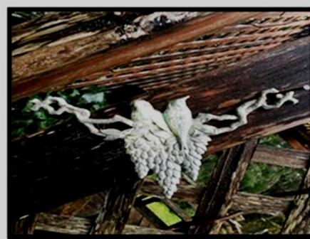
The photo above was during a sabbatical type trip, and in the garden was this image I took a picture because God had begun to send me angelic visitors for a few years, and other things prophetically were happening. I snapped this picture and my interpretation of this originally was two birds facing in opposite directions sitting on top of what I viewed as a womb, and ovaries.
Also, it has three grape clusters below and during this trip one night I had a dream all night of Jesus on my right side, with outstretched hand wearing a white robe, crown, and blue sash said over and over again to me “I am going to begin working IN and THROUGH you.” I believe currently as of May 2022 that this was an indicator of what God would do in the future regarding the woman bringing forth the manchild/male, Rev 12 taking place on Sept 23, 2017 and travailing to bring forth the children (represented by the cluster of grapes).
Micah 4:10 Be in pain, and labour to bring forth, O daughter of Zion, like a woman in travail (Rev 12 Manchild=MALE): for now shalt you go forth out of the city, and you shalt dwell, lodge, lay, abide, lie down, sleep, destroyed, pour out a vessel, in the field (Medford prison to homelessness, field, soil, land, not tents or homes), and you shalt go even to Babylon (H894 confusion [by mixing] male and female genders, confuse self on account of shape shifting, their wasting strength, fodder/feed animals); there shalt you be delivered; there (H8033 from that time-“they have transgressed the covenant therein they have rebelled against me”) the LORD shall redeem thee Daughter of Zion from the hand of thine enemies.
I believe that I am this daughter of Zion, and the daughters of Babylon who were the bloodline of Israel and Judah along with others (males) had me arrested, but first they surrounded me and plotted to take me for over a month. Once they had I was put into prison, and after about 14-15 days let out into the field, no coat, transportation, phone, food ($97.00) and was followed and attacked in many places, not physically but with words.
My Mother, my Sister, and a gal named Jordan/Nancy/Giza also were involved, my daughter, along with many others, including men who were trying to remove me, and carry on their plot. Why? I explain this in other documents because this bringing forth the manchild involved me, and his removing where they had intended to have him for themselves, and I was not a part of the plan.
Why? Because God and Gabriel began a plan that in some way did not work in their favour, which was regarding Gabriel. This plan truly originated with God in the beginning, a plan of the ages to be performed in this time during the 7 year tribulation (w/Great Tribulation) and Mark of the Beast the ‘V’. This plan was to take him and I, use as a teaching tool about his plan, and reveal mysteries along the way.
I had encounters with the Lord in this journey, also many angelic meetings which were not planned by me. They brought many prophetic insights, confirmations, and understandings to what was taking place, and this process that had begun. All of this is related to the redemption, the 144,000 elect sealing, the 12 Tribes of Israel which they are those either helping or in opposition (War), however, not of my choosing, but it has happened anyway.
During a period of 2017 – 2022 during Trumps presidency who is also Gabriel was about the Messiah (Trump=Man/Male) who was in the Revelation 12 sign in the sky that took place Sept 23, 2017. We began to come together and a grand process began. So did the attacks, these attacks come from those who hold positions of power worldwide.
Their goal right now is to put me away if possible when I go to trial, because they have not stopped attacking, and trying to find ways to delegitimize me, slander, or whatever they can concoct.
In 2017-18 bringing forth this manchild (family-Trump, I knew him as Gabriel) who was a man coming out of Babylon, Egypt, and Illuminati. This bringing forth is about leaving that life he lived prior being, and believing in a promise of God that involved me. I actually have court coming up, and many are involved corruptly I might add because they are in power in the justice system.
Zech 2:7 Deliver yourself, O Zion, that dwells with the daughter of Babylon. King David’s Daughter, and His anointed. 10 Sing and rejoice, O daughter (Me) of Zion: for, lo, I come (The Lord), and I will dwell (H7931 by transmission, lodging, tabernacle, abide, inhabit, remain= H7901 to lie (basically denoting UNION represented as sexual relations which is an anointing-to be located in a particular place, to hide, used of a woman) in the midst of thee, saith the LORD.
Zech 9:9 Rejoice greatly, O daughter (Me) of Zion; shout, O daughter of Jerusalem: behold, thy King (the Lord God, and Gabriel-In covenant) cometh unto thee: he is just, and having salvation; lowly, and riding (H7392 chariot, sit, horseback, vehicle, to be carried Jehovah, upon the clouds, a horseman, upon the wings of Cherubim Ps 18:11, Deut 33:26, a place, the hand-on the wings of the wind)
upon above, over, in addition, together with her Zion,
an ass (H2543/2560 a heap, to boil, foam, foam up, to be red, my bowels are in ferment, redness, in turmoil Lam 1:20= Job 16:16 my face is reddened from weeping),
and upon a colt (H5895 bearing a burden, raising a He-ass a young ass (as just broken to a load; from its swift ardent running-opening the eyes, to awaken, to arouse ones strength, “as a eagle stirs up her nest, hovers over her young” to watch, against anyone)
the foal (H112/29 son, male child, member of a guild, class, Babylon, Egypt, a young bullock [All Gabriel and family] the Kings Son, Sons of the Ethiopians, Jews, Levites, son of DEATH or one doomed to die to rebuild a house and establish a family, restored exiles)
of an ass H860/386 sense of patients a She-ass=ME, a female donkey (Night Journey-Obama/ Sinwars’ speech) and the Son is to be strong, perpetual, constancy=fidelity, faithfulness, loyal, dependability, single-mindedness, enduring “with continual war in his bones” “a mighty nation” the potent-the both to continue enduring).

ZION is where the Ark of the Covenant was, but ZION stood for Mt. Moriah and it is a Spiritual application the Google search reveals that Myra is also MORIAH.
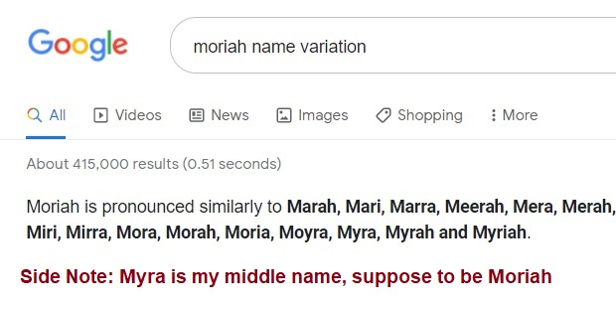
The above verse is related to where God sits in Zion (Mt. Moriah my middle name is Myra, aka Moriah, and Gabriel conjoined). This is an example of the Ark or rather throne of God which is in the body temple of God where in the future New Jerusalem he will dwell in, with, between upon his throne in covenant and marriage. Also, God moves through the air, atmosphere, through the wind.
(Jer 6:2, Ps 50:2, 129:5, Daughters of Babylon dislikes her Ps 48:12, Micah 4:7-8, 10, Isa 40:9, Isa 52:1, Prov 31:26, Rev 12:1, Jer 8:19 the Lord is in Zion, 97:8, Ps 99:2, 45:13, Zeph 3:14; also Mother I have been told Gal 4:1)
Zion’s Princess YouTube reveals that ‘She’ (daughter of ZION) is an oracle (to prophesy, forewarning, prediction, seer, vision, trumpet and voice of God) a temple/body for the Lord to speak. Jeremiah was her friend, and Isaiah were her friends.

LINKS - DAUGHTER OF ZION:
By Zion’s Princess
1. https://youtu.be/0SwDw_sTnac Daughters Of Jerusalem And Daughters of Zion Judgments & Envy Against Queen Zion &Prophetic Word!
2. https://youtu.be/df1hPKoXPEY Daughters of Jerusalem And Daughters of Zion And Envy Against Queen Zion PT2
Note: She (daughter of ZION) is an oracle (to prophesy, forewarning, prediction, seer, vision, trumpet and voice of God) a temple for the Lord to speak. Jeremiah was her friend, and Isaiah.

