Omicron

(Omicron is a variant of Covid/Hiv/Aids/Sars etc Virus)

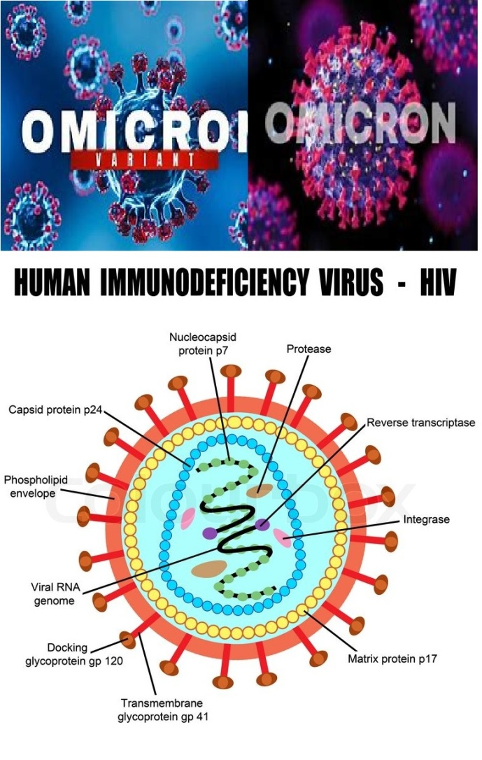
Omicron or any other so called variant or strain of all other viruses are basically the same. The Vax has these in them along with other viruses, nano bots, crystal receivers/transponders/chips and so forth.

Omicron is the 15th letter of the Greek alphabet. This letter is derived from the Phoenician letter AYIN: In classical Greek, omicron represented the sound in contrast to omega and οu. In Modern Greek, both omicron and omega represent the mid back rounded vowel. Letters that arose from omicron include Roman O and Cyrillic O. The word literally means "little O" as opposed to "great O". In the system of Greek numerals, omicron has a value of 70.
Wikipedia icon Wikipedia
In Astronomy-the letter omicron [which represents 70 (′ο) in the standard system] is not used in sexagesimal, it is re-purposed to represent an empty number cell. In some renditions the cell was just left blank (nothing there = value is zero), (70 as in 70 year captivity which started 1948 being ended by God, while others go into captivity through the ‘V’)
NOTE: Why do they emphasize great O, opposed to little o? I think this refers to the Omega as in God himself, and the little o symbolizes the small gods; little ‘g’ as in no gods. These would be the many gods and fallen angels.

OMICRON=AYIN or EYE in the Bible
H5869 עַיִןʿayin eye, sight, seem, colour, fountain, well, face, pleased, presence, displeased, before, pleased, conceit, think
Cont. H5869 Ayin/EYE: by analogy, a fountain (as the eye of the landscape):—affliction, outward appearance, before, think best, colour, conceit, be content, countenance, displease, eye (-brow), (-d), -sight), face, favour, fountain, furrow (from the margin), × him, humble, knowledge, look, (+ well), me, open(-ly), + (not) please, presence, regard, resemblance, sight, × thee, × them, + think, × us, well, × you(-rselves)... as showing mental qualities, of mental and spiritual faculties (fig.) spring, fountain
H5870 ʿayin eye of God, horn, or man (Dan 7:8, 4:34 for research-Numbers 15:24 between the EYES/AYIN on the FOREHEAD, Ex 13:9, 16; Deut 6:8, 11:18) <<<Mark of the beast.
OMICRON
In Mathematics the big-O symbol introduced by Paul Bachmann in 1894 and popularized by Edmund Landau in 1909, originally standing for "order of" ("Ordnung") and being thus a Latin letter, was apparently viewed by Donald Knuth in 1976[3] as a capital Omicron, probably in reference to his definition of the symbol (capital) Omega.
Ordnung means sect, or group of likeminded believers, like the Amish, but in this case it would be the little god worshipers and whose lights are being snuffed out, and they worship any or all gods of the world including mammon, or materialism. Ordnung is the German word for order, discipline, rule, arrangement, organization, or system (Beast). Heterarchy, a system of organization (grading of a group) wherein the elements have the potential to be ranked a number of different ways of importance, status, affecting their feeding and mating behavior, religion ranks, the body, standard, etc.
They become one body, group, one mind, and have their own Ordnung. Just as Jesus the Lord God Yah have his body, beliefs, and moral behavior i.e. class structure, and chain of command.
Hierarchy, an arrangement of items that are represented as being "above", "below", or "at the same level as" one another, an action or inaction that must be obeyed, mandated by someone in authority.
In Science it is a signal process, and the V is connected to the web, internet, and in the minds of the vaxed, hence a SIGNAL PROCESS. Order of computation, the computational complexity in the analysis of algorithms...Big O notation; determining a function or result of action by vaxed individuals, including division splitting into parts or separating the group from others, but in the mind partitioning the persons soul from God to Satan, but also placing into their mind (Holy of Holies) their rules, system, and overriding beliefs other than worship of the Omega God of the Bible.
If you apply this to the V'd and the Non-V’d you have those in one system of beliefs and expected behaviors, and the others. This is all related to the Anti-Christ Beast System, and the variants are because of those who are vaxed. Also, it divides those into different camps.
Biblically I would consider the V’d the Tares, and the rest as grain, wheat, fruit, or others. Because this is about eternal souls being taken and either controlled by Satan’s “Son of Perdition” (Obama) people are changing, dividing into two groups predominately V’d and Non-V’d. People once thought to be Christians are now going another way (variant), and those still fighting for various reasons are the others.
See my Website for more documentation: www.yourawake.weebly.com
ORIGIN from Greek o mikron ‘small o’.
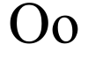 Greek alphabet letters
Αα Alpha - Οο Omicron - Ωω Omega

