Signs in the Heavens-Gemini “Twins”
Prophetic fulfillment in 2015-2022, and forward
True Sequence of Events - By Phoebe www.yourawake.weebly.com

Table of Contents
INTRO 2
1 GEMINI “TWIN” SIGN IN THE HEAVENS 6-25-2021 4
2 THE ROE IN ZOHAR, LOCK-UP, CREATOR JESUS VISIT 5
ZOHAR “THE COMING OF THE MESSIAH” 5
TAKEN, LOCKED-UP, AND VISITED BY THE CREATOR, AKA JESUS 8
3 JOHN – SON OF MAN - BENJAMIN 10
BENJAMIN IS? OCT 20, 2018 IP Name Benjamin S Email(...)@aol.com Comment 10
Benjamin Text Rev 1 11
4 HEAVENLY SIGN - MOON AND GEMINI Feb 13, 2022 Valentine Day 14
5 ODIN AND GABRIEL/TRUMP 8/16/2019 16
Odin-Adon-Adoni the line of David, Jews, and the Royal Houses of Europe 16
The Lion and the Unicorn 22
Heraldic imagery 22
Josephs Coat of arms of many colors 23
The lyre is of Ireland 23
6 ISAIAH 9 AMERICA IS ISRAEL EPHRAIM & NORTHERN KINGDOM 27

INTRO
There were prophets from about 2008 forward that were prophesying about God giving scribes or prophets golden pens to write the prophetic happenings taking place. I believe that I am one, and the information to follow is a record of the unfolding of prophecy, but it is in ways that point to other documents that I have written regarding the unfolding of the 70th week of Daniel, aka 7 year Tribulation, also the revelation of Messiah (Trump), the Mark and more. This is about two individuals Trump and another called Castor who is represented in this unveiling of the prophetic hidden events taking place. In order to get other research and prophetic revelation follow-up go to www.yourawake.weebly.com.

Summary of the Content: All the revelation or unveiling that is in this particular document began Sept 23, 2017 with Rev 12 sign that took place in the Constellation of Virgo/Woman and Leo/Judah. I will give a picture, and quick understanding. The Jupiter planet revealed Jesus the King, and the King Star Regulus in the Paw of Leo/Judah represented the King male being born, aka Trump (also, Pollux-Bridegroom/Jesus, etc.), the Son given in Isaiah 9, and the woman (Castor-Me-Bride) helping to bring him forth, a male child (Son given Trump).

Also this sign and alignment of all 12 planets found by NASA is a revelation regarding what was taking place in a book I was commissioned to write in 2016 (uploaded to Amazon) called “Donald the Last Trump” and so much more.

Remember, in scripture the Sun, Moon and Sun along with the heavens would be for signs, and declare God glory/greatness.

Luke 21: 11...and great signs shall there be from, out of, parts of heaven 25 And there shall be signs in the sun, and in the moon, and in the stars; and upon the earth distress of nations, with perplexity; the sea (nations/weather etc) and the waves roaring;

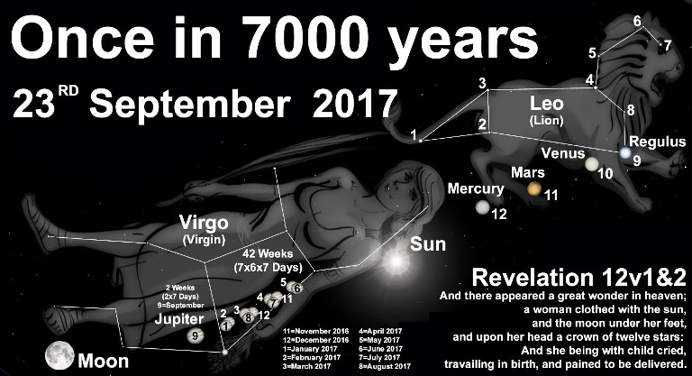

Note the MOON under her feet, the twelve stars has one application with regard to the sealing of the 144,000, and the child (as we are all God’s children) manchild=Trump was crying to be delivered. This means out of Babylon, Sodom and Gomorrah, Egypt which is a type of America, pagan worship, and worship of mammon. This person predominately was Trump, known to me as Gabriel.

Trumps bloodline is ancient, and to my surprise I was also part of this ancient Jewish bloodline, and his name is prophetic linking him to Messiah or anointed one. (Gen 37:9 Joseph dream of the Sun, Moon and Stars worshiping him, bow down, reverence, and obeisance=the twelve tribes of Israel)

Originally, I was given Rev 12 as a sign; from who I believe was either a messenger of God or Jesus himself. I also have an email from him which reveals who that messenger is. This unveiling is about two individuals that are now known to me as Pollux (Trump) and Castor (male/female) whom represent the Bridegroom and Bride, the wedding, and Jesus aligned with them, representing Jesus and his people Israel (Judah).

Those who are choosing to come out of their past and remember their God and savior Jesus during this Feast of Atonement. These are the bloodline that went after other gods, are now to be written in the book, and not blotted out of the Book of Life, the final harvest and last call of God before his wrath begins. They are coming out of Babylon, Sodom and Gomorrah and Egypt. Trump fulfilled part of the Trumpet Feast called Rosh Hoshana as Messiah anointed by God/Jesus in the midst of us by way of his Holy Spirit, and the Feast of Atonement is where we are currently. After Jesus visited me at Jasper Café in S. Oregon, he continued to make his presence known, and on one occasion I drove through the gas station and he was sitting near an electrical unit in the back part. I noticed it was Jesus in my side mirror, he was wearing a prayer shawl and covering.

Later I went to park, and looked up cover in the blueletterbible and it led me to the Ark of the Covenant, and I knew that he was telling me that he was our atonement, that his blood was put on the mercy seat for our sins. He is the fulfillment and his presence is in the midst of us through Trump predominately, and in another way. Next is the feast of Sukkot/Tabernacles where we leave this temporary tent, tabernacle and body to receive our immortal one of the Lord Jesus, and almighty most high Yah (Father and Son the Holy Spirit Comforter) who dwells amongst us.

1 GEMINI “TWIN” SIGN IN THE HEAVENS 6-25-2021
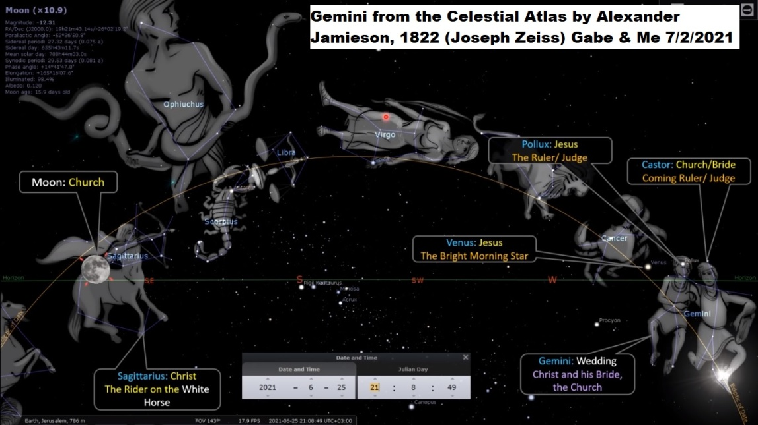
Missler: https://youtu.be/BJ6szvfApNM
Mazzoroth/Biblical Zodiac: https://youtu.be/FEnVQC22SeE
Rev 12 sign reveals Venus 6/25/2021: Jesus the bright and morning star lines up with Gemini the Twins; Pollux as Christ/Messiah/Trump=ruler/judge, and the Bride/Castor the coming ruler/judge, so examine the photo above and see the 1822 study done by Joseph Zeiss.
Act 28:11 “And after three months we (Disciples) departed in a ship of Alexandria, which had wintered in the isle, whose sign was Castor and Pollux.” (I interpret it below, but SIGN has meaning for now)

2 THE ROE IN ZOHAR, LOCK-UP, CREATOR JESUS VISIT
April 6, 2017 ZOHAR 700 Year Old Messiah Prophecy:
How I ended up at this 700 year old messiah prophecy is a small journey that begun with the numbers, and specifically 66, in 2012-13 or 2014-15 Trump announces he is running for President 2015 approx; WW3 officially began, and He was 69 yrs old – His presidency began the 70th week of Daniel Jan 2017 inauguration day) which I have been seeing almost every day. It has many meanings; one is the “Star of David” which is considered by the Rabbi’s as the Messiah/Christ star. I wondered what other meanings does 66 have, and somehow through a YouTube video heard about a 700 year old messiah prophecy, so I typed it in, and it begins below at #203…as I read I came across the 66 again and if you read you will see where. This is related to the 700 year old church that has the corner stone carving of what now is believed to be Donald J. Trump by those who see it.
Song 4:1-5 thy two breasts are like young ROES that are “Twins.” (Love between God and his people, but also between Pollux & Castor the wedding and more)

ZOHAR “THE COMING OF THE MESSIAH”
Shemot [Exodus]
96) Rabbi Shimon raised his hands and wept. He said, “Woe unto he who will be at that time, and happy is he who will be and can be present at that time.” “Woe unto he who will be at that time” because when the Creator comes to visit the deer (fallow [white],roebuck, reddish in color, serrated horns, fallow [lamp, candle, light] deer, troubled, to boil up with anger, the face inflamed with weeping, foam up, troubled in turmoil, plowing, tillage of soil) meaning Divinity,
He Creator/Jesus will look to see who are the ones that are standing with HER, He will observe all the deeds of each and every one of those who are with HER (Me & Ecclesial Bride) , and no righteous shall be found. It is written about that, “And I looked, and there was none to help.” At that time, many troubles (Jacobs’s next-Wrath of God) will come over Israel.
Note: The ROE was me, given over and over by messengers called “Warriors” the ROE is a sign and represented as Castor in Gemini Constellation – the Bride). Please, continue to investigate this information and research.
Help: H5828 support, succor, surround, aid, defending, shielding, caring, loving, relieve, a cry for aid, and protect; make easier, rally round, smooth the progress of, make easy, take pressure off, support, promotion, protection, defense.
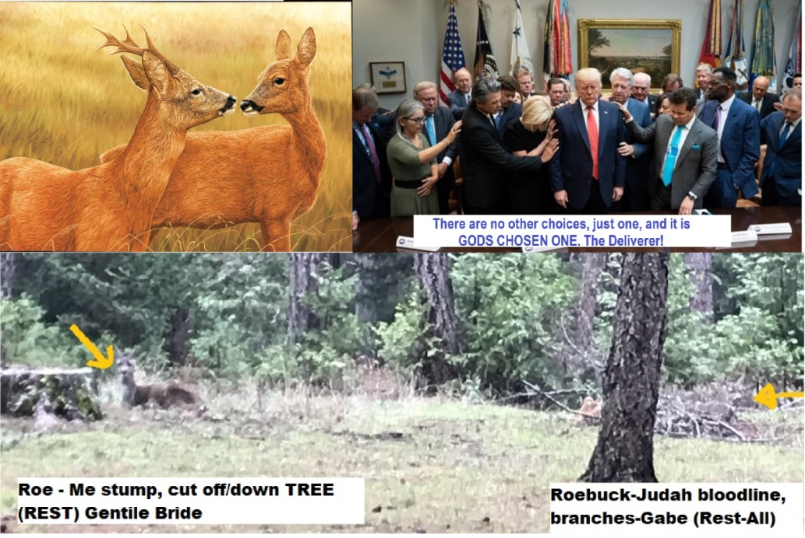
I began a journey as the betrothed Roe, and in that journey in the summer after the sign in the heavens 6-25-2021, of Venus=Jesus lining up with Pollux=Trump and Castor the Roe (Photo above is my yard above and deer laying at the foundation roots, and one at the branches broken off-a sign), I was pursued by many in this bloodline because they were steeply involved in pagan activities, and ultimately through a chain of events ended up on the street. This is the illuminati bloodline predominately and I am one. I did not know this until later.
I was led one morning to a YouTube video (7/2/2021) that was about Jesus/Venus aligning with Pollux and Castor in the constellations and I put the cover image above for your examination. I believed it may be pointing to Trump/Gabriel and Me fulfilling and being the representation teaching tool of the Lord Jesus on earth to his people who do not have years and years to grow.
Zohar 99) At that time, the Messiah King (Jesus/Trump) will awaken to come out of the Garden of Eden, from the place called “the bird’s nest,” and will appear in the land of the Galilee
(i.e. America in Isa 9, Ephraim Northern Kingdom of the Gentiles, District, a circle, turning, ring, seek occasion, wallow, to transfer what is rolled from one onto another to God himself his children, a heap of stones, rolled in blood).
And on the day when the Messiah goes out there (Galilee/America), the whole world will be angered and all the people in the world will hide in caves (Obama’s hideout, Apartments, dwellings, concrete condominiums potentially, but also underground facilities-military=WW-3) and in crevices in stones (same-COVID, etc.) and they will not know how to be saved. It is written about that time, “And men shall go into the caves of the rocks, and into the holes of the earth, from before the terror of the Lord, and from the glory of His majesty, when He arises to shake mightily the earth.” (Two fold application one now-another future)
100) “Before the terror (Wrath of God) of the Lord” is the angering (Satan’s wrath against the Eccl) of the whole world. “And from the glory of His Jesus/Creators majesty” is the Messiah Trump. “When He, Jesus/Creator arises to shake mightily the earth” is when the Messiah rises and will appear in the land of the Galilee/America, since this is the first place that was ruined in the Holy Land by Assyria. For this reason, he will appear there before all other places, and from there he will evoke wars upon the entire world. (Trump has).
I do not want to explore here how the Eclipse that took place starting in Oregon in 2017, and crossing 7 cities of Salem and 33rd parallel, which means Jerusalem a reveals that America is a dual application regarding prophecy and pointed to Trump and the fulfillment of Messiah who was cut off midpoint of 7 year Tribulation here in America. (See Rabbi Cahn “The Harbinger” and website in the Intro above). Link of Eclipse 2017, next in 2024; 7 years but shortened? https://youtu.be/P4RRPjdfQu4
Link to info on Shape shifting: https://youtu.be/op1dIJdR-4E Shape shifting is what this bloodline has done from before Odin led them into Ireland, Scotland, and Europe, etc.
During this 7 years approximately (Aug 2017-2024, shortened?) I have been learning of these prophetic happenings regarding this ancient bloodline that is Judah or Israel which has been the mingled seed/children through history and “As in the Days of Noah, so shall they be in the days of the Son of Man” Trump/Gabriel is the son of man.
In the book of Enoch shape shifting was a reality, and it is today in this bloodline that I am revealing in this research document. I discovered the shape shifting and even though I cannot do this myself I am aware that it is done around my life.
Many of the bloodline are those/or like them in the times after the flood were part Jew and part Angel. God is redeeming his people, and will be using them for the final battle called the “Day of the Lord” (some 144,000 plus) right now many being redeemed are in the battle of helping others to come out as scripture says regarding Babylon in Revelation 18.
Trump is of royal lineage, and so am I and I go into a little in a later chapter just touching on whom he is and the connection to bloodline that were after the flood, a mingled blood of angel and human Israel, and this redemption atonement time and feast. Trump actually fulfills the feast of Trumpets also known as Rosh HaShanah.
Trump (Gabriel/Pollux/one of the Twins-I the other) wrote the “War Scroll” at 6 years old in his head, and the war scroll is found among the Dead Sea Scrolls and speaks of this pending final battle of the Sons of light and Sons of Darkness (Belial). Where it states that after this battle (Gog and Magog...WW3) we all are caught up to God to be changed forever.
Side note: Lucifer/Satan was the covering Cherub over the throne of God until he was cast out of heaven, and he was over the Reptile kingdom which gets into the corruption and dinosaurs. They came unto the daughters of men, and ultimately animals and other creatures in different shapes called “Shape shifting” in the book of Enoch.

TAKEN, LOCKED-UP, AND VISITED BY THE CREATOR, AKA JESUS
After I had been chased around the area I was taken and locked up, 15 days later let out, and one night around Sept-Aug 2021 First encounter with Jesus was that day at St. Vincent DePaul, and later I walked to Jasper Café’ up the street as it was becoming night.
He, Jesus showed up, walked over to the Café’ and He came up to me, the first time he mentioned ‘AYE’ now I believe it means Adam Y for Branch and Eve, he had two diamond crowns on his hat. Other words were said but I do not recall.
At the Café’ Jesus began sharing many things and I could not keep up, trying to make mental notes of his words because I had no notepad and only a pencil. We talked of many things, and here are a few that he mentioned. He first asked me if I knew who he was, and I said “I think so” because I was expecting a visit from him because of the Zohar prophecy about the Roe.
Song 7:3 “Thy two breasts are like two fawns, that are twins of a Roe.”
One topic he mentioned was that of Gemini, and Yes as in it applied to me and Gabriel/Trump, Pollux and Castor, Yes., Adam and Eve, Yes, that before Adam and Eve were the Druids, and that I was one, a good one, so was Gabriel/Trump. In my notes it reveals that the original marriage came back around, but the twins were Siamese meaning conjoined like the Ark.
Celtic Druids myth or history represents them with Irish ancient roots, as Aristocrats, they were Seers (Doyw) Wiseman/women of the woods, a tree, solid and steadfast, who know or perceive (Seers), Oaks H424 number linked to Messiah, divine, strong tree, mighty man (shape-shifter/hybrid, a Ram, skin dyed RED, for Tabernacle). North American Indians and Ancient India are linked to them.
They were a religious group, classes of noble men, Knights, teachers and judges. Some were seen as Warrior Queens (Castor), Priests in white robes or dress who carried a Rod or Staff like Moses/Aaron which I have been given or left for me at least 5-10. They were of the Royal Heir Cast and Rulers, and possible link to the mythological city of Atlantis. They were Levite types.
When this first began around 2018, Gabriel spent many hours and days together. Gabriel (DJT), he mentioned many things about us, that we were rare, and also Gabe mentioned that he was in the beginning Gabe/Trump said that I was, as Eve, but maybe this just means that I am the first woman, and he the first man as Adam to go through this journey that we have been on?
How is this possible well I am family to him, and unbeknownst to me Gabriel was Trump (Shape shifter) Messiah anointed one chosen by God, and we are both prophets, my gift also is a Seer. Something huge had begun and I was just learning about many of these things.
I have heard of people in heaven being sent here to earth on assignments and then being made to forget, which is what Jesus said about me, and that I would be made to remember my past. I have other information about them being religious leaders, Aristocrats, and more.

3 JOHN – SON OF MAN - BENJAMIN
This email was on my website regarding the book “Donald the Last Trump” I saw it a year later, and then responded, and he text me, etc.

BENJAMIN IS? OCT 20, 2018 IP Name Benjamin S Email(...)@aol.com Comment
I would like to ask you questions about the Messiah to come. I didn't read your books yet but you nailed it with your wisdom. I think you want to speak with me so i can fill you in on missing wisdom. I was never religious till 1/20/17 Trump inauguration day. There been crazy things happening to me since that day that I can't explain. All I can say every time I take a pictures or videos there rainbows around me with faces looking down upon me. If you're serious about Trump who I believe has a biblical link to me let's speak,asap. My email is (deleted). My grammar isn't good so hard for my to express my points by emails. I'm 50yrs old now but wasn't till turn 48yrs old that Holy Spirit had filled my soul with knowledge of the scripture. The book of Revelation is my life. The scriptures are talking about me. Everything in the first 4-chapters is about me and what happening to me last 2-yrs also book of Daniel from chapter 7 to 11 is me. Let me prove to you who I'am and if i don't hear from you then I know the holy spirit will not allowed you to contact me. Please reach out to me and I won't disappoint you. Thanks Benjamin, Rev 4:2-3 talks about a person sitting on the throne appearance of Jasper(which is stone of Benjamin)then is mentions about rainbow encircled the throne shone like Emerald.(Emerald means tribe of Judah,also stone for Month of May,also stone for Gemini. I'm born on May 26,1968,70-week of Daniel,which started the day Trump sworn into office bc Trump was 70 yrs,7-months and 7-days old on Jan 20,2017 in Hebrew yr 5777. The 70-weeks is about atonement to end sins for the Messiah which would end on last day his turns 49 yrs old. Do the math 70th week of Trump's presidency was Friday May 25th 2018. The next day I turned 50 and that's when all of sudden the pictures inside my phone,I saw these heavenly lights around me. I would love to speak to you bc I have no one who can understand me about this. Btw,my mother was 16yrs of age when she conceived me and was virgin and not married yet. She was married by the time of my birth. I hope to hear from you this is my cell phone number (omitted)

Benjamin Text Rev 1
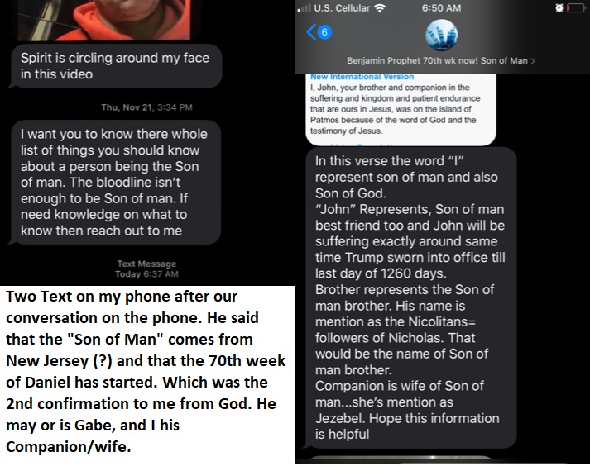
In the email above it mentions Jasper, and it just so happened that the Lord Jesus Creator God came to me at the JASPER Café’ in S. Oregon that was closed (COVID) may have closed it also not sure when I first was on the street. It was the visit to the Roe (Me/us) that was spoken in the Zohar that I was led to regarding the Messiah who is Trump, Gabriel and my Bridegroom and Husband according to Jesus.
This all started with a betrothal spoken to me in 2018 approx., and later at the Jasper café’ Jesus told me I was now his Gabriel/Trump/Benjamin, etc... wife (An example; this is for the New Earth and Heaven, a new thing being done during the Dan 9 fulfillment of prophecy including the book of Revelation, etc. also, this is about the 144,000 harvest workers that ultimately will be sent out 2 x 2 after the catching up of the bride both male and female) Many prophets are having dreams and visions of this.
Note: Gemini Pollux is seen as a warrior judge/Hercules, and a picture of Jesus, the husband, and bridegroom. Castor is seen as male and female, a warrior judge, and married to Pollux. Seen not as both male, but also male and female holding hands in the constellation of Gemini in the Zodiac/Mazzoroth of Dendera, these are sometimes called Adam and Eve=which represents the bride of Jesus Christ (Christ is a title of on anointed also meaning Messiah).
In the beginning one Adam and Eve were deceived by the serpent in the tree, and now being awoken to choose once again between the Lord and Mammon, the world or eternity, and Trump, and I represent Adam and Eve choosing the promises of God over the reports of the world where truth is concealed and deception reigns and yet many are choosing and remembering their God once again as scripture speaks of.
In some document, email, conversation I was told that the Son of Man/Messiah had to come from the tribe of Judah and Benjamin, Emerald for Judah, May, and Gemini “Twins.” The Jasper, for the stone of Benjamin in the email above.
Rev 2:18 ... These things saith the Son of God, who hath his eyes (sight, the eyes of the mind, the faculty of knowing, to appear, wide-open, observation, to look at, to stare at, to perceive, to know by experience G3700-3788, G3708) like unto a flame (flash)of fire, and his feet are like fine brass;
Flame G5395: Act 7:30 “And when forty years were expired, there appeared to him in the wilderness of mount Sina an angel of the Lord in a flame G5395 of fire in a bush” (from H7878/H8534; a shoot, shrub, plant as if uttered or put forth (H8524) through the idea of vibration, wavy, branch, fig. used of women’s hair).
2Th 1:8 “In flaming G5395 fire taking vengeance on them that know not God, and that obey not the gospel of our Lord Jesus Christ...”
Rev 4:2 “And immediately I (Son of God & Son of Man) was in the spirit: and, behold, a throne was set in heaven, and one sat on the throne.3 And he that sat was to look upon like a jasper and a sardine stone: and there was a rainbow round about (Benjamin in a Mov.file) the throne, in sight like unto an emerald.”
This individual who emailed me who says his name is Benjamin, linked to Trump, and May “Gemini” is potentially Trump and Gabriel the shifter version whose birthday matched Gabriel’s in another alternate form as well whom I knew personally initial “M”.
In the text from Benjamin it reveals that “I” represents the Son of God and the Son of Man and these are linked to Gemini the twins, Jasper Café’ linked to Benjamin where the Lord Jesus met with me. There seems to be a twin/dual representation like the Ark of the Covenant which is two pieces but seen as one.
Israel was betrothed and married to the Lord, but went backsliding and left him for other gods, and now God is redeeming them back to him, the feast of atonement that we are in now, and their education has come in a unusual manner.
Jeremiah 3:14 “Return, O backsliding children/Israel,” says the LORD; “for I am married to you. I will take you, one from a city and two from a family, and I will bring you to Zion.”
Ezekiel 16:8-21 'When I passed by you again and looked upon you, indeed your (Israel/Jews) time was the time of love; so I spread My wing over you and covered your nakedness. Yes, I swore an oath to you and entered into a covenant with you, and you became Mine,' says the Lord GOD... 'Moreover you took your sons and your daughters, whom you bore to Me, and these you sacrificed to them to be devoured... Jeremiah 2:2
Jer 2:2 “Go and cry in the hearing of Jerusalem (Salem/America), saying, ‘Thus says the LORD:“ I remember you, The kindness of your youth, The love of your betrothal, When you went after Me in the wilderness, In a land not sown. (Amos 3:1-2)
Like the two covenants the Old Testament/Covenant, and the New Testament/Covenant or Testimony/witnesses. Symbolizing both pieces of the Ark of the Covenant, Law and Atonement, people being twin in essential application, prototype or need, where one without the other is not complete. Just as the bridegroom without the bride is incomplete, the Law without the sacrifice of grace through Jesus is incomplete.

4 HEAVENLY SIGN - MOON AND GEMINI Feb 13, 2022 Valentine Day

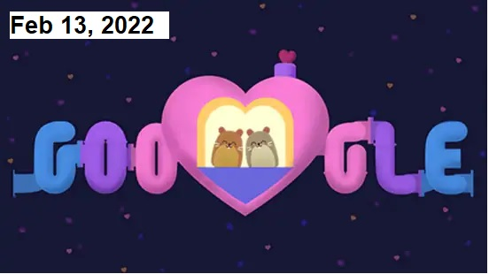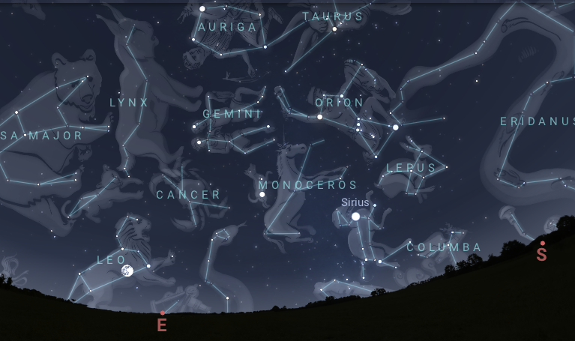
Google Art on Valentine’s Day (first photo is related to my Pod dream (2020) where Trump/Gabriel and I are sitting inside awaiting of our taking out, aka Rapture of the 144,000 and Tribes; 2nd image is Gemini above the Unicorn – not the view that I saw, but giving an idea to proximity, the moon is in Leo now)
StarDate: February 13, 2022
Pollux and Castor (Apollo), the twins of Gemini, stay close to the gibbous Moon tonight. They line up to the upper left of the Moon as night falls, with Pollux (also, Hercules) closer to the Moon. The twins are to the right of the Moon as they set, in the wee hours of the morning.
Feb 13, I went on Stellarium without knowing of this alignment and typed in moon, and there I saw the moon aligning with Gemini the Twins Pollux and Castor situated above the moon. Below the moon immediately there shot a shooting star upwards under their feet and into the Pleiades Constellation area (far north=heaven). I saw it was a horse with a horn called Monoseros meaning Unicorn (a type of Christ).
All this is pointing to Jesus coming for his bride, the last harvest and Jesus the Creator God Yah is bringing in the final precious fruit of the earth, his people Israel who have gone into captivity in various way, and he is calling her (the Bride; male and female) out from among them and become his again. Gabriel and I are a type, example and teaching tool to reveal what Gods plan is right now. I cannot get into that in this because it is complex, but the signs in the heaven and how they have applied to us, the redemption is happening, and I am trying to explain this.
The moon was below Pollux and Castor in alignment, and the Unicorn from the horn shot a shooting star under their feet, past them into the northern part of heaven in the image that is to follow. I pieced it together to show what I saw.
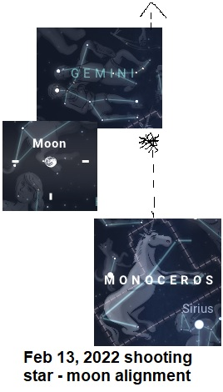
Castor and Pollux appear to be some kind of sign according to Alexander Jamieson, and 1822 Joseph Zeiss, but not explained to me further other than being related to the heavenly signs, and yet they were mentioned in scripture. I believe a sign for these prophetic times, a sign of the Bridegroom & Bride, the wedding, and Jesus.
Paul Arrives at Rome- Act 28:11 “And after three months we departed in a ship (to pass in vessel, navigate, plunging through water, to wash: with reference to clothing, wash clothing/garments, sinless and pure) of Alexandria, which had wintered in the isle, whose sign was Castor and Pollux. 12 And landing to be brought down in a ship at Syracuse, we tarried there three days.
Alexandria: a native or resident of a city in Egypt (note Egypt) Acts 18:24 Apollo/Castor connection. Pollux and Castor G1359 “Sons of Jupiter” this can be seen as of the Lord God, or the Fallen Host, also a maiden, or damsel
Sign G3902 G4591: side-marked, labeled (with a badge (figure-head) of a ship/vessel, corresponding to the various cases with which it is joined, to make known, a mark, by indirect course-not occurring immediate, stages or straightforward relationship):—sign (Rev 1:1).
Website for other documents and further research:www.yourawake.weebly.com

5 ODIN AND GABRIEL/TRUMP 8/16/2019
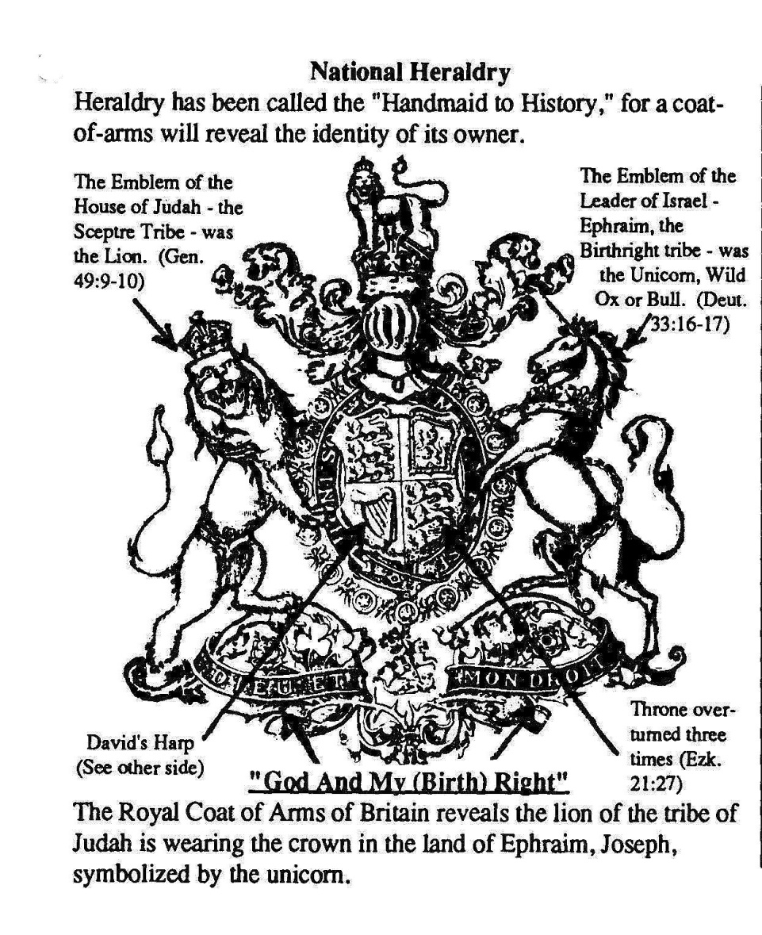

Odin-Adon-Adoni the line of David, Jews, and the Royal Houses of Europe
https://www.ucg.org/bcse/search/Odin
Who is Gabe=Trump and Me. August 14, 2019 Gabriel talked of this the night before I researched this information!!! He and my family are actually royalty in England and possibly other nations.
Last night the 13th of Aug 2019 I had another conversation with Gabe in regards to Odin and the gods. I have not understood what he wanted me to get from them, and during the conversations he said “Do your homework!” read books, papers, and other stuff.
He says his family worshipped these gods which his bloodline is the line of David and Mine is of Jewish ancestry which based on historical record came from Turkey, Russia and the Carcasus in the north which also land of Giants or rather God man origins in Europe area, to Scotland, Ireland, Great Brittan and Joseph originally and the Jews – 10 tribes all immigrated to America) some royal houses were involved with a worship of Bel or Baal – also called Odin/Adon/Adoni (linked to God, mingled worship of the true God and paganism)
A variety of monarchs of Europe, declare that the medieval Viking histories, and pedigree of every European royal line are all traced back to the same person Woden/Odin with different spellings. Traced back to the mythical Valhalla (“Hall of the Chosen”) in Asgard—considered the Norse version of “heaven.” Which Gabriel recently read in full and I wondered why if he was being called by Elohim/Adonis=Bel=Baal and linked to Zeus, God of the Jews that Gabe would read Valhalla, and now I know.
Gabriel had told me in one conversation that I was Freya, which was Odin’s wife, and at the time did not understand until 2021 where the Lord Jesus visited me and told me that I had been in the beginning as a Druid, a good one, and that Gabriel was as well. He said I had no memory of which he would correct or bring back to me.
Odin = Don and was thought to live in northern Russia, it is claimed by an explorer Hayerdahl that Odin was more than a myth, but a man. Coauthor with Hayerdahl Lillestrom says that ‘In ancient times, people treated Gods and Kings as one and the same thing.’
In the Caucasus mountains near Gobustan, an ancient cave dwelling found 30 miles west of Baku [in Azerbaijan] native Norway” Scandinavian Ancestry reveals similar rock carvings.
One source says “The Royal House of Britain: An Enduring Dynasty: “The traditions of our Scandinavian forefathers tell of a great conqueror, the hero king of Asgard—Odin, and Gabe is linked to Odin if not himself Odin which is not Bel, Baal, but somehow linked. He was so heroic a king and so great a conqueror, that the superstition or reverence of him in after ages made a god of him … He led our forefathers across Europe”
Odin left for Scandinavia during the second half of the 1st century AD according having to do with the generation of the kings, they were Jewish lineage the line of David many royal houses, and in scripture it says that Zerah (Judah-Ethiopian) & Perez (Judah-Ethiopian) were the line of David by intermarriage and the royal houses of Europe are Davidic.
This goes back to messages given to me that somehow I went back to Europe as well which is also written in this book of the Kings and Priests elsewhere, and royal line of Troy was descended from Judah’s son Zerah.
“To him (of Odin) a crown was given by the great Over ruler (Father God) of all things, which he multiplied, crowning his sons kings of the countries he conquered, thereby securing his own position as the Royal Ancestor of all the dynasties of Europe and line of David tribe of Judah.
Jer 17:25

Then shall there enter into the gates of this city (Type of the New Jerusalem/heavenly) kings and princes sitting upon the throne of David, riding in chariots and on horses, they, and their princes, the men of Judah, and the inhabitants of Jerusalem: and this city shall remain forever (It comes down from heaven God with his people-to new earth).
1Ch 2:4 “And Tamar (H8558 “Palm-tree,” Phoenix=mythical Eagle, Lion, graceful stature, to be erect, palm branches, town, daughter of David=line of Judah and promises about the eternal throne) his daughter-in-law, bore him Perez and Zerah. All the sons of Judah were five.” God gives us beauty for ashes, the Phoenix Palm rises up from the ashes/people/bloodline.
Gabe to my understanding is of the line of David and to be King, Gabe/Trump was elected by lot to be President, aka King of America in 2017 the anointed one/Messiah. Also related to the Revelation 12 sign where he is related to the tribe of Judah, the lion, the king star and planet Jupiter/Zeus. Zeus is also another ‘g’ that he has mentioned.
“Milner says of Odin: His name is Hebrew— Aud’n or Odn=Don (for the broad A-Alpha in the Hebrew carries often the sound of O-Omega), meaning Lord —human or divine” (p. 32). The Companion Bible states: “Adon is one of the three titles (Adon, Adonai, Adonim = God), all generally rendered Lord; but each has its own irregular, atypical and individual usage and association. They all denote headship in various aspects. They have to do with God as over-lord” There was a river called Don (Donald?) something that had archeological findings relating to Odin.
Greek Adonis, equivalent to the Canaanite Baal or Babylonian Bel, names also meaning “Lord.” Odin was already a title of deity when our historical figure came to power—Bel being related to W. Cambel the first angelic encounter I had that lead to the book “Donald the last Trump” also seemingly related to Gabriel, McCleoud, DJT, line of David, and the more.
In regards to me and the application of how I fit in, one is in the Zohar 700 year old prophecy, me as the Roe who God visits. Also, 700 year old prophecy is linked to the cornerstone carving who was Trump in a 700 year old church in England and found by the Priest.
Odin was seen as a God, and yet was a man, chief, ruler, king, and royal line of David in Europe, Great Brittan, that migrated to Norway, Ireland, Scotland, America, and other nations. These bloodlines were reinforced time and again through marriage probably many arranged. (Our betrothal)
Note: when I was betrothed to him we began the representation of the Bridegroom and Bride not yet together, but when Jesus takes us home we begin the process and wedding supper of the Lord, these 2x2 unions of Adam and Eve types are part of the 144,000 harvest workers, and we are one pair, or shall I say “Twins.”
Rev 19:9 “Then the angel said to me, “Write this: Blessed are those who are invited to the wedding supper of the Lamb!” And he added, “These are the true words of God.”
Lately Gabe has been calling me ‘Freya’ and now I know that this was the name of Odin’s wife who was a prophetess. Was he Odin that leader as he has sometimes interjected in our conversations, was he there, an immortal in a way that always returned in some form and lived through various ages, and is God redeeming his people the Jews once again? Because through me somehow Gabe was affected, and corrected in some way, not happy about it, but I believe that God has just begun his transformation.
Why Gabe? Because he will understand the enemy and like King Solomon partook of every aspect of life. The family Jewish bloodline that is also being redeemed will go from the old ways back to their true God (many people and tribes) and will understand in truth the reality of the gods that they worshipped, not that they cannot be redeemed I am just not sure of certain aspects of this information or how it will relate to the redemption taking place right now, but just the beginning.
Gabe will plan for war according to my other documents, He wrote the War Scroll of the Dead Sea Scrolls (2,500 year old document plus) and God will catch him up to his Gods/Gabes throne removing him from danger placing him in safety because God has chosen to redeem him, and make him a king to rule, judge and reign, as well as prepare for the “Day of the Lord” which will be against the fallen host that are irredeemable.
Gabe/Trump was a hidden one, but will be the leader like Moses of the Israel, the Jadeites family, neighbor, and friend across the land that he is to govern and rule.
No matter where his gifts originated God will endow him with the very same, expand, he will be given other weapons of warfare from God as well as become the leader (also, 144,000 harvest workers) that God has chosen. These gifts will enable him to war effectively as he has lived potentially as a leader of soldiers through time. I cannot prove all of this, but it seems that is what is happening and I am seeing this in many documents as well as it being written in the stars and the signs in the heaven. He will be given a crown and great ruler ship,
The royal line of Troy was also descended from Judah, Gen 49:10 the scepter shall not depart from Judah, nor a lawgiver from between his feet, until Shiloh – (Messiah=embryo, his son, be happy, prosper, at ease, tranquil, be in safety, free from anxiety-Samaritan) come; and unto him shall the gathering of the people be.
My first encounter with an angel of the Lord was Woody Cambel, and I interpreted bel/Bel as part of his name researched. One question I asked Woody Cambel was: “Does God have His angels, and men of flesh that are here? He said “yes! And that they manifest, reveal, visible, able to be seen, and discernible in different ways.” I say this because the angelic host is being revealed to me and manifest in observable ways to my eyes and perception which applies to the supernatural kingdom of God on earth as it is in heaven in spades.
This leads to my interaction with Gabe and others, the messages given to me over months and how they apply to what is going on with Gabriel right now who is trying to relate some understanding to me possibly for this book which makes absolute sense about being royal, a god, but in the way he means it, and that I am that prophetess like ‘Freya’ (Norse mythology or not in human representation) and he has been related as Odin/Adon/Adoni a great military (Pollux) warrior leader.
Odin; he was a man famed for his wisdom and every kind of accomplishment. His wife was called Frigida, whom we call Frigg [or Freya]” Gabriel said that I was Freya. What is also interesting is that Odin could have been a meshing of the true God and the myth, or since man was also turned into a God or saint it could be that he sees himself the same.
Windsor is the Scottish house and the lineage comes from the Vikings, Saxons, Danes, Tudors and Stuarts. My Gedney lineage also links me back to the Vikings through Mormon genealogical records. Many symbols that I have seen or seem to be given to me are that I am symbolically a “Great Dane” and am just one symbol on trucks, dogs, and other logos.
In the book of the Danes; the potential origin of the tribe of Dan, and are of Danish descent North Germanic group of Indo-European languages.
I have often told Gabe that he reminds me of a Viking with a robust laugh, he has red hair and once I said I was like his “wench” kind of interestingly humorous considering this information kind of confirms the reality of this. I was also told by three separate young males in 2015-16 approximately that I am royalty and a queen, but this has been understood over months of pieces of information coming together.
Once again: Exo 6:6 “Therefore say to the children of Israel: ‘I am the LORD; I will bring you out from under the burdens of the Egyptians, I will rescue you from their bondage, and I will redeem you with an outstretched arm and with GREAT judgments. This is happening right now 2017-2022 on.
2Sa 7:23 “And who is like Your people, like Israel, the one nation on the earth whom God went to redeem for Himself as a people, to make for Himself a name—and to do for Yourself great and awesome deeds for Your land—before Your people whom You redeemed for Yourself from Egypt, the nations, and their gods?
God once again in these end times redeems his people from where they were scattered, out of the worship of false Gods into the one true God, and their Messiah.
1Ch 9:1 “So all Israel were reckoned by genealogies; and, behold, they were written in the book of the kings of Israel and Judah, who were carried away into Babylon (America-told by Aaron or Woody?) for their transgression.”
Eze 9:9 “Then said he unto me, The iniquity of the house of Israel and Judah is exceeding great, and the land is full of blood, and the city full of perverseness: for they say, The LORD hath forsaken the earth, and the LORD seeth not.”
Jer 30:3 For, lo, the days come, saith the LORD, that I will bring again, out of the captivity=restore of my people Israel and Judah, saith the LORD: and I will cause them to return to the land that I gave to their fathers (Promise land/Heaven), and they shall possess it.
Eze 37:16 “Moreover, thou son of man, take thee one stick, and write upon it, For Judah, and for the children of Israel his companions: then take another stick, and write upon it, For Joseph, the stick of Ephraim, and for all the house of Israel his companions: 17 And join them one to another into one stick; and they shall become one in thine hand.”
Right now God is pulling the Jew and Gentile Judah and Israel who is Joseph in Ephraim/America and the house of Israel and Judah within and in the Land across the ocean are to be redeemed back to God, and Gabriel is one warrior, soldier king, and President of the bloodline of shape-shifters that will lead them back to God out of pagan worship, etc, and who is being turned back to God himself once again.
Trump/Gabe I was told in a dream by Jesus that He was Elijah/Elisha for this end time kingdom come to earth as it is in heaven, the overthrow of the thrones of Satan who was the covering cherub over the throne of God. Also, I was told he was Enoch who never died. So this is revelation.

The Lion and the Unicorn
The Lion Judah, the Unicorn which represents Gabriel, and ‘I’ the unicorn – 12 Tribes. Britain’s heraldic imagery takes on great significance in light of the true biblical identity of the British people and their royal family. Many of the bloodline are Illuminati, the very Rich and Powerful worldwide.
Joseph’s eldest son Manasseh was to become a great single nation—and certainly has done so through his descendants, the majority of the people of the United States. Joseph’s younger son Ephraim, on the other hand, was to become even greater. This prophecy has been fulfilled through the British Empire according to many while Manasseh is referred to by name in Revelation 7:6, in the same context Ephraim/America is actually called Joseph (verse 8).
Yet while the birthright blessings were promised to the descendants of Joseph, the line of kings leading to the ultimate King, Jesus the Messiah, went to the tribe of Judah, and born to him were the twin sons Perez and Zerah. Though Perez was born first, Zerah’s hand had actually come out first and had been marked with a scarlet thread (symbol, image, allegory, mark of lips-Song 4:3).
Through Zerah came many of the royal lines of Europe—through Perez that the primary line of royalty would come—King David and later Jesus Today’s British royal family is actually a union of the royal houses of David (of Perez) and Zerah.
Twin Perez H6555: “breach” to break or burst out (from womb or enclosure) to break through or out, to break away, to disperse hostile forces, overflow with new wine, to separate oneself from anyone. To spread out their seed, and descendants as the dust of the earth. I had to separate myself to Gabriel and break away, etc.
Twin Zerah H2226: “rising” of light, dawning, shinning, King or Leader of the Ethiopians, a Prince, son of Judah, lofty and majestic- to irradiate (or shoot forth beams), i.e. to rise (as the sun). And the glory of the Lord is risen upon thee Isa 60:1 (Gabe/Trump?)

Heraldic imagery
Jacob and Moses both delivered prophecies from God about the future of the various tribes of Israel, and the tribal emblems of Israel would later be illustrated on the standards or early flags of the tribes. (Numbers 2)
Moses said of Joseph: “His glory is like a firstborn bull, and his horns [weapons] are like the horns of a wild ox” (Deuteronomy 33:17), and I kind of think as Gabriel as a wild bull, RAM, or ox and “a wild ox,” might also represent the “unicorns” were portrayed with horse faces, The bull or unicorn thus became the symbol of Joseph.
Of Judah, God said through Jacob: “Judah, you are he whom your brothers shall praise; your hand shall be on the neck of your enemies; your father’s children shall bow down before you. Judah is a lion’s whelp; from the prey, my son (Gabriel/Trump/Joseph), you have gone up.
He bows down, he lies down as a lion; and as a lion, who shall rouse him, and from Judah was to come the king of Israel, David, and ultimately the King of Kings, Jesus Christ who is referred to as “the Lion of the tribe of Judah, the Root of David” (Revelation 5:5).
I have been shown by supernatural phenomenon that He and I are the roots and foundation of the New Jerusalem to come (Ancient Stock).
Amazingly, though the birthright blessings of power and greatness were to go to Joseph, these blessings would, as God foretold, eventually be made to serve the kingly line of Judah. God portrays Israel’s end-time national power in terms of a lion and tribe of Judah within America or from outside in Europe (Micah 5:8-9).

Josephs Coat of arms of many colors
Most of the information in this part of the document comes from this website: https://www.ucg.org/bible-study-tools/ebooklet/the-throne-of-britain/appendix-9-the-lion-and-the-unicorn
Now, where is all of this leading us? To the British royal coat of arms, flanking the shield are the lion along with a unicorn! The rampant lion (risen on one foot to strike), said to be the golden lion of England, has a crown upon its head while the rampant unicorn, a symbol from Scottish heraldry, has a lesser crown around its neck.

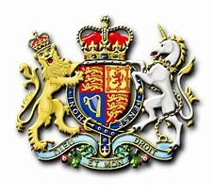
The lyre is of Ireland
One source explains: “King James VI of Scotland succeeded Elizabeth I when she died childless in 1603, effectively uniting Scotland and England beneath one rule. The Scottish Royal Arms had up to that point used two unicorns as shield supporters. The English Arms had used a variety of supporters, but most frequently had included a lion. In a tactful gesture then, he placed a lion upon the left of the new Arms, and a unicorn upon the right.
“This was a potent bit of symbolism, for both the lion and the unicorn had long been thought to be deadly enemies, where the unicorn rules through harmony while the lion rules through might, the rampant red lion—was the primary symbol of Scotland. Certainly, for Scotland and England are both Ephraim (represented by a bull or unicorn)—and are both ruled over by the Judahite house of David (represented by a lion). America is Ephraim who came from Great Britain which came from the Old Roman Empire.
Between the lion and unicorn is a garter around the central shield said to represent the Order of the Garter, an ancient order of knighthood. Which one person that may have come back around who I named ‘Jacob’ (Robert Green) considered himself a knight and left me a staff against the front yard tree before he died...Is he a sign or did he just come back around as I have been told about certain others. Ps 22:22 the unicorn = horns, the buffalo, represents Christ/Messiah, and prostrate-make powerless, miserable, drained, and are lifeless, dead, unresponsive in everything.
Beneath the shield sovereign, “Dieu et mon droit,” meaning, “God and my right,” that is, the right of kingly succession (as David’s line has by God’s promise) or right of birth.
Upon the shield of the arms appear the golden passant lions of England—It is said that Henry II’s arms originally consisted of two lions, and that he added a third on marriage [in 1152]” (Patrick Montague-Smith, The Royal Line of Succession , Pitkin, 1968, p. 2).
The two lions had been the emblem of William the Conqueror prior to 1066 was apparently of the Jewish line of Zerah “The Family of Odin” of Davidic lineage, the lions of Edward Plantagenet’s chair were probably part of the throne design in Scotland.
The lion was and remains the primary symbol of Scotland and adorns the Scottish flag, the shield of the British royal coat of arms, and transferred to the Davidic monarchy from Ireland to Scotland around A.D. 500
“‘First therefore came from Ireland Fergusius a man very famous for his skill in blazoning of armies. Himself bore the Red Lyon, rampant in a Golden Field the Stone of Destiny fashioned like a throne and laid it up in the country for a Jewell, and in Scotland he left it, which they used many years after, in Coronation of their kings at Scone.’
“Thus, it will be seen, that the Lion of Scotland was, in reality, the Lion of Ireland: and, as the Lion is no more an Irish than a Scottish wild beast, it is evidently an importation to that Country from the East: further, as having been associated, as is seen above, by Fergus with the National and Family Stone, it is clear that he must have considered it equally as the Family and National Standard” (F.R.A. Glover, England, the Remnant of Judah, and the Israel of Ephraim , 1861).
Why a red lion? Again, Scotland’s monarchs originally came from Northern Ireland—that is, from Ulster, which also used the symbol of the Red Hand and the Red Branch. It is explained elsewhere in this publication that these likely originated with the descendants of Zerah (Ethiopians)—but perhaps colored it red to represent the scarlet cord. Note: It is believed that Adam was the original DNA of an African...Hum?
The British coronation chair looks like the top of a Star of David, and the star actually appeared on the throne in Scotland as the six-pointed Star of David another symbol which still appears on the flag of Northern Ireland, the Red Hand displayed within it.
I was told that I was Irish, German and half Jewish by an older seemingly homeless woman on a park bench in California. I went home and found out that at least the part that I was Irish and German was true, but my mom laughed at the Jewish part.
This information is important in that Gabriel is from one of these Royal lines, and I am also linked as I have put in the other parts of the book. He is from the line of David, symbols around him are the lion, unicorn i.e. horses, red being ruddy and related to the king planet Jupiter which relates to the Revelation 12 sign, the woman potentially is symbolic of me and Gabe is the man child in the sign in the heavens which took place Sept 23, 2017.
He Gabriel calls me mother, Mary, Freya, woman, daughter, and others, and I believe he is pointing things out to me over time, and I am also his wife, through the betrothal (good as married-lasting less than a year or a year of preparation like Esther) arranged marriage, and the marriage takes place at a future time. In some way this is related to the Don, and McCleoud and this is also entered in parts of this book. END ODIN
http://en.wikipedia.org/wiki/Northern_Kingdom
In the Hebrew Bible, the Kingdom of Israel has been referred to as "House of Joseph"; it is also frequently referenced (particularly in poetry) as Ephraim, the tribe whose territory housed the capitol cities and the royal (Kings) families. It has also been referred to as "Israel in Samaria” Levi had no territory, but lived among them [another study].
Samaria is the Metropolis City of the nation and in the case of Isaiah 9 and 9/11 was Manhattan N.Y., also gateway into America; remember all the immigrants came to America past the Statue of Liberty.
Southern Tribes- Benjamin, Judah and Simeon (Levi had no territory, but lived among the other Tribes).
Many wondered what happened to the Northern Kingdom of Israel; well they immigrated to America, and like the largest tribe Ephraim is the last to be overrun by Moslems/Assyrians.
Many royal lines live in America, even if it is their second home from other nations. Gabriel/Trump came from Scotland, Ireland, England, Black Sea Russia area, and even Africa, etc. His name Trump came from Drumpf and supposedly was changed in Germany. I have research on one of his lineages.
Ephraim is America, or the largest tribe of the Northern Kingdom that went into exile by the Assyrians/Moslems and never returned as a nation back into the land, Judah went captive into Babylon but returned to become a nation in 1947/48. Ephraim was the 13th tribe and all the northern tribes escaped into Ephraim and it was the last and largest tribe to be conquered by the Assyrians.
Note: Isaiah 9 See “The Harbinger” by Rabbi Cahn-where 9/11 began signs taking place in America, and in the scripture he uses as the beginning of his revelation reveals that Ephraim spoke Judgment on America, and it was our leaders like VP John Edwards and Senator John Kerry.

6 ISAIAH 9 AMERICA IS ISRAEL EPHRAIM & NORTHERN KINGDOM
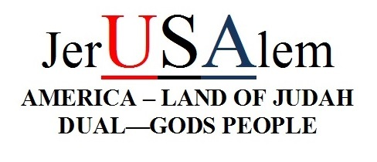
ISAIAH 9 PROPHECY FROM 2008
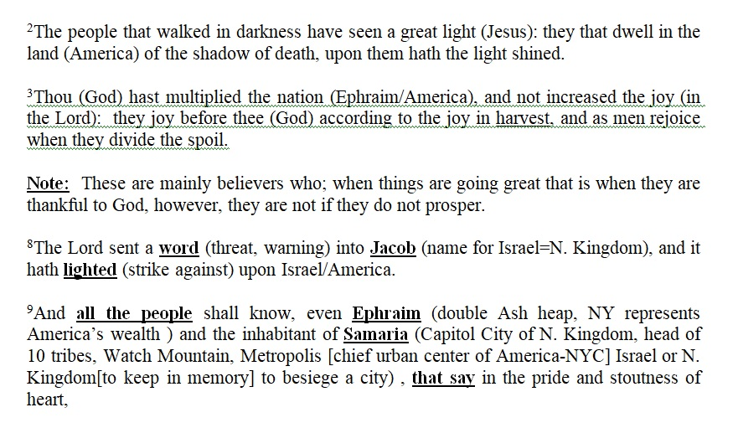
2nd half 2008 See interpretation above within context note date in the header (NOW is NWO New World Order)
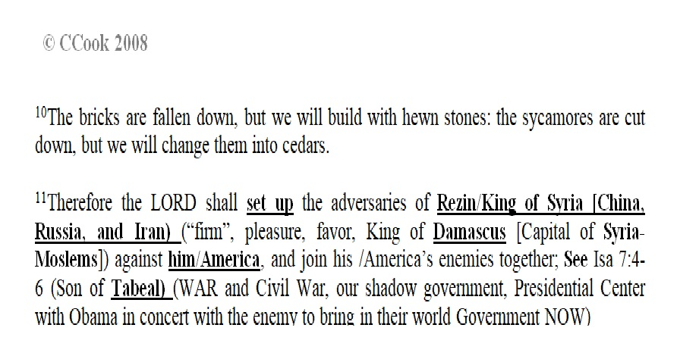
Jerusalem has a dual application in scripture, twin application, and other Nations see the Land of Judah, aka Israel as the little ‘Satan’ and America Israel as the big ‘Satan.’ Rabbi Cahn discovered America fulfilling prophecy specifically 9/11. This points to how America has been chosen to fulfill Gods word, and begin the redemption process here and abroad. Gabe and I were chosen vessels by which God would do this, at least in one sequence and processes.
The signs in the heavens and on earth are his unveiling of the mysteries, opening of closed books, and revelation. D. Trump was elected as President/King, the mark of the beast 666 the (V), WW...3 on the threshold, and so much more. All pointing to the fulfillment of Dan 9, Revelation and other prophetic books.
So much needed to be written for better understanding, but I have already written many research documents that can be found on my website I include below. I was given the golden pen of a ready writer, to reveal prophecy and Gabriel/Trump, etc. also has.
It’s time to repent, ask Jesus the Holy Anointed One of God to save you from your sins, call on him and you will be saved. Time is up, and this is a documentation of part of Gods end time fulfillments and revelations. www.yourawake.weebly.com
IF YOU MISS SOMETHING AND PARTS DO NOT MAKE SENSE THERE SHOULD BE SOME MENTION ELSEWHERE THAT YOU CAN PULL TOGETHER and OTHER PARTS THAT HELP BRING MORE INSIGHT INTO WHAT IS PRESENTED HERE.

