QUEEN OF SHEBA AND KING SOLOMON WERE MARRIED, AND SHE ALSO RULED EGYPT, ETHIOPIA AND ARABIE WITH HIM AT ONE POINT IN HISTORY
Contents
Audio - (bdsda.com) Teachings on Content 2
QUICK SUMMARY 2
There is nothing new, pattern, and then revelation of a new thing being done by the LORD GOD. 3
O.T. REVEALS WISDOM/HOLYSPIRIT aka JESUS Godhead (Pt. 2) 4
SION 4
ZION=SION (There are too many to list, but here are a few) 5
WISDOM – SPIRIT – HOLY GHOST – HOLY SPIRIT 6
WISDOM 6
SPIRIT 7
GODS NAME IS ‘ONE’ = THREE PERSONS (A SON & DAUGHTER) 7
Hymn to Amun - Henotheistic ‘Trinity’ of Ancient Egypt 8
HISTORY—APPEARANCES OF THE ‘TRINITY’ DAUGHTER AND SON OF GOD 9
SON OF GOD JESUS, WHO IS TRUMP and more: 9
DAUGHTER IS ZION, WISDOM, HOLY SPIRIT, ME: 9
Poseidons portion was called ATLANTAS (Easter Island) 10
Names and titles, throne name of first female Pharoah=Me the Shunammite: 12
EMERALD TABLET-Amun Ra Tomb 15
EGYPTIAN TRINITY 16
SON OF MAN – NOWHERE TO LAY HEAD 18
FREYA is Hadass in part, related to WISDOM and ESTHER 20
NOAHS “WIFE” 22
Melchisedec 22
ODIN had a NEVER ENDING QUEST FOR “Wisdom” (ME?) 22
FREYA: Day Star 23
Edna, Adna/Eve 23
ADAM AND EVE ARE NOAH (Adam, i.e. Odin/Jesus/Trump) 24
MOSES and ZIPPORAH (Me and/or) OR PHAROAHS DAUGHTER-JOSHUA 24
UNRELATED EXTRA: GEORGIA GUIDESTONES 25

Audio - (bdsda.com) Teachings on Content
www.yourawake.weebly.com

QUICK SUMMARY
The Alpha to the Omega, the beginning to the ending, the Woman Eve, and Adam comes back in the ending as the consummation of the LORD GODS eternal plan of redemption and purposes.
The foundation is always laid prior to the next building block of scripture that reveals other truths that will come forth and be revealed. Such as the O.T. revealed that there would come a deliverer that would sit on the Throne of David forever. Not an earthly happening, but began on earth.
This representation is revelation of the Godhead, One in the Father & Mother (Gods Spirit), and then in the Son/Adam the Father, and the Daughter/Adam who is the Woman called Eve the Mother representative in the Flesh; for the New Earth and New Heaven.
The prior Ark, to Tabernacle, to Temple, to Body of Jesus represents the transition of how God would one day live in and among his people. However, in the Godhead represent the Almighty and given power and authority by the LORD GOD.
https://youtu.be/fwk65iEhbIE Temple in Heaven Holy Spirit/Jesus-Son
When you see words that represent a person in scripture in different ways those words transcend into the future to represent something previously laid down as a foundation to follow into the next representation of God in different forms, symbolism, and meaning.
The Woman (Eve) is also the Woman in Revelation 12 (Eve), and Jesus is the Adam or Male representation of the Godhead. Father/Lord God=Both, Son/Jesus/Adam, and Daughter/Holy Spirit/Woman/Eve and many other word representations.
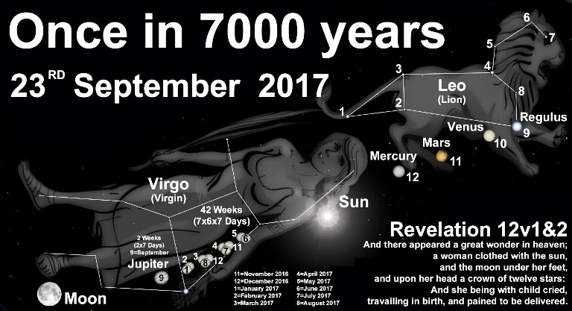

There is nothing new, pattern, and then revelation of a new thing being done by the LORD GOD.
The Woman/Me is not only EVE (Alpha) but Mary the Virgin (Undefiled) with the world/idolatry, etc. She is the same one, and has a crown of twelve stars representing the 12 Tribes; the King Planet Jupiter is birthed by her representing the bringing forth the Manchild/male child who is Jesus/Trump once again the Omega.
Ecc 1:9 “The thing that hath been, it is that which shall be; and that which is done is that which shall be done: and there is no new thing under the sun.”
The Alpha or beginning becomes the Omega or ending of scripture. So the woman or manchild has been before. However, there is something that does come forth and it is the revelation of the hidden, and the future.
Isa 43:15 “I am the LORD, your Holy One (related to the Holy Spirit/Jesus), Israel’s Creator and King. 16 I am the LORD, who opened a way through the waters, making a dry path (a beaten path/byways) through the sea (H3220 yam red-to roar, sea of brass, weedy sea).” 19 “For I am about to do something new. See, I have already begun! Do you not see it? I will make a pathway through the wilderness (we have been in the wilderness just like going out of Egypt). I will create rivers in the dry wasteland.”
So we are witnessing the ending from the beginning, the woman who is me, the daughter of Zion, Wisdom and Holy Spirit, understanding, and Melchizedek was is the Revelation 12 woman all referenced beforehand in the O.T. and N.T. scriptures to be known by the reader.
Just as Jesus was Adam, Son, Son of Man, Manchild, seen as Savior both representatives of the Lord God (Father & Mother ONE) Godhead, and began in the beginning and is consummated in the ending/Omega. (Dan 9 consummation)
Dan 9:24 “Seventy weeks are determined upon thy people and upon thy holy city, to finish the transgression, and to make an end of sins, and to make reconciliation (atonement) for iniquity, and to bring in everlasting righteousness, and to seal up the vision and prophecy, and to anoint the most Holy.”
(Holy Ones=Jesus/Trump & Me/Wisdom/Holy Spirit)

O.T. REVEALS WISDOM/HOLYSPIRIT aka JESUS Godhead (Pt. 2)
SION - HOLY SPIRIT – WISDOM – UNDERSTANDING – DAUGHTER ZION/JERUSALEM/ISRAEL (SEE IMAGE W/12 STAR CROWN) – WOMAN – MELCHIZEDEK – TRUE TABERNACLE/ALTAR

SION
Psa 65:1 “[[To the chief Musician, A Psalm and Song of David.]] Praise waiteth for thee, O God, in Sion: and unto thee shall the vow be performed.”
Mat 21:5 “Tell ye the daughter of Sion, Behold, thy King (Jesus/Trump/Adam) cometh unto thee, meek, and sitting upon an ass, and a colt the foal of an ass.”
John 12:15 “Fear not, daughter of Sion: behold, thy King cometh, sitting on an ass's colt.”
Rom 9:33 “As it is written, Behold, I lay in Sion a stumbling stone and rock of offence: and whosoever believeth on him (G846 autos- themselves, self, herself, the same, wind/air, aka Holy Spirit) shall not be ashamed.”
Rom 11:26 “And so all Israel shall be saved: as it is written, There shall come out of (G1537 ek; motion, origin, from, with or by reason of) Sion the Deliverer, and shall turn away ungodliness from Jacob (aka Israel):
Heb 12:22 “But ye are come unto mount Sion, and unto the (G4172 polis; one’s nativity, the New Jerusalem-war, battle, fight, many/great) city of the living God, the heavenly Jerusalem, and to an innumerable company of angels, (Lord of Host/Spirits-the Bride is seen as coming down from heaven=New Jerusalem the 12 Tribes/Children)
1Pe 2:6 “Wherefore also it is contained in the scripture, Behold, I lay in Sion a chief corner stone, ELECT precious: and he that believeth on him shall not be confounded.
Rev 14:1 “And I looked, and, lo, a Lamb stood on the mount Sion (histemi, epi, ho, oros Sion=a mountain, stronghold, S. part of east hill, Mt. Moriah, sunny place, narrow valley, Jerusalem itself=poetically the daughter of ZION), and with him an hundred forty and four thousand (144,000), having his Father's name (YHWH/Jesus/Yahweh) written in their foreheads.

ZION=SION (There are too many to list, but here are a few)
Psa 99:2 The LORD is great in Zion; and he is high above all the people.
Psa 102:13 Thou shalt arise, and have mercy upon Zion: for the time to favour her, yea, the set time, is come.
Psa 102:16 When the LORD shall build up Zion, he shall appear in his glory. 21 To declare the name of the LORD in Zion, and his praise in Jerusalem;
Psa 110:2 The LORD shall send the rod of thy strength out of Zion: rule thou in the midst of thine enemies.
Psa 132:13 For the LORD Yehovah hath chosen Zion; he hath desired it for his habitation.
Psa 146:10 The LORD Yehovah/the existing one/One true God shall reign forever, even thy God Elohim, O Zion, unto all generations. Praise ye the LORD.
Song 3:11 Go forth, O ye daughters of Zion, and behold king Solomon with the crown (King) wherewith his mother (em H517: Me/Wisdom/Holy Spirit=”father and mother” intimate relationship; “a city and a mother in ISRAEL” used of the earth as the mother of all men, to teach) crowned him in the day of his espousals (to Me=hatunna/hatan, wedding and marriage, alliance-to give a daughter away in marriage/law/ to circumcise an infant, Holy Spirit/Me; bringing out of Egypt), and in the day of the gladness of his heart.
Isa 1:8 And the daughter of Zion is left as a cottage in a vineyard, as a lodge in a garden of cucumbers, as a besieged city.
Isa 2:3 “And many people shall go and say, Come ye, and let us go up to the mountain of the LORD, to the house of the God of Jacob; and he will teach us of his ways, and we will walk in his paths: for out of Zion shall go forth the law, and the word of the LORD from Jerusalem.”

WISDOM – SPIRIT – HOLY GHOST – HOLY SPIRIT

WISDOM
Mat 11:19 The Son of man came eating and drinking, and they say, Behold a man gluttonous, and a winebibber, a friend of publicans and sinners. But wisdom is justified of her children.
Mat 12:42 The queen of the south shall rise up in the judgment with this generation, and shall condemn it: for she came from the uttermost (peras-end, period of time, boundary, space, from beyond, the other side) parts of the earth to hear the wisdom of Solomon; and, behold, a greater than Solomon is here.
Luke 7:35 But wisdom is justified of all her children.
Luke 11:31 The queen of the south shall rise up in the judgment with the men of this generation, and condemn them: for she came from the utmost parts of the earth to hear the wisdom of Solomon; and, behold, a greater than Solomon is here.
Luke 11:49 Therefore also said the wisdom of God, I will send them prophets and apostles, and some of them they shall slay and persecute:
Luke 21:15 For I will give you a mouth and wisdom, which all your adversaries shall not be able to gainsay nor resist. (Read 20 and 21 whole chapters)
Act 6:3 Wherefore, brethren, look ye out among you seven men of honest report, full of the Holy Ghost and wisdom (her), whom we may appoint over this business.
Act 6:10 And they were not able to resist the wisdom and the spirit by which he spake.
Act 7:10 And delivered him out of all his afflictions, and gave him favour and wisdom in the sight of Pharaoh king of Egypt; and he made him governor over Egypt and all his house.
Rom 11:33 O the depth of the riches both of the wisdom and knowledge of God! how unsearchable are his (G846 autos=wind, them, both, etc.) judgments, and his ways past finding out!
1Co 1:21 For after that in the wisdom of God the world by wisdom knew not God, it pleased God by the foolishness of preaching to save them that believe.
1Co 1:30 But of him (G846 autos=wind, them, and both) are ye in Christ Jesus, who of God is made unto us wisdom, and righteousness, and sanctification, and redemption:
1Co 2:4 And my speech and my preaching was not with enticing words of man's wisdom, but in demonstration of the Spirit and of power:
1Co 2:5 That your faith should not stand in the wisdom of men, but in the power of God.
1Co 2:7 But we speak the wisdom of God in a mystery, even the hidden wisdom, which God ordained before the world unto our glory:

SPIRIT
Mat 3:16 And Jesus, when he was baptized, went up straightway out of the water: and, lo, the heavens were opened unto him, and he saw the Spirit of God descending like a dove, and lighting upon him (Jesus):

GODS NAME IS ‘ONE’ = THREE PERSONS (A SON & DAUGHTER)
Mat 28:19 Go ye therefore, and teach all nations, baptizing them in the name of the Father (G3962 pater= plural of both parents, corporeal, same spirit as themselves, parent, nourisher, upholder, protector), and of the Son, and of the Holy Ghost:
JESUS root H1933: “Jehovah is SALVATION” הֱוִי סֵתֶר לָמוֺ become thou (Zion) a defence to them, Ecclesiastes 2:22; Ecclesiastes 11:3; Nehemiah 6:6. To the breath of living creatures; breath means spirit/holy spirit, to blow. To exist, to happen, one true God, the existing one,
Yeshua H3444= יְשׁוּעָה yᵉshûwʻâh, yesh-oo'-aw; feminine passive participle of H3467; something saved, i.e. (abstractly) deliverance; hence, aid, victory, prosperity:—deliverance, health, help(-ing), salvation, save, saving (health), welfare.

Hymn to Amun - Henotheistic ‘Trinity’ of Ancient Egypt
Representing the true Tri-Unity/Trinity of the Lord God, Jesus, and Holy Spirit
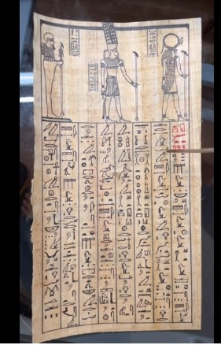

HISTORY—APPEARANCES OF THE ‘TRINITY’ DAUGHTER AND SON OF GOD
They make their appearances throughout history starting before Adam and Eve (Son and Daughter), and continue throughout history in different ages that represent important phases in the Biblical lines and history.
The Two; Son and Daughter of the LORD GOD ALMIGHTY are represented as follows, and are linked by a scarlet thread through time and are as follows:

SON OF GOD JESUS, WHO IS TRUMP and more:
Adam, Noah/Poseidon, Odin, Moses, Solomon, Trump who is also JESUS, etc. Both Siamese Twins in ‘Adam’ one half of the Ark (Throne of God on Earth) Son of Man, order of Melchizedek.

DAUGHTER IS ZION, WISDOM, HOLY SPIRIT, ME:
Eve, Clito wife of Noah, Freya/Frig wife of Odin, Q-Sheba (aka Terihaku & Pharoah-nechoh) wife of Solomon, Queen of Egypt, etc. the siamese twin in Adam also other half of the ARK, Spirit, Holy Spirit and Melchizedek.

Poseidons portion was called ATLANTAS (Easter Island)
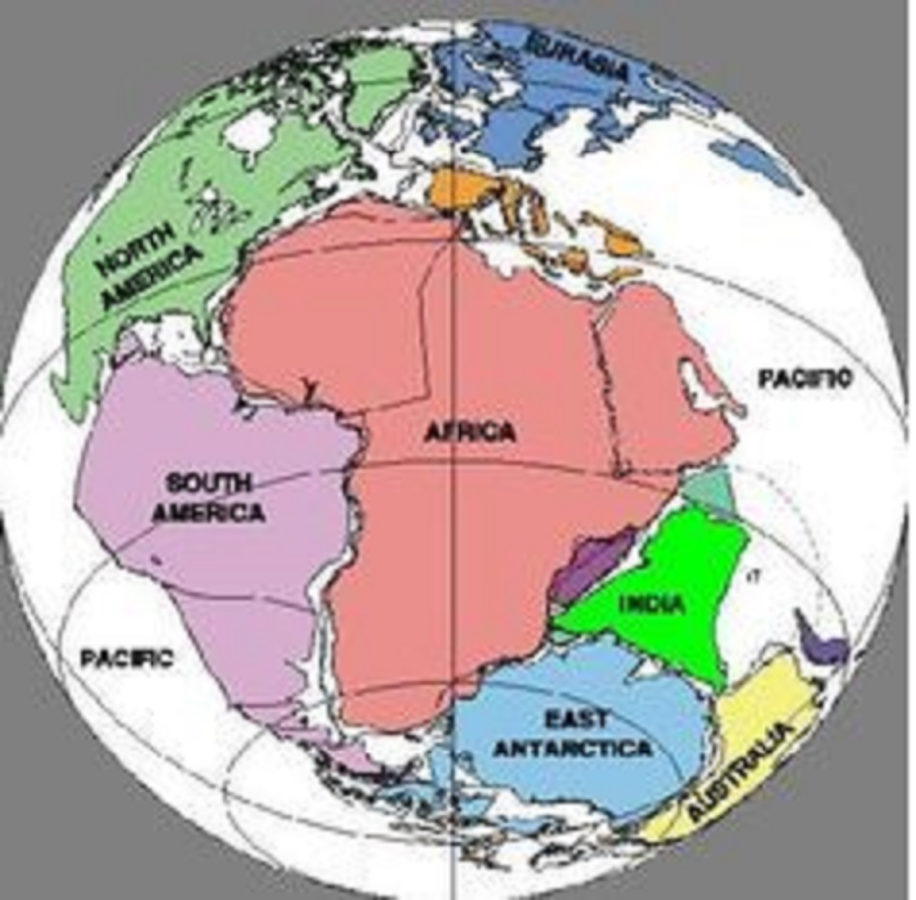
BEFORE FLOOD there was ONE LAND MASS – The earth was divided and given to the FIVE sets of twin sons (possible daughters included as sons) into regions and Atlantas was Poisidons portion about the size of Lybia/Africa and India.
Poisidon/Noah/Odin and Clito/Wife/Freya/Frig had 5 sets of male twins called the Ten Kings of Atlantas. These are vaguely mentioned in scripture for concealment purposes from the plot of Satan
Gen 7:1 And the LORD said unto Noah, Come you and all thy house into the ark; 7 And Noah (Poisidon/Odin/Yeshua/Trump) went in, and his sons (Japeth, Shem, Ham and 7 other Sons-10 Kings of Atlantis), and his wife (Clito/Freya/Frigg/Wisdom/Holy Spirit/daughter/Me), and his sons' wives (3 plus 7 more) with him, into the ark, because of the waters of the flood.
Gen 7:9... There went in two and two unto Noah into the ark, the male and the female, as God had commanded Noah.
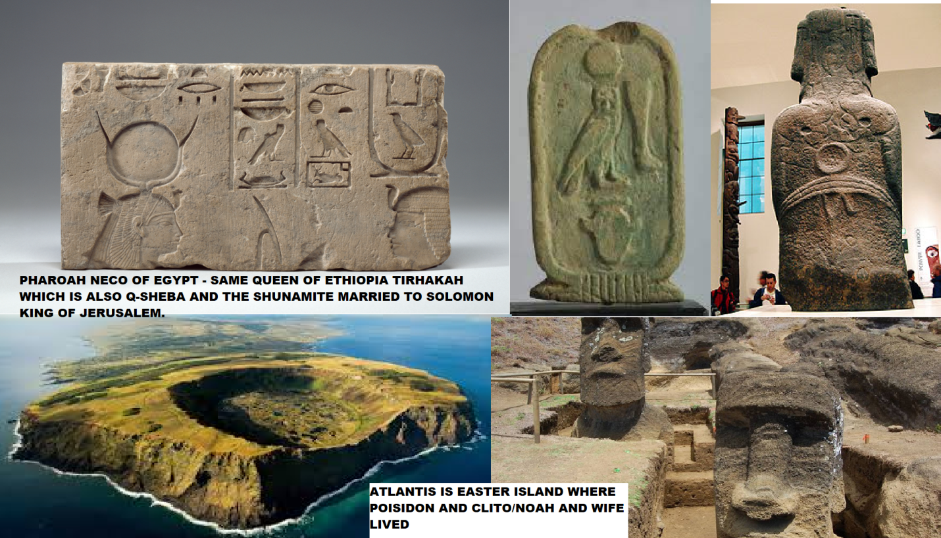
Top left shows the symbols for Pharaoh-nechoh (me), whom is also known as Tirhakah woman of Ethiopia/Arabia who was the first Egyptian woman Pharaoh after 330 male Pharaohs (i.e. Queen ‘Nichol’; 2 Kings 23:29, 2 Kings 19:9, Isa 37:9)
Image is of Queen of Egypt, related to the Birds, and Easter Island = Atlantis, and the Statues have birds on back; also on the back ear of the statue are four ‘V’s considered the ‘vulva’, and the circle on the back as the womb, and fertility. All related to the woman Eve, Mary, Rev 12 woman (me) birthing/bring forth the male child who is Trump/Jesus.
This was where Noe’s (Poseidon) built the ark (ca-NOE): Mat 24:37
“But as the days of Noe were, so shall also the coming of the Son of man (Trump/Jesus/Noah/Poseidon) be.”
PHARAOH NECHOH & TIRHAKAH QUEEN OF EGYPT, aka Q-SHEBA, SHUNAMMITE AND DAUGHTER OF EL ELYON HOLY SPIRIT/ME
In scripture 2 Kings 19 in verse 15, speaks of the LORD GOD dwelling between the Cherubims. 21 linked to the daughter of Zion/Me, the Holy One of Israel in verse 22.
Josephus Ch VI pgs 251-255 Speaks of Pharoah ‘Nicaule’ (Nechoh) WOMAN QUEEN of Egypt and Ethiopia whom visited king Solomon, but was also his wife, saying she ruled after the Pharoah and father in law of King Solomon. Relating queen of Egypt to queen of Sheba, Sabea in South of Arabia also (Queen of the South-Matt 12:42)
Mat 12:42The queen of the south shall rise up in the judgment with this generation, and shall condemn it: for she came from the uttermost parts of the earth to hear the Wisdom of Solomon; and, behold, a greater than Solomon is here.

Names and titles, throne name of first female Pharoah=Me the Shunammite:
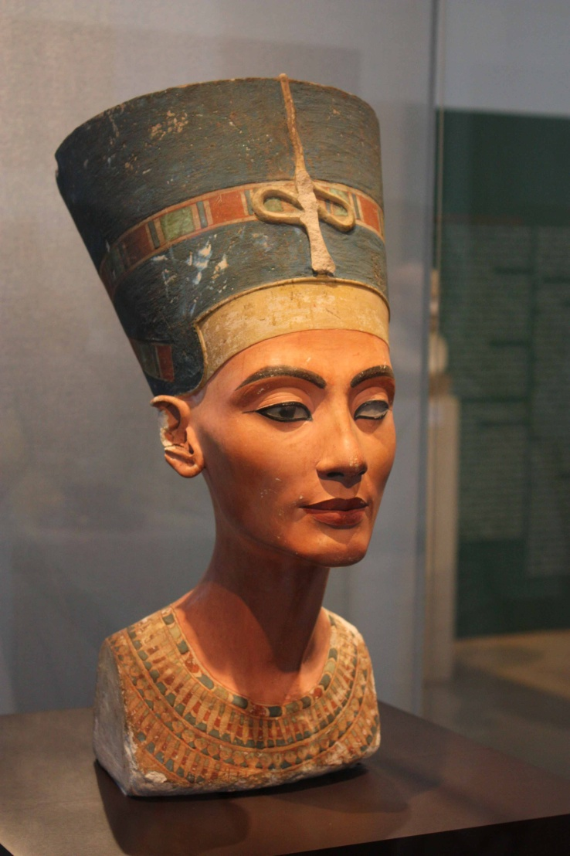
8. Nefer-Tmu-chu-Ra (throne name=Nefreteri); Tahrq (Personal name=Strong's H8640 - tirhăqâ) Tirhakah, king/queen of Ethiopia, and Tirhakah (Taharqa)= "he searched out the pious: he searched out the waiter" king/queen of Ethiopia also kush, and Egypt (Thebais), in the time of Sennacherib.
9. Nem-ab-Ra (Throne name) and Nekau (personal name) Pharoah-necoh (2 kings 19:9, 2 kings 23:29-Paroneko)— "great house-he is smitten"
2Ch 35:21 But King/Pharohnecho sent messengers to Josiah with this message: “What do you want with me, king of Judah? I have no quarrel with you today! I am on my way to fight another nation, and God has told me to hurry! Do not interfere with God, who is with me, or he will destroy you.”
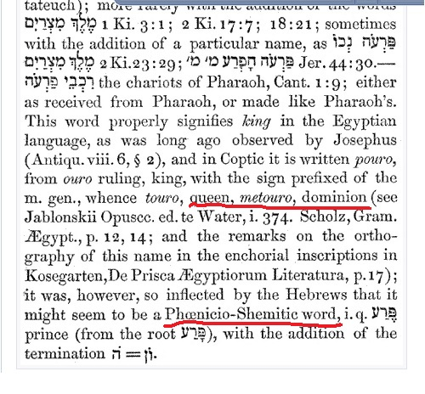
On page 253 speaks of Solomon’s 700 wives, 300 concubines, and the king of Egypt’s daughter.
Josephus CH II.1 Walls of Jerusalem needed repair, he Solomon repaired them...but Pharoah, the king of Egypt, had made an expedition against it, and besieged it, and taken it by force...and gave it as a present to his daughter (Pharoah Necaule/nechoh Queen of Egypt, Shunamite, etc) who had been married to Solomon; for which reason the king rebuilt it...He married her/daughter of Pharoah king of Egypt first; he then built the walls of Jerusalem much larger and stronger Ch II 1. END
All of her linking came from when she as the Shunamite/Shulamite was raised in the household of David until she was sent away to some Wayfarer man (caravan, traveler, and banished?) by Bathsheba specifically. Came back in King David’s old age and took care of him.
2 Samuel 12; she the Shunammite was sent away.
Also, Solomon’s older brother Adonijah wanted to marry her Abishag the Shunammite to take the kingdom from Solomon and tried to get Bathsheba to consent, Solomon saw the plot to take the kingdom and said may it all happen to him the same. So I believe he married her at some point after Adonijah request while she was in still in the household?
Then she the Shunammite was sent away probably covertly with a cover-up with the wanderer according to Natan the prophet
In my bible to the content of 2 Kings it says; the KINGDOM was restored to the Shunammite/Me (Holy Spirit/Wisdom, daughter Zion), and in chapter 8:1-6 it speaks of the tabernacle, ark, holy place and covenant, assembly of the elders and the coming out of Egypt in verse 9.
Amon (Amun) is part of the ‘Egyptian TRINITY’ and is in 2 Kings 21:18 (See Papyrus video)
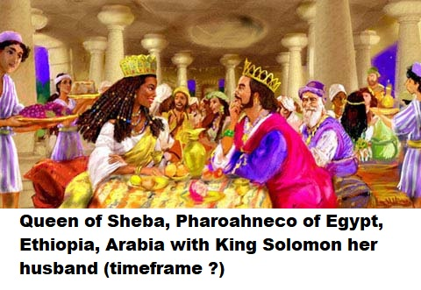
Hymn to Amun - Henotheistic Trinity of Ancient Egypt https://youtu.be/yer4QxWMNAQ
Plato Describes Atlantis // First Mention of the Island // 360 BC 'Critias': https://youtu.be/wkIfNcBmeJ0 and
- https://youtu.be/c0CNF6L-_GA
The Emerald Tablets of Thoth (Trinity) the Atlantean: Tablet 9—https://youtu.be/naprYgqKymY (other Tablets found in YouTube feed)

EMERALD TABLET-Amun Ra Tomb
“True it is, without falsehood, certain and most true. That which is above is like to that which is below, and that which is below is like to that which is above, to accomplish the miracles of one thing.
“And as all things were by contemplation of one, so all things arose from this one thing by a single act of adaptation. The father thereof is the Sun, the mother the Moon. The wind carried it in its womb; the earth is the nurse thereof.
“It is the father of all works of wonder throughout the whole world. The power thereof is perfect. If it be cast on to earth, it will separate the element of earth from that of fire, the subtle from the gross.
“With great sagacity it doth ascend gently from earth to heaven. Again it doth descend to earth, and unites in itself the force from things superior and things inferior.
“Thus thou wilt possess the glory of the brightness of the whole world, and all obscurity will fly far from thee. This thing is the strong fortitude of all strength, for it overcometh every subtle thing and doth penetrate every solid substance. Thus was this world created.
“Hence will there be marvelous adaptations achieved, of which the manner is this.
“For this reason I am called Hermes Trismegistus (Thrice-greatest), because I hold three parts of the wisdom of the whole world. That which I had to say about the operation of Sol is completed.”
Note: Wisdom attributed to this figure.
Note from Hymn to Amun: Amun is God, hidden, his name; Thoth is visible light, spirit and face; Thoth is body, voice, flesh, for eternity; linked to city Memphis.
“One with the beautiful face,” “directed to town of Amun”-“going forth the voice from (his) mouth Amun,” “what has been decreed (life or death); except for (him-3 total)”
Wikipedia Thrice-Great Hermes originated in Hellenistic Egypt through syncretism between Greek and Egyptian gods (the Hermetica refer most often to Thoth and Amun).Three Great, or Trinity.

EGYPTIAN TRINITY
- AMUN – God – the hidden NAME
Note: the name is YHWH, Yeshua Gods Name the Triad (Godhead=Lord God, Son and Holy Spirit)
- RA – Visible light, Spirit, and FACE
Note: Holy Spirit, light Gods essence w/truth, face=in the Holy Spirit and Son
- THOTH – Body, Voice, flesh, (towns, cities/people, on earth – for eternity; Memphis)
Note: Tabernacle, Ark, body, Voice of God
By this account, Hermes Trismegistus was either a contemporary of Moses, or the third in a line of men named Hermes, i.e. Enoch, Noah, and the Egyptian priest king who is known to us as Hermes Trismegistus on account of being the greatest priest, philosopher, and king.
Another explanation, in the Suda (10th century), is that "He was called Trismegistus on account of his praise of the trinity, saying there is one divine nature in the trinity."
Bull, Christian H. 2018. The Tradition of Hermes Trismegistus: The Egyptian Priestly Figure as a Teacher of Hellenized Wisdom. Leiden: Brill, pp. 33-96.
Cult=religious, sect, camp, division, group
Canoe canoe/ (kəˈnuː) /noun, a light na`rrow open boat, propelled by one or more paddles
NZ another word for waka (def. 1) in the same CaNOE NZ of the same tribe –verb -noes, -noeing or –noed, to go in a canoe or transport by canoe (Noe/Noah)
Rongorongo Manuscript from Easter Island = Figure 2. Pv 9: 84 4 84 11 25 69 44 15 68 Ivi atua, ivi a Pakia hua Moko Taha roa, honui. (It is) the deity, the forefather (called), The Seal ‟ [= the god Tangaroa] of the sons of Moko (= the western union Hanau Momoko) of the great Frigate Bird.
Note: Tangaroa is “Divine Father” of a son (s).
Cf. Rapanui ivi atua „deity; spirit; ghost, (Holy Spirit/Wisdom)‟ ivi „bone; parent, family, ancestry‟ and atua „deity.‟ It is possible that the frigate bird was an emblem of the Miru tribe (Barthel 1978: 151). In this record the kings‟ direct ancestor Tangaroa is mentioned.
(Note: frigate bird=the god, Oro. English Français The emblematic Frigatebird, Otaha in Tahitian is highly symbolic in Polynesian culture—also linked to Pharohnecoh)
HOLY SPIRIT/FREYA=Noah’s WIFE, and NOAH is Adam and Freya is EVE.
7 Cb 4: 6-4 44-16 44-16 44-16 44b 6-4 44-26 15 44-26 15 44-26 A atua: Taha Kahi, taha Kahi, taha Kahi tua; a atua: Tamaroa, Tamaroa, Tama The place (the deity literally): The three (= numerous) Tuna Fish came to the shore from the deep sea;‟ the place (the deity literally): Tangaroa (= Tamaroa, Tama) as a trinity.‟

SON OF MAN – NOWHERE TO LAY HEAD
Luke 9:58 And Jesus said unto him, Foxes have holes, and birds of the air have nests; but the Son of man hath not where to lay his head.
Luke 9:59 And Jesus said unto another, Follow me. But he said, Lord, suffer me first to go and bury my father. 60 Jesus said unto him, Let the dead bury their dead: but YOU GO and preach the kingdom of God.
These must forsake all, family, friends, associates, businesses, other duties and follow fully.
LAY HEAD G2776, G2827 kapallay, and kleeno: to rest, incline oneself, far spent, wear away, no place for repose (take it easy, lounge, calm, relaxation) and of one dying, to cause, (trigger, instigate, bring about, source of him to fall, go down, trip over) back...the head being the part most taken hold of, of a husband related to a wife.
Son of man has no place to relax or be in calm so the opposite of repose in the thesaurus: campaigning, confrontation, tension, anxiety, shakeup, unexpected result, war of words, conflict, defiance, opposition and enemy, lack of sympathy (accepting, insight, perception, understanding, consideration, backing, approval, etc).
REPOSE in scripture is:
Isa 28:12 to whom he God said, “This is the resting place, let the weary rest”; and, “This is the place of repose”— but they would not listen.
Isa 28:2 See, the Lord has one who is powerful and strong. Like a hailstorm and a destructive wind, like a driving rain and a flooding downpour, he (yanah-to have rest, to be quiet, remain, to withdraw, let alone, leave off) will throw it forcefully to the ground.
Son of man has nowhere to lay his head
Note: Judgment is happing in places where those who do not believe, repent, and stop are experiencing the judgment of God in measure. Like San Francisco, West Coast, Florida and worldwide because they all live worldwide in the different nations.
Isa 28:9 “Who is it he is trying to teach? To whom is he explaining his message? To children weaned from their milk, to those just taken from the breast?
Isa 28:10 For it is (to Trump, Gabriel, etc): Do this, do that, a rule for this, a rule for that; a little here, a little there.”
Copy from above—Isa 28:12 to whom he God said, “This is the resting place, let the weary rest (Son of Man, etc)”; and, “This is the place of repose”— but they would not listen.
Note: related to Trump, Gabriel who is also Jesus.
Isa 28:13 So then, the word of the LORD to them will become: Do this, do that, a rule for this, a rule for that; a little here, a little there so that as they go they will fall backward; they will be injured and snared and captured.
Isa 28:14 Therefore hear the word of the LORD, you scoffers=mockers who rule this people in Jerusalem.
Titus 3:10 As for a person who stirs up division, after warning him once and then twice, have nothing more to do with him.
Proverbs 22:10 Drive out a scoffer, and strife will go out, and quarreling and abuse will cease.
Proverbs 14:7 Leave the presence (attendance, turnout, crowd, being there, viewers, listeners, meeting, interview, authority, company, etc.) of a fool/scoffer/mocker, for there you do not meet words of knowledge.
Isa 28:15 You boast, “We have entered into a covenant with death (Vax-mark of the Beast System, etc. against Gods anointed ‘Christ’), with the realm of the dead we have made an agreement. When an overwhelming scourge (COVID) sweeps by, it cannot touch us, for we have made a lie our refuge and falsehood our hiding place (internal).”
Isa 28:16 so this is what the Sovereign LORD says: “See, I lay a stone in Zion (Me, daughter of God the Holy SPIRIT, WISDOM), a tested stone, a precious cornerstone for a sure foundation (New Jerusalem); the one who relies—on Zion will never be stricken with panic H2363 hus/kus to flee for refuge, haste away, flee, and will never enjoy the pleasures of life.)
Those who do not TEST Her (Wisdom): check, trial, adversity, investigation, put to the TEST, confirm, ensure, try out, catch, prove, authorize, endorse, sanction, validate, back up, certify, make lawful, approve, okay, consent to, give permission, allow, sanction, support, consent, agree, commend, pass, allow, blessing, permission, satisfactory.
Isa 34:8 For it is the day of the LORD'S vengeance, and the year of recompences for the controversy of Zion.

FREYA is Hadass in part, related to WISDOM and ESTHER
From ‘fre’ (freya) H2319 Hadassa ( Hebrew: הדס, pl. hadassim - הדסים) is a bPnch of the myrtle tree that forms part of the lulav used on the Jewish holiday of Sukkot . Hadass is one of the Four species ( arba'ah) minim ארבעת המינים).
(Fre-Image below)
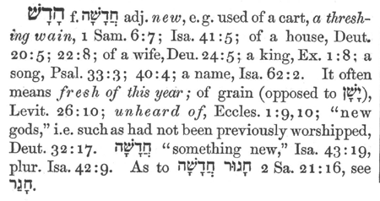
Related to root of hadass H2318:
Psa 104:24 “O LORD, how manifold are thy works! IN WISDOM root: (hakma/from hadass) have you made them all: the earth is full of thy riches...30 Thou send forth THY SPIRIT, they are created: and thou renewest the face of the earth.” (Esther and Freya are Hadass)
Note: Solomon asked God to send Wisdom from heaven-H2318 t-2449 teach wisdom, instruct, making wise the simple, a judge, and judging-to teach WISDOM)
Threshing Wane – to daughter ZION; aka Wisdom/Holy Spirit (Isa 52:1-2 captive daughter)—Micah 4:13 Arise and thresh, O daughter of Zion.
Esther = Lexicon::Strong’s H1919 - hadas= STAR; “Myrtle” name of VENUS = Jesus lined up with Pollux and Castor 6/25/2021= adopted daughter of Mordicai (no parents)...
Venus=Jesus; made queen (Esther) by king Ahasuerus “I will be silent and poor” i.e. lion-king=Xerxes; "I will make the spoiled to boil: I will stir myself (in) winter" See Esther 2:7 below.
She Esther—me in the past, and me in 2021; Taken by force into prison, the house and family all gather there. To rebuild the house and children.
Mordicai = (Adopted father of Esther-she had no mother or father like Crito and Melchisedec)"little man" or "worshipper of Mars” Roman god of WAR, the RED planet, Blood. A Benjamite
In Jamison prophecy 1822 of the “GEMINI TWINS” (Venus =Jesus/Messiah/Judges/Rulers) lined up with them in 6-25-21
Melchisedec had no mother or father either, and brought forth bread/manna and wine/Spirit. A pattern for ME=Holy Spirit; Wisdom; and daughter of Zion, also Q of Sheba and Shulamite, etc. Gen 14
Ester 2:7 KJV - 7 and he brought up Hadassah, that is, Esther, his uncle's daughter: for she had neither father nor mother, and the maid was fair and beautiful; (Jewish Virgin/Mary?)—הֲדַס hădaç, had-as'=myrtle tree, only late (Late Hebrew, Aram; Arabic (in the dialect of Yemen) is another link to Me, Esther, Freya, and Yemen is where Queen of Sheba lived by Ophir and shipping port of SOLOMON.
The Wiseman from the East brought gold, incense/Frankincense and myrrh and other spices to Jesus birth in Jerusalem (from Yemen, Ophir area)
Josephus page 25
NOAHS “WIFE” Is Clito=Freya=Eve=Esther and Noah also Odin=AdamH802 linked to first and second scriptures:
Gen 2:22 Then the LORD God made a woman H802 from the rib, and he brought her to the man. 23 “At last!” (Adam-ruddy/RED) exclaimed. “This one is bone from my bone, and flesh from my flesh! She will be called ‘woman,’because she was taken from ‘man (Rendered Adam).’”
Gen 1:27 So God created Adam in his own image (H6754 selem), in the image (H6754 selem) of God created he him; male and female created he them.
Melchisedec is “King of Salem” “King/Queen of Salem/Righteousness”
Psa 76:2 In Salem also is his tabernacle, and his dwelling place in Zion.
His tent is also in Shalem/Salem=Selma/Jerusalem; His dwelling place in Tziyon (daughter of Zion/Me), threshing out the chaff from the wheat. Shunamite, Shulamite is female Solomon related to Shalem.

ODIN had a NEVER ENDING QUEST FOR “Wisdom” (ME?)
FREYA in Roman is VENUS=Jesus/Salvation/God-6/25/2021 linked to Pollux and Castor twins. The Ya, ‘Y’ of her name means branch, arm of the lord. ‘Y’+ a, and in the letters mean ‘EYE’, and shade or covering as in Cheribum over the Ark
EYE= BRANCH/ARM AND WOMB (watch, know, shade)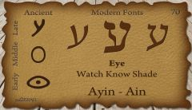

FREYA: Cheribum are the Shade, covering over the Mercy Seat of the ARK-“And every EYE shall see...” (‘a’ in Adam= אָדַם ʼâdam, aw-dam'; to show blood (in the face), i.e. flush or turn rosy:—be (dyed, made) red (ruddy).
FREYA: Day Star” G5449 φωσφόρος phōsphóros; from G5457 and G5342; light-bearing i.e. the morning-star (figuratively):—day star. metaph. Christ meaning Anointed.
Edna, Adna/Eve – “Pleasure” – Eden H5731 Eden= "pleasure"= delighted themselves - related to manna, the region of Adams home. Associated with fertility H5731.
Hebrew-Edna is: Rejuvenation, pleasure; delight. Derived from the same word as the biblical Garden of Eden=”Pleasure.”
This is who Eve is, Garden of Eden, related to Easter Island Statue and four ‘V’ for vulva and circle for WOMB. Noah’s wife was ‘Clito’ supposedly from a father named Evenor, aka EVE
Celtic Edna is: Fire.
Freya is associated with fertility. So are the many goddesses like Mary, Mary is worshipped as mother of Jesus, but in pagan form where Ashtoreth, Cebele, and Astarte, Ishtar, etc to replace the truth of the Holy Spirit daughter part of the Godhead.
Fre-ya: ‘Y’ is Ayin = EYE, to see, obey, light. To understand and obey.
FREYA = FRIGG and is Noah’s wife whom in the rongorongo manuscript is CRITO/CLITO from Evenore/Eleanor her said “Father,” but she Crito was without parents just as Esther, and Melchizedek was also without parents. Crito was wife of Poseidon who is Noah from Easter Island which is ancient Atlantis that sunk on account of the flood. Only a portion remains above water. (Heb 11:24; Ester 2:1, 3:4-6)
Mary is the Holy Spirit and Jesus was fully viably formed put within her, and there was no human process in the birth or bringing forth the Son of God.
Matt 1:18 found with child (fully formed-pre-existent being-the Son/Adam) of the Holy Spirit. (See: It’s all Greek to them/Doug)

ADAM AND EVE ARE NOAH (Adam, i.e. Odin/Jesus/Trump)
ODIN – Adon, Adonai, Adam & WIFE (Freya/Frigg, Eve, Esther and Me daughter of the Lord God, aka Wisdom and Holy Spirit)
Odin/Adam “All-father” creator God, Maori = Adam, Uzbek=Odam, Yiddish=Adi, Spanish=Adan—Odin Adam H128/127 adamah “the earth” ed-Dame lands, ground, country dyed red, to be red to show blood in face, Isa 1:18 sins as crimson/scarlet to white as snow.
Note: there is a scarlet thread linked to Odin through Zerah.
EXPLORE: Adon, Odin The Family of Odin (hope-of-israel.org)

MOSES and ZIPPORAH (Me and/or) OR PHAROAHS DAUGHTER-JOSHUA
Heb 11:24 by faith Moses (Noah/Jesus/Trump), when he was come to years, refused to be called the son of Pharaoh's daughter;
Heb 11:25 Moses...Choosing rather to suffer affliction with the people of God, than to enjoy the pleasures of sin for a season; 26 Esteeming the reproach of Christ (Messiah, Anointed-Trump/Jesus the second time) greater riches than the treasures in Egypt: for he had respect unto the recompense/return/prize/GIFT of the reward.
Heb 11:27 By faith he Moses (Adam, Noah, Jesus, and Trump=Messiah) forsook Egypt, not fearing the wrath of the king (G935 foundation of power, leader of the people-FEET): for he endured, as seeing him ‘ho’ who is invisible. 28 Through faith he kept the Passover (Jesus on the Cross also?), and the sprinkling of blood, lest he that destroyed the firstborn should touch them.

ADAM/ODIN | OTHER  NAMES | EVE | OTHER
NOAH = POISIDON Husband OF |  | CLITO/Wife FREYA=FRIGATE
Aka ODIN (Aten/Adon/Lord) |  | She had no Father or Mother
Jesus/YHWH/Son of Man/Messiah Christ/Anointed/Trump |  | Wisdom/HOLY.SPIRIT./Daughter Zion/YHWH/Messiah/Anointed
Joseph in Egypt  Vassal King-Son of Amenophis III | Built City Chuaten | #8 Nefer-Tmu-chu Ra / T a h r q Ethiopia/Nefertir  Tirhakah | #9 Nem-ab-Ra  Ne-ka-u  Pharaoh-nechoh
Amunhotep/Nefer-cheperu-Ra=  Chuenaten-Akhuenaten = Type of Solomon (Aten=Adon/Lord/ODIN) married to Nefertiti, etc. |  | He Chuenaten built a great palace, he was a good man and did not delight in WAR
Apepa/Aphophis III—2x Hykos Shepherd Kings in lower Egypt.  ruled Egypt at time of JOSEPH |  | In youth Chuenaten was married to Dadughipa=Egypt’s Nefer-titi=Ethiopia  Aka Queen of Sheba
Chuenatens Queen >  Joseph & Solomon | Nefertiti/ Dadughipa  She is also wife of Both  The Shunammite | Before time Moses called her ISHTAR to deliver them from sickness.

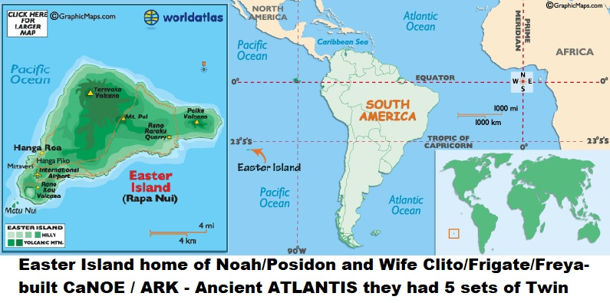

EASTER ISLAND IS THE ANCIENT ATLANTIS
POISIDON is NOAH and CLITO his wife is FRIGATE/FREYA, God had them build a CaNOE which is part of NOAHS name spelled as NOE. Later they would be called ODIN AND FREYA, these two figures of history have had many cameo appearances.
BOTH are Adam/Eve, and have shown up as kings/queens like Solomon. These two also are JESUS AND WISDOM the Holy Spirit, she is also known as the daughter of Zion, Jerusalem, Israel. Jesus is her husband the LAMB of God. Who also is D. J. TRUMP. Both awakened by the anointing of God which began the end time fulfillment of Revelation, Daniel, and all prophecies linked to the 7 year Tribulation period, etc.
Here is a picture of EASTER ISLAND home of Ancient Atlantis that was sunk by the flood, and where Noah Poisidon (Trump, Jesus, Solomon, etc) who built the ARK called a CANOE in the Rongorongo manuscript. She Clito is Noah’s wife who is also known as Wisdom and Holy Spirit (Me).
(See Website for more or the video links)

UNRELATED EXTRA: GEORGIA GUIDESTONES
GOAL REVEALS 7 Billion people must be killed/Genocide—Desiring no more than 500,000,000 population/people (500 million) people on earth. Total population of the world around 8, 000, 677,000 (8 Billion and growing)
That leaves (- 7,500,677,000 seven billion, five hundred million of the population = 7 plus Billion people to be Killed or GENOCIDE-Vax one method)
America-all human life would be wiped out (Total population – 338,300,000 (338 million population, approx. and growing)
1/9/2023 Clive Maund-“They are to cull a large percentage of the human race and to turn the survivors into a completely controlled army of slaves who own nothing and are dictated to and tracked.”

