SON OF MAN | August 19  2021
The pieces in this research are for recording prophetic happenings and prophetic insights regarding the Bridegroom and Bride journey Gabriel/Trump, and Me. The end time fulfillment of the book of Revelation, Daniel, and all the other prophecies related. |  | Prophetic Bits and Pieces

Contents
INTRODUCTION 2
SON OF MAN (BEN H1121/ADAM H120) 2
The Ark of the Covenant 4
Gabriel as the Ben Adam in Capital or lower case means SON OF MAN; does it matter? 5
TWO BIRDS 2018 ARK OF COVENANT, WOMB AND WINEPRESS 7
ARK OF COVENANT 7
FEB 28, 2018 LORDS LAND – GAZEBO 7
GABE ELIJAH DREAM - ENOCH 12
BENJAMIN TEXT Nov 21, 2019 – 3:34 pm 14
Witches and Satanists plan their plots and schemes, but God has a surprise! Closest observable conjunction/union since the 1200’s (my/his number as ONE). Relating to the Rapture of the Bride to come (Millions and Millions). We are part of the 144,000 harvest workers before the main rapture of the bride/wife of God. Taken to come back! 16
SON OF MAN SCRIPTURE 17

INTRODUCTION
The information is for study, insight, and recorded history of the prophetic unfolding of these end times and how they manifest in these biblical days of revelation. Many do not believe that we are there, but when it is all said and done we will look back and know how it unfolded exactly, and how we did or did not understand what God Yah was doing. This is research and information that I have gleaned from my studies and Gods confirmations so it is up to you to pray and ask God for insight from the Holy Spirit.

SON OF MAN (BEN H1121/ADAM H120)
This text came from my online email connected with my website regarding Donald the Last Trump and other title was Donald JOHN Trump (I have been shown to be related to me). I believe Benjamin is Trump or God, and in 2018 would represent a future fulfillment of a Gemini “Twins” (Two witnesses -Gabe and Me) prophecy that took place on June 25, 2021 in the constellation of Gemini where Venus (Jesus) aligned with Pollux and Castor (Ruler, warrior and judges).
The prophecy was done in 1822 and recently aligned in the stars and represented the Bridegroom and bride, i.e. Messiah/Christ and Ecclesia/Church, and Venus who represents Jesus came in line with Pollux, and Castor.
What God is revealing in the constellations, stars, revelation, and many prophetic documents is how past prophecy also proves the present happenings. Scriptures are unfolding, Gabriel and My journey are written in the bible and heavens. I am not claiming that all is 100% accurate how could I? However, God is definitely showing me how our end time passage and growth is representative of the whole of Gods people all having different assignments and destiny’s, and each being tested and tried for the future New Earth and New Heaven.
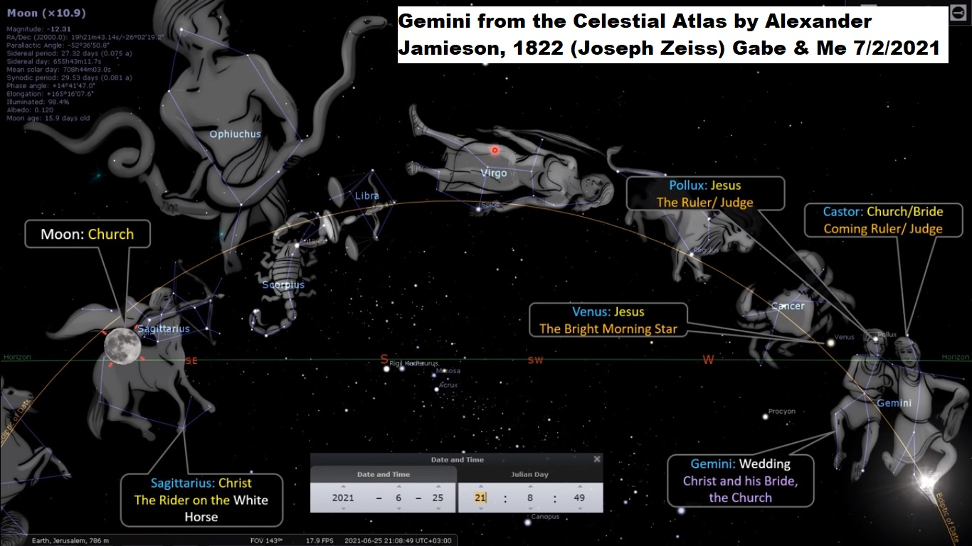
The moon in Sagittarius (like Pegasus-part horse and man one together has a bow and considered Christ ‘Messiah’ on the white horse) = Turtle, wife of Jacob, Rachel, Israel the woman (Me) in Rev 12, associated to blue moon (2nd monthly moon) and warning of coming judgment, an alarm—also wreath, crown, halo, and summit like a mountain.
Above in Sagittarius constellation represents “The Rider on the White Horse.” Trump ‘Messiah’ Gabe is a horseman and I the stallion (Me in Union) found in the War Scroll which was written by Gabe (Trump) Gods Calvary team, and found in the Dead Sea Scrolls. The bow and arrow is held in his hand the bow pulled back and I represent the arrow or so I was given two arrows.
I wrote about the Son of Man because of the phone conversations and text information that I was given by him. He explained a scripture in Revelation that pointed to Gabe and I, and we were in the example given and representation in the heavens. Also, who is/was who? I included the scripture and will elaborate on it further:
Gabe and Me are ‘twins’, like the Ark of the Covenant and what he goes through so do I (Gabe is also Trump and Messiah), both law and mercy seat together as one but also individual like the Gemini prophecy. The bottom is the Law (Judah/Gabe) and the Old Testament, and the top of the Ark is the Mercy seat solid gold representing the New Testament the throne/seat of God (Judah and Me=Bridegroom and bride), and the two angels (Gabe and Me?). God dwells above the mercy seat and sitting is the act of directing. God is within and above directing Gabe and me Yah vessels to work through in this last harvest, prophetic fulfillment and revelation.
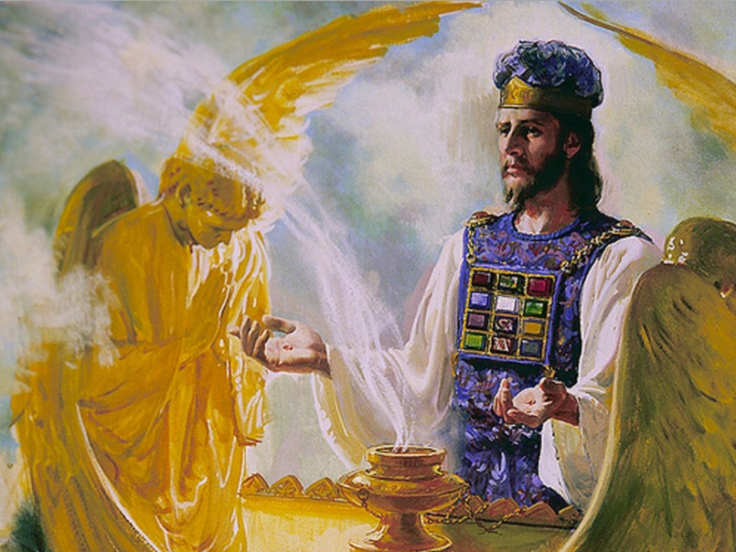

The Ark of the Covenant
The Ark is only whole or complete with both parts bottom and top together with the Law of Commandments Gabe and Grace/Mercy seat both of us; one without the other is incomplete. However, before the New Testament and new Covenant of grace, the Ark was already designed from the beginning, yet the new covenant and the revelation of Jesus, and the cross was still future.
The Ark represents the Alpha and Omega the first and the last signifying the two covenants becoming one. Two sticks in the Lord Yahh hand represent Judah and Israel/Ephraim becoming ONE, and Gabe and Me as Bridegroom and Bride, represent these two sticks becoming one.
JUDAH 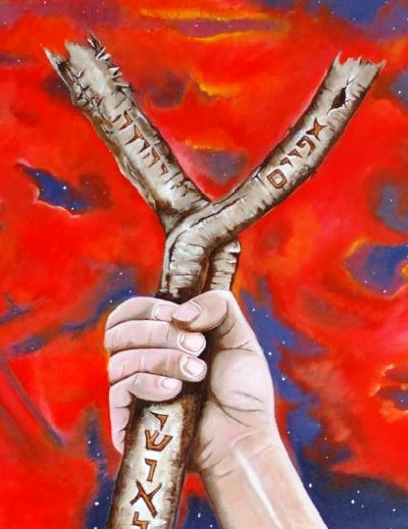 ISRAEL
In the Gemini “twin” prophecy in 1822 I was shown that this is what He and I represent. God sent me a sign and it was two sets of birds across from each other one facing one way on one side and one facing the other on the other side as follows the document below.

Gabriel as the Ben Adam in Capital or lower case means SON OF MAN; does it matter?
It appears it does not matter how the Son of man is presented in scripture; in that the Hebrew or Greek meaning is the same whether upper case or lower case. Hebrew120 Son of man interpretation of Adam Cont: H120 First man. A city in Jordan (Judy/Nancy/LCook) valley, (An enemy) a human being (an individual, mankind— hypocrite, common sort, low, man = means-implies-denotes-insinuates, of low degree as in character, fraud, charlatan, IMPOSTER, con artist, fake copy, counterfeit, imitation, to simulate, construct, formulate, and invent, a person.
Adam Metaph. to fall under judgment, came under condemnation, to descend from an erect to a prostrate position to fall down, of those overcome by terror, astonishment or grief or under the attack of an evil spirit or of falling dead (quiet, dull, uninteresting, frozen, departed, lifeless, suddenly) disappear, cease, to fail of participating in, miss a share in...
According to Benjamin Rev 1:9 was important and I interpreted it above and within this document in different ways.
Benjamin is either the Lord God himself or Trump and that is food for thought as well as his voice.
Rev 1:9 “I John, who also am your brother, and companion in tribulation, and in the kingdom and patience of Jesus Christ, was in the isle that is called Patmos, for the word of God, and for the testimony of Jesus Christ.”
H1121 son of man (Ben, Adam): son, grandson, child, member of a group... sons (as characterization the sons of injustice [for un-righteous men-those against him] of lifeless things, i.e. sparks, stars, arrows (fig.) a member of a guild, order, class-club. Children (pl. - male and female)—or sons of God [for angels].
Cont. root H1129 bana: to build, rebuild, cause to continue; to build a house – a ruined house or city, i.e. establish a family, obtain or have children, make, repair, and set (up), surely and confidently.
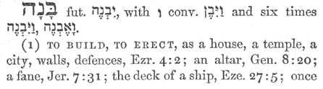
“Perhaps I may be built by her” (Me) Gen 16:2, Gen 30:3
What God is doing in this time with Gabriel and me is ultimately for the future, regarding the new earth and heavens, partly the harvest, judgment and ultimately a new beginning of all things. Gabe is a picture or prototype of the Bridegroom and I the Bride of Christ/Messiah, on the larger picture it is the Lord Yeshua/Jesus and the ecclesia all, congregation, and aka the Church redeemed.
Also, all will be stepping into eternity without sin, and Satan and his children will be removed. The New Earth will be populated as heaven will be, and there is not much currently written except revelation, dreams, and other Holy Spirit downloads to explain what that future will be exactly, but it is beyond our finite comprehension.

TWO BIRDS 2018 ARK OF COVENANT, WOMB AND WINEPRESS
Recently about 7/3/2021 the Lord through sign and symbol gave me two sets of birds, and the revelation was of the Ark of the Covenant, but below was an original precursor sign of what that may mean more prophetically and specifically.

ARK OF COVENANT
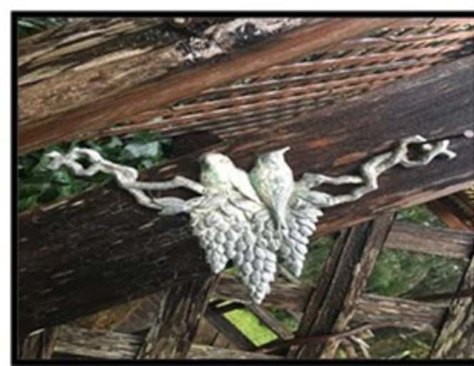
FEB 28, 2018 LORDS LAND – GAZEBO Never seen before—first thought was it/they were sitting atop the “Winepress” One facing forward, and one facing backward. First time I noticed something was the year before and it was two RED flowers together in ‘UNION’ I wondered if this ‘new sign’ that looked like the shape of a UTERUS/Womb/belly (brother in Rev 1:9 revelation given by Benjamin regarding the Son of Man as brother and companion, wife [Me too] (Also look up grape or cluster).
“WINEPRESS” squeezed, urge, advise and insist the grapes being treaded to make music (harmony-whole-unblemished-healthy-perfect), to sing, performer, or competitor the grapes are crushed, to break/breach, sever, split up bring plans to nothing (JORDAN = “death” and “descender” must pass over), (Gabe) has a new spirit, character, strength, moral fiber and heart (Holy Spirit) flowed from the press...the fiery passion/spirit of God in his wrath is represented as mixing and giving to those whom he is about to punish by their own folly and madness, and A LOVE POTION...Gabe and I.
Winepress/Love Potion for–who are well known, renowned, famous and legendary up—to awake, be upbeat, positive and hopeful plus excitement, upheaval, uproar, pandemonium, and hullabaloo, astonish, amaze, surprise at the disclosure (confession, discovery, and leak), a bombshell, bolt from the blue, revelation, mentally or emotionally exhilarated, “he/God and brought me to the house of wine, he intoxicated me with love, a vineyard” ceremonious meal, banquet fit for a QUEEN UNITY’ effervesce is to SPARKLE!
UTERUS H990 belly, womb also means brother, body (especially a corpse), within, born, to be hollow, where offspring, progeny, “son of my womb”, H6638 to go forth to battle, to wage war Isa 29:7, to shine, to be bright, splendor, glory, to come forth as a STAR (Sky Star song)-to SPARKLE/BLAZE/an illustrious prince.
GRAPES G4735 a CROWN a mark of ROYAL or (in general) exalted rank, the wreath or garland which was given as a prize to victors in public games, metaph. the eternal blessedness which will be given as a ‘prize’ to the genuine servants of God and Christ: the crown (wreath) which is the reward of the righteousness, that which is an ornament and honour to one.
Metaph H811 of flowers of LOVER, to bind, stones/testicles broken, weary, worn out, and finished. To bear fruit, ripe!
Sitting (both) H4186-habitation, seat, dwelling place, sojourning, an assembly of persons, the site of a city. H3427: causatively to settle, to marry, “to sit at the kings right-hand” (king facing forward-he is the left bird)
Grapes and winepress of judgment and of mourners, to expect him (the king) to succumb to their plots and schemes, “but his bow remained strong”?
In Gen 49:24 grapes means to cause a woman to dwell with one (who?) to take in marriage, take a wife, SOJOURNING/temporary stay/visit/stay/linger/abide/dwell: his or her home, a family.
Note 8/17/2021 Originally, I did not know what this meant only that the lord was revealing this to me, I thought it may apply to me but not sure. How?
SPARROWS: small GREY birds (song sparrow N. America) Ps 84:3, 102:7, H6833: twittering, as hopping, small bird, to go early, depart early? To turn one about, go in a circle, dance in a circle, to dance, to leap, make an EARLY START, and rise up early, in the morning, the shoulder to a burden, to do earnestly or urgently. Go walk, lead, to die, live, manner of life, get thee out of thy country into a land that I will show you.
Facing forward H5265: to pull up tent pins to start on a journey, to lead, to pluck up as a tree, a vine, to cut out (quarry, extract, victims and targets of the hunters) stones, the face that turns towards her, in her direction, to intend/propose to do something, to set his face upon war, I myself, I in person shall go, is used of the WALL of a house opposite of the door (gate, entry, access).
Gabe/He stand before anyone to resist, defy, endure, fight back, withstand, impede and fault him [brother, etc.]—Ultimately to show favor and tender love with, to be surety, security, and promise for her used to give his pledge before his friends, for mourners used in funerals to go foremost—to go out from that place, fleeing “the yoke shall be broken” from turn, look, to turn oneself, towards a place, to regard someone especially of God who heard and answered someone. (Probably Me). Also “from that day and onward” (Isa 33:20 H6440, H1973)
YOKE: Of calamity, servitude, to act severely, deal with severely, make a fool of someone—to act or play the child—to busy oneself, divert oneself, deal wantonly, deal ruthlessly, mock, to ill treat,
Facing backwards H322: afterwards, hereafter, in a time to come, “My brother is evil” (Nicholas) used of the friends, of the masculine gender “and they separated the one from the other” used of people who were allied, connected, linked or partnered...(Brother Nicholas [code]) is bad, disagreeable, malignant/narcissist, hurtful, unpleasant nasty, mean, spiteful, tactless, insensitive, wounding, upsetting who is mischief and trouble (in nature and morals) a good for nothing, shows forth himself as FRIENDLY, but he lives wickedly .
Backwards cont: Num 11:11, to be broken in pieces by a blow, hereafter, time to come, afterwards, in the future to return home, to be drawn away by admiration to follow one, to allow oneself to be seen, to appear. Take heed; beware of things divine, the counsel of God. To know God’s will... (H268, H322, G3694)
FACING backwards: she “who provoke me to my face” “(God) will recompense to she to his face” to turn her course, of an angry or sad countenance to turn, prepare and to be turned back, in order to go anywhere.
Facing backwards: Also H1870 road, distance, journey, manner course of life and moral character...a mode of action, to go ones way, to go home, to the true and genuine worship of God, archer, bow-benders (God), to trample with the feet ‘winepress’ to tread down enemies as if they were grapes.
GRAPE/CLUSTER (Micah 7:1) to eat a land, field, a vine, to eat anyone’s words is to receive them eagerly, to eat the fruit of good or evil actions, sexual pleasures, to destroy the flesh.
Two Bird final thoughts and note 8/17/2021: This was done in 2018 without knowing many things written within the document. The two birds on each side of the walkway, or as represented the symbol of the ark, revealed Gabe and I both independent parts of the ARK of COVENANT and yet ONE whole. This took place where God sent 4 birds two on one side and two on the otherside, and I spoke it and God confirmed it. END TWO BIRDS
TWINS-GABE-TRUMP, ETC., AND ME: The information I am about to reveal is in part, but I was given and the info was mostly confirmed by the Lord in regards to me and Gabriel. About two years ago it was mentioned about twins and shown a picture of two puppies, reddish in color and I thought that it represented potentially Gabe and his brother. How I know this information is through seeing some of family ancestry and pictures. I do not have an explanation but God has confirmed.
The twins would be the male and female which I believe are so conjoined (become joined-holy matrimony) as the Gemini “Twins” documents says; which lined up with Venus (Jesus/Yeshua) on 6-25-2021 in the Constellation of Gemini. Called a trio, and I have said for a long time that Gabe, Me and the Lord Jesus (Yahweh) are going to be a tri-force.
Like Adam and Eve bone of his bone and flesh of his flesh; where she is made from his flesh symbolically, physically from the beginning like Gabe said, or she is actually mystically connected to him.
There seems to be more of an actual genetic connection and bloodline connection of which I have never been told, but am now realizing. We have similar color hair my natural hair is honey colored, and so is his. There are connections in ancestry that I have seen. I have not been told exactly any of this but God confirms it to me in different ways.
God brings Eve to Adam after God made her for Him two parts that make the whole. I was told that I (Eve) was made for him/Gabe (Ben Adam), and God emphatically said yes to me three times right after I said this suprisingly! Brother has a sense of union, they coexist in one another. The bridegroom and bride.
BENJAMIN IS? (Gabe, Woody-Joseph Michael – him)
Oct 20, 2018
I would like to ask you questions about the Messiah to come. I didn't read your books yet but you nailed it with your wisdom. I think you want to speak with me so i can fill you in on missing wisdom. I was never religious till 1/20/17 Trump inauguration day. There been crazy things happening to me since that day that I can't explain. All I can say every time I take a pictures or videos there rainbows around me with faces looking down upon me. If you're serious about Trump who I believe has a biblical link to me let's speak,asap. My email is (... email) My grammar isn't good so hard for my to express my points by emails. I'm 50yrs old now but wasn't till turn 48yrs old that Holy Spirit had filled my soul with knowledge of the scripture. The book of Revelation is my life. The scriptures are talking about me. Everything in the first 4-chapters is about me and what happening to me last 2-yrs also book of Daniel from chapter 7 to 11 is me. Let me prove to you who I'am and if i don't hear from you then I know the holy spirit will not allowed you to contact me. Please reach out to me and I won't disappoint you. Thanks Benjamin, Rev 4:2-3 talks about a person sitting on the throne appearance of Jasper(which is stone of Benjamin)then is mentions about rainbow encircled the throne shone like Emerald.(Emerald means tribe of Judah,also stone for Month of May,also stone for Gemini. I'm born on May 26,1968,70-week of Daniel,which started the day Trump sworn into office bc Trump was 70 yrs,7-months and 7-days old on Jan 20,2017 in Hebrew yr 5777.
Cont: The 70-weeks is about atonement to end sins for the Messiah which would end on last day his turns 49 yrs old. Do the math 70th week of Trump's presidency was Friday May 25th 2018. The next day (26th) I turned 50 and that's when all of sudden the pictures inside my phone,I saw these heavenly lights around me. I would love to speak to you bc I have no one who can understand me about this. Btw,my mother was 16yrs of age when she conceived me and was virgin and not married yet. She was married by the time of my birth. I hope to hear from you... (This refers to whom I believe is Gabe - Son of Man - Twins)
Points: G3956 All, every man, all manner of, daily, immovable G1476:—settled, stedfast, fixed in purpose.

GABE ELIJAH DREAM - ENOCH
I was told in a dream by Jesus that Gabriel is Elijah, and Benjamin said Elijah is Enoch whom had no death-for God took him. According to Benjamin He, the Son of Man, Trump (G?) had to live and go through what he did to understand how, what and why of the life he lived, the hidden secrets, etc. God brought him out.
God is going to take the few and first group (Take Out-Omer=144,000 leaders of the 12 tribes-2x2 harvest workers-primarily the Jews) the roots and foundation out first, and then the (Epah) branches, the 2nd out is the lump, and multitude (martyrs-Jacob, the Jewish converts to Messiah Jesus) second the RAPTURES, and heavens door will close, and the final judgment will consumate.
ELIJAH H452 Eliyah-“My God is Jehovah” (1Kings 17:1) from H410-352-193 and God is 213 times in scripture. Immanuel means God with us and with means, mighty men, men of rank (President cabinet/others), mighty hero, the one true God, Jehovah, mighty one of the nations, “it is in the power of my hand” In Gen 31:29 Elijah 352x means ram(s) in scripture means strong man leader chief. Ram has curved and twisted horns, mans will is bent, and can also mean SHOFAR from Rams horn (Trump), from H193 mighty, prominence, noble, wealthy man, “the leaders of the land”

ELIJAH Yahh/ya – name of God, LORD forty-eight times, JAH one time, the proper name of the one true GOD, Jah the sacred name, 510 times as GOD, the existing one, -to be, come, come to pass, come about, happen (occur, crop up, transpire, take place, or materialize, appear, become visible, show up), 1933-be thou, happen (same as happen above), to desire, longed, lust, covet, crave, to wish for, howl, or cry out—ELIJAH –ELI means God, and Yah means God/Lord (Matt 27:46). Reference to Elijah = HOLY ONE (H3050-68-156x-H183-193-1961-1933-H183, H6005, 2x).

In a dream I had which was from the Lord Jesus told Gabriel that he was Elijah.

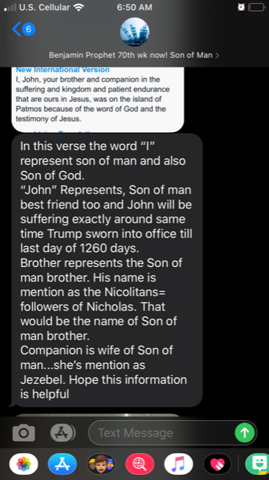
BENJAMIN TEXT Nov 21, 2019 – 3:34 pm

Below Bible Code: TISHRI (Sept/Oct), Efraim (America), Son of David (Gabe and?) Elijah (Gabe), the Repentance 2021, Ten days (Yrs cut down to half which was around 2015 - 2020) of Repentance (2014-15—2024), Messiah, and “God will be sure to take notice of you”
Text explanation: In the Rev 1 verse: the word “I”represent son of man and also Son of God.
“John” Represents, Son of man best friend too and John will be suffering exactly around the same time Trump sowrn into office till last day of 1260 days. (3.5 yrs) Brother (i.e. Nicholas) represents the Son of man brother. His name is mention as the Nicolitans=followers of Nicholas.
That would be the name of Son of man brother. Companion is wife of Son of man...she’s mention as Jezebel. Hope this information is helpful
I want you to know there whole list of things you should know about a person being the Son of man. The bloodline isn’t enough to be Son of man, If need knowledge on what to know then reach out to me.”
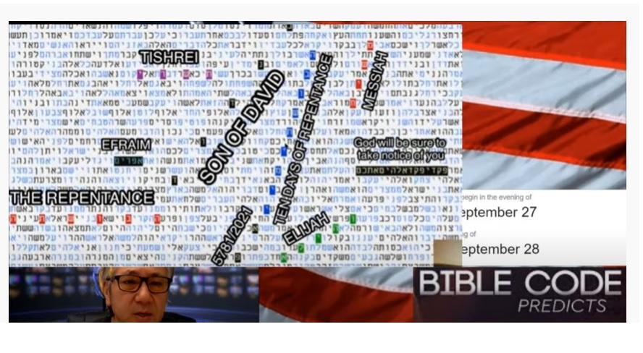
Sept 21, 2020
TRUMP INTERVIEW TODAY 4/1/2021
Quote: “I think there is ROOM for something, and I bring allot of people WITH ME” part of a questioned by Laura Trump regarding getting the news out there and new platform...he never answered it but with the final quote above.
Room: G5253 the highest part of a house, upper chamber, above, for ones sake, beyond, over, chiefest apostles, to pierce through the other side. (Joel 2:16) Chamber: Joe 2:16 “Gather the people, sanctify the congregation, assemble the elders, gather the children, and those that suck the breasts: let the bridegroom go forth of his chamber, and the bride out of her closet. H2315 inner, most inward parts (inner man), private chambers, enclosed, surrounded (flesh-body) to give him a stable abode...to cause him to prosper...”I will give them a fixed abode”
JUPITER = KING PLANET ALSO ZEUS Hebrew 2203 (Gabe & my NO.s)
Biblically specific, it is referred to Jupiter as the King Planet and the Planet of the Messiah = the planet is striped— What is interesting is that at the midpoint of Jupiter’s Retrograde/backwards, occurs midpoint on April 10, 2017 which is Passover— However to have it synchronized to the Virgo Sign and Comet 67p adds great significance. September 9, 2017 ‘Birth of Manchild’ or Translation of Jupiter.
Jupiter and Saturn Conjunction Union/Combination-Representing Gabriel and I or ultimately Jesus and his Bride face to face; high 5 victory-celebration, to build up, the earth in either sleeping hat or Santa (Nicholas) hat jumps for JOY! Since Gabriel and I represent as a symbol for the King of Kings and his bride or wife who made herself ready this applies to us, but on the whole to Messiah (Trump) and his bride/wife and Christmas relates to the slave being set free, turning of tables and realities.

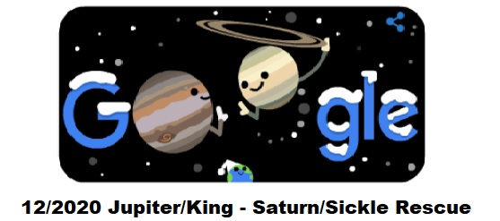
Witches and Satanists plan their plots and schemes, but God has a surprise! Closest observable conjunction/union since the 1200’s (my/his number as ONE). Relating to the Rapture of the Bride to come (Millions and Millions). We are part of the 144,000 harvest workers before the main rapture of the bride/wife of God. Taken to come back!

JUPITER Rev 12 link to the KING Planet – Representing Messiah/Trump, Son of Man, and Gabriel another KING. Jupiter also was seen as ZEUS – drinking, parties, pagan worship (sacrifices). Pluto=Hades and underworld
conjunction in AQUARIUS (New Age)-Illuminati regarding the SUN and worship which rises in the East (Muslim-Myth gods) Free love, peace without God, destruction of Gods people ultimately. All of this began in Sept 23, 2017 right after the inauguration of Trump who is also Gabe.

AIRE=Aquarius: Eph 2:2 “wherein ye once walked according to the course of this world, according to the prince of the powers of the AIR, of the spirit that now worketh in the sons of disobedience;” Tight coupling ‘conjunction’ union in our case regarding the Bridegroom and awaiting bride and wife. Right on top of each other like my dream.

Sun is parallel Pluto – Angel of Hell. Sun or Son of God is parallel a comparison = Trump vs. Son of Perdition ‘Obama’ Good vs. Evil. See the 5th Dimension Song AQUARIUS.

The new age waited for this time, and it relates a Mystic revelation/False Prophet/Messiah Obama, etc. https://youtu.be/UTzoC8WQhZw
Regulus = King Star in Leo with a Sickle for the reaping of the harvest. See website for further information regarding Regulus which represents either Gabriel or Me?

SON OF MAN SCRIPTURE
Pro 30:1, Jer 26:20, 35:4, Jer 35:19, Jer 40:15
1Ch 22:9 Behold, a son shall be born to thee, who shall be a man of rest; and I will give him rest from all his enemies round about: for his name shall be Solomon (H7999 – šālam-peace, David’s successor, completeness, soundness, in body from war, to be rewarded, uninjured, and finished), and I will give peace and quietness unto Israel in his days.
Mar 14:41 And he cometh the third time, and saith unto them, Sleep on now, and take your rest: it is enough, the hour is come; behold; the Son of man is betrayed into the hands of sinners.
Mar 14:62 And Jesus said, I am: and ye shall see the Son of man sitting on the right hand of power, and coming in the clouds of heaven. (Woody the Lord God said I was sitting at the right hand of God)
Luke 5:24 But that ye may know that the Son of man hath power upon earth to forgive sins, I say unto thee, Arise, and take up thy couch, and go into thine house.
Luke 6:5And he said unto them, That the Son of man is Lord also of the Sabbath.
Luke 7:34 The Son of man is come eating and drinking; and ye say, Behold a gluttonous man, and a winebibber, a friend of publicans and sinners! (This sounds like Gabriel)
Luke 9:22 Saying, The Son of man must suffer many things, and be rejected of the elders and chief priests and scribes, and be slain (G615 to kill in any way whatever-the letter killeth, but the spirit gives life- of separation of a part from the whole-departing and fleeing), and be raised (to arouse from sleep, to awake- to raise up i.e. cause to be born, of buildings, to raise up, construct, erect-from sleep sitting or lying, from obscurity, ruins, from inactivity, market, market place, for public debating, for elections) the third day (Yr).
Luke 9:26 For whosoever shall be ashamed of me and of my words, of him shall the Son of man be ashamed, when he shall come in his own glory, and in his Father's, and of the holy angels.
Luke 9:44 Let these sayings sink down into your ears: for the Son of man shall be delivered into the hands of men.
Luke 9:56 For the Son of man is not come to destroy men's lives, but to save them.
Luke 12:8 Also I say unto you, Whosoever shall confess me (Jesus) before men, him shall the Son of man also confess before the angels of God:
Luke 12:10And whosoever shall speak a word against the Son of man, it shall be forgiven him: but unto him that blasphemed against the Holy Ghost it shall not be forgiven.
Luke 12:40 Be ye therefore ready also: for the Son of man cometh at an hour when ye think not.
Luke 17:22 And he said unto the disciples, The days will come, when ye shall desire to see one of the days of the Son of man, and ye shall not see it.24 For as the lightning, that lighteneth (Gabe said he was hit by lightening-Me)26And as it was in the days of Noe/Noah, so shall it be also in the days of the Son of man.:30Even thus shall it be in the day when the Son of man is revealed.
Luke 18:8I tell you that he will avenge them speedily. Nevertheless when the Son of man cometh, shall he find faith on the earth?
Luke 18:31, 19:10For the Son of man is come to seek and to save that which was lost.
Luke 21:27, 36, Luke 22:22 And truly the Son of man go, as it was determined: but woe unto that man by whom he is betrayed!
Luke 22:48 But Jesus said unto him, Judas (G2455 Judah/Juda, ancestors, of man power and strength [Master-bate] a phallus- part, fractional part, share, time, repetition), betray thou the Son of man with a kiss (G5368 - phileō? he who associates familiarly with one, a companion, a friend, to be friendly with one, actively) 69 Hereafter shall the Son of man sit on the right hand of the power of God.
Luke 24:7 Saying, The Son of man must be delivered into the hands of sinful men, and be crucified, and the third day rise again.
John 3:13And no man hath ascended up to heaven, but he that came down from heaven, even the Son of man which is in heaven.
John 3:14, 5:27, 6:27, 6:53, 6:62 what and if ye shall see the Son of man ascend up where he was before?
John 8:28 Then said Jesus unto them, When ye have lifted up the Son of man, then shall ye know that I am he, and that I do nothing of myself; but as my Father hath taught me, I speak these things.
John 12:23And Jesus answered them, saying, the hour is come, that the Son of man should be glorified.34The people answered him, we have heard out of the law that Christ abideth for ever: and how say you, The Son of man must be lifted up? who is this Son of man?
John 13:31 Therefore, when he was gone out, Jesus said, Now is the Son of man glorified, and God is glorified (G1392: to make glorious, adorn with lustre, clothe with splendor, to think, suppose, be of opinion) in him.
Act 7:56 And said, Behold, I see the heavens opened, and the Son of man standing on the right hand of God.
Heb 2:6 But one in a certain place testified, saying, What is man, that thou art mindful of him? or the son of man, that thou visitest (G1 o look upon in order to help or to benefit, to look after, have care for, provide for: of God- one to choose, employ, etc. superimposition, a watch [scout, sentry]) him?
Rev 1:13 And in the midst of the seven candlesticks one like unto the Son of man, clothed with a garment down to the foot, and girt about the paps with a golden girdle.
Rev 14:14 And I looked, and behold a white cloud, and upon the cloud one sat like unto the Son of man, having on his head a golden crown, and in his hand a sharp sickle (Regulus King Star in Leo Constellation-Saturn).
Exo 33:11 And the LORD spake unto Moses face to face, as a man speaketh unto his friend. And he turned again into the camp: but his servant Joshua, the son of Nun, a young man, departed not out of the tabernacle.
Num 24:3, Num 24:15, Num 26:65,
Num 27:8 And thou shalt speak unto the children of Israel, saying, If a man die, and have no son, then ye shall cause his inheritance to pass unto his daughter.
Eze 40:4 And the man said unto me, Son of man, behold with thine eyes, and hear with thine ears, and set thine heart upon all that I shall shew thee; for to the intent that I might shew them unto thee you are brought hither: declare all that thou see to the house of Israel.
Eze 43:7 And he said unto me, Son of man, the place of my throne, and the place of the soles of my feet, where I will dwell in the midst of the children of Israel for ever, and my holy name, shall the house of Israel no more defile, neither they, nor their kings, by their whoredom, nor by the carcasses of their kings in their high places.
Eze 43:10Thou son of man, shew the house to the house of Israel, that they may be ashamed of their iniquities: and let them measure the pattern.
Eze 44:5 And the LORD said unto me, Son of man, mark well, and behold with thine eyes, and hear with thine ears all that I say unto thee concerning all the ordinances of the house of the LORD, and all the laws thereof; and mark well the entering in of the house, with every going forth of the sanctuary.
Eze 47:6 And he said unto me, Son of man, hast thou seen this? Then he brought me, and caused me to return to the brink of the river.
Dan 7:13 I saw in the night visions, and, behold, one like the Son of man came with the clouds (H6050 cloud-mass—G3507of theophanic cloud-led Israelites in the wilderness) of heaven, and came to the Ancient of days, and they brought him near before him.
Dan 8:17 So he came near where I stood: and when he came, I was afraid, and fell upon my face: but he said unto me, Understand, O son of man: for at the time of the end shall be the vision.
Mat 8:20 And Jesus saith unto him, The foxes have holes, and the birds of the air have nests; but the Son of man hath not where to lay his head.
Mat 9:6 But that ye may know that the Son of man hath power on earth to forgive sins, (then saith he to the sick of the palsy) Arise, take up thy bed, and go unto thine house.
Mat 10:23
Mat 11:19 The Son of man came eating and drinking, and they say, Behold a man gluttonous, and a winebibber, a friend of publicans and sinners. But wisdom is justified of her children.
Mat 12:8 For the Son of man is Lord even of the Sabbath day.
Mat 12:32 And whosoever speaketh a word against the Son of man, it shall be forgiven him: but whosoever speaketh against the Holy Ghost, it shall not be forgiven him, neither in this world, and neither in the world to come.
Mat 12:40 For as Jonas was three days and three nights in the whale's belly; so shall the Son of man be three days and three nights in the heart of the earth.
Mat 13:37,41 The Son of man shall send forth his angels, and they shall gather out of his kingdom all things that offend, and them which do iniquity;
Mat 16:13 When Jesus came into the coasts of Caesarea Philippi, he asked his disciples, saying, Who do men say that I the Son of man am?
Mat 16:27 For the Son of man shall come in the glory of his Father with his angels; and then he shall reward every man according to his works.
Mat 16:28Verily I say unto you, There be some standing here, which shall not taste of death, till they see the Son of man coming in his kingdom.
Mat 17:9And as they came down from the mountain, Jesus charged them, saying, Tell the vision to no man, until the Son of man be risen again from the dead.
Mat 17:12 But I say unto you, That Elias is come already, and they knew him not, but have done unto him whatsoever they listed. Likewise shall also the Son of man suffer of them.
Mat 17:22 And while they abode in Galilee, Jesus said unto them, The Son of man shall be betrayed into the hands of men:
Mat 18:11For the Son of man is come to save that which was lost.
Mat 19:28 And Jesus said unto them, Verily I say unto you, That ye which have followed me, in the regeneration when the Son of man shall sit in the throne of his glory (greatness-Make America Great), ye also shall sit upon twelve thrones, judging the twelve tribes of Israel.
Mat 20:18 Behold, we go up to Jerusalem; and the Son of man shall be betrayed unto the chief priests and unto the scribes, and they shall condemn him to death,
Mat 20:28 Even as the Son of man came not to be ministered unto, but to minister, and to give his life a ransom for many.
Mat 24:27 For as the lightning cometh out of the east, and shineth even unto the west; so shall also the coming of the Son of man be. (Trump said the coming will END the Plan-Dem-ic)
In Rev 1:9 reveals John as the Son of Man but also the companion wife, and it seems that this also points to me. So if the lightning that comes from my body is related; this points to both of us; Gabe and Me because we are twins that are both needed to be the ONE trio. Like the Ark of the Covenant bottom and top as one together, and Pollux and Castor seemingly one yet two, where God dwells in and above for now.
Trio or Tri-Force has been a word that I used allot and represented Gabe, Me and the Lord as One and a Force for Gods (Yah) purposes in the near future, regarding the judgment, harvest, and rule.
Mat 24:30 And then shall appear the sign of the Son of man in heaven: and then shall all the tribes of the earth mourn, and they shall see the Son of man coming in the clouds of heaven with power and great glory.
(Exo 19:9 And the LORD said unto Moses, Lo, I come unto thee in a thick cloud, that the people may hear when I speak with you, and believe you forever. And Moses told the words of the people unto the LORD.
G3509 Nephos a throng, a large dense multitude, a cloud in the sky.
H6051 Cloud a covering a veil over heaven, a morning cloud, image of something transient, observer of times, to make appear, produce, act covertly, magical arts (supernatural, mysterious, ethereal, airy and otherworldly) .
G3507-3509 a cloud which lead Israelites, same as above 3508-9 definite masses of vapor (H5387 mist, smoke, prince, captain, ruler, governor) with some form or shape, to be lifted up, exalted, to be carried, aided, assist, be swept away, to take, to receive, to lift up the hand in swearing, H5375 nasa)
Mat 24:37 But as the days of Noe/Noah were, so shall also the coming of the Son of man be.
Mat 24:39 And knew not until the flood came, and took them all away; so shall also the coming of the Son of man be.
Mat 24:44 Therefore be ye also ready: for in such an hour as ye think not the Son of man cometh.13 Watch therefore, for ye know neither the day nor the hour wherein the Son of man cometh.
Mat 25:31 When the Son of man shall come in his glory, and all the holy angels with him, then shall he sit upon the throne of his glory:
Mat 26:2 Ye know that after two days is the feast of the Passover, and the Son of man is betrayed to be crucified.24The Son of man goes as it is written of him: but woe unto that man by whom the Son of man is betrayed! it had been good for that man if he had not been born.45 Then cometh he to his disciples, and saith unto them, Sleep on now, and take your rest: behold, the hour is at hand, and the Son of man is betrayed into the hands of sinners.
Mat 26:64 Jesus saith unto him, Thou hast said: nevertheless I say unto you, Hereafter shall ye see the Son of man sitting on the right hand of power, and coming in the clouds of heaven.
Mar 2:10 But that ye may know that the Son of man hath power on earth to forgive sins, (he saith to the sick of the palsy,)
Mar 2:28 Therefore the Son of man is Lord also of the Sabbath.
Mar 8:31 And he began to teach them, that the Son of man must suffer many things, and be rejected of the elders, and of the chief priests, and scribes, and be killed, and after three days rise again.
Mar 8:38 Whosoever therefore shall be ashamed of me and of my words in this adulterous and sinful generation; of him also shall the Son of man be ashamed, when he cometh in the glory of his Father with the holy angels.
Mar 9:9 And as they came down from the mountain, he charged them that they should tell no man what things they had seen, till the Son of man were risen from the dead.12 And he answered and told them, Elias verily cometh first, and restores all things; and how it is written of the Son of man, that he must suffer many things, and be set at nought.31 For he taught his disciples, and said unto them, The Son of man is delivered into the hands of men, and they shall kill him; and after that he is killed, he shall rise the third day.
Mar 10:33 Saying, Behold, we go up to Jerusalem; and the Son of man shall be delivered unto the chief priests, and unto the scribes; and they shall condemn him to death, and shall deliver him to the Gentiles:
Mar 10:45 For even the Son of man came not to be ministered unto, but to minister, and to give his life a ransom for many.
Mar 13:26 And then shall they see the Son of man coming in the clouds with great power and glory.
Mar 13:34 For the Son of man is as a man taking a far journey, who left his house, and gave authority to his servants, and to every man his work, and commanded the porter to watch.
Mar 14:21The Son of man indeed goes, as it is written of him: but woe to that man by whom the Son of man is betrayed! good were it for that man if he had never been born.
Mar 2:28 Therefore the Son of man is Lord also of the Sabbath.
Mar 8:31 And he began to teach them, that the Son of man must suffer many things, and be rejected of the elders, and of the chief priests, and scribes, and be killed, and after three days rise again.38 Whosoever therefore shall be ashamed of me and of my words in this adulterous and sinful generation; of him also shall the Son of man be ashamed, when he cometh in the glory of his Father with the holy angels.
Mar 9:9 And as they came down from the mountain, he charged them that they should tell no man what things they had seen, till the Son of man were risen from the dead.12 And he answered and told them, Elias verily cometh first, and restoreth all things; and how it is written of the Son of man, that he must suffer many things, and be set at nought.31 For he taught his disciples, and said unto them, The Son of man is delivered into the hands of men, and they shall kill him; and after that he is killed, he shall rise the third day.
Mar 10:33 Saying, Behold, we go up to Jerusalem; and the Son of man shall be delivered unto the chief priests, and unto the scribes; and they shall condemn him to death, and shall deliver him to the Gentiles:45 For even the Son of man came not to be ministered unto, but to minister, and to give his life a ransom for many.
Mar 13:26 And then shall they see the Son of man coming in the clouds with great power and glory.34 For the Son of man is as a man taking a far journey, who left his house, and gave authority to his servants, and to every man his work, and commanded the porter to watch.
Mar 14:21 The Son of man indeed goeth, as it is written of him: but woe to that man by whom the Son of man is betrayed! good were it for that man if he had never been born.
Eze 20:, Eze 20:4,
Eze 20:27 Therefore, son of man, speak unto the house of Israel, and say unto them, Thus saith the Lord GOD; Yet in this your fathers have blasphemed me, in that they have committed a trespass against me.46 Son of man, set thy face toward the south, and drop thy word toward the south, and prophesy against the forest of the south field;
Eze 21:2 Son of man, set thy face toward Jerusalem, and drop thy word toward the holy places, and prophesy against the land of Israel,6 Sigh therefore, thou son of man, with the breaking of thy loins; and with bitterness sigh before their eyes.
Eze 21:9 Son of man, prophesy, and say, Thus saith the LORD; Say, A sword, a sword is sharpened, and also furbished:
Eze 21:12 Cry and howl, son of man: for it shall be upon my people, it shall be upon all the princes of Israel: terrors by reason of the sword shall be upon my people: smite therefore upon thy thigh.14 Thou therefore, son of man, prophesy, and smite thine hands together, and let the sword be doubled the third time, the sword of the slain: it is the sword of the great men that are slain, which entereth into their privy chambers.19 Also, thou son of man, appoint thee two ways, that the sword of the king of Babylon may come: both twain shall come forth out of one land: and choose you a place, choose it at the head of the way to the city.
Eze 22:2 Now, thou son of man, wilt thou judge, wilt thou judge the bloody city? yea, thou shalt shew her all her abominations.18 Son of man, the house of Israel is to me become dross: all they are brass, and tin, and iron, and lead, in the midst of the furnace; they are even the dross of silver.
Eze 22:24 Son of man, say unto her, Thou art the land that is not cleansed, nor rained upon in the day of indignation/WRATH.
Eze 23:2 Son of man, there were two women, the daughters of one mother:
Eze 23:36 The LORD said moreover unto me; Son of man, wilt thou judge Aholah (1st) and Aholibah (2nd)? yea, declare unto them their abominations; (two twisted boots on feet?)
Eze 24:2 Son of man, write thee the name of the day, even of this same day: the king of Babylon set himself against Jerusalem this same day.16 Son of man, behold, I take away from thee the desire of thine eyes with a stroke: yet neither shalt thou mourn nor weep, neither shall thy tears run down.
Eze 24:25 Also, thou son of man, shall it not be in the day when I take from them their strength, the joy of their glory, the desire of their eyes, and that whereupon they set their minds, their sons and their daughters,
Eze 25:2 Son of man, set thy face against the Ammonites, and prophesy against them;
Eze 26:2 Son of man, because that Tyrus (Satan is King-Coastal City) hath said against Jerusalem, Aha, she is broken that was the gates of the people: she is turned unto me: I shall be replenished, now she is laid waste:
Eze 27:2 Now, thou son of man, take up a lamentation for Tyrus;
Eze 28:2 Son of man, say unto the prince of Tyrus (Coasts-Satan the King), Thus saith the Lord GOD; Because thine heart is lifted up, and thou hast said, I am a God, I sit in the seat of God, in the midst of the seas (nations); yet thou art a man, and not God, though thou set thine heart as the heart of God:
Eze 28:12 Son of man, take up a lamentation upon the king of Tyrus, and say unto him, Thus saith the Lord GOD; Thou sealest up the sum, full of wisdom, and perfect in beauty.21 Son of man, set thy face against Zidon (Coastal City like Tyrus), and prophesy against it,
Eze 29:2 Son of man, set thy face against Pharaoh king of Egypt, and prophesy against him, and against all Egypt:
Eze 29:18 Son of man, Nebuchadnezzar king of Babylon caused his army to serve a great service against Tyrus: every head was made bald, and every shoulder was peeled: yet had he no wages, nor his army, for Tyrus, for the service that he had served against it:
Eze 30:2 Son of man, prophesy and say, thus saith the Lord GOD; Howl ye, Woe worth the day!21Son of man, I have broken the arm of Pharaoh king of Egypt; and, lo, it shall not be bound up to be healed, to put a roller to bind it, to make it strong to hold the sword.
Eze 31:2 Son of man, speak unto Pharaoh (Obama) king of Egypt, and to his multitude (Illuminati Group following Gabe and I-and others); whom art thou like in thy greatness?
Eze 32:2 Son of man, take up a lamentation for Pharaoh king of Egypt, and say unto him, Thou art like a young lion of the nations, and thou art as a whale in the seas: and thou came forth with thy rivers, and troubled the waters with thy feet, and fouled their rivers.18 Son of man, wail for the multitude of Egypt, and cast them down, even her, and the daughters of the famous nations, unto the nether parts of the earth, with them that go down into the pit.
Eze 33:2 Son of man, speak to the children of thy people, and say unto them, When I bring the sword upon a land, if the people of the land take a man of their coasts, and set him for their watchman:37 So thou, O son of man, I have set thee a watchman unto the house of Israel; therefore thou shalt hear the word at my mouth, and warn them from me.
Eze 33:10 Therefore, O thou son of man, speak unto the house of Israel; Thus ye speak, saying, If our transgressions and our sins be upon us, and we pine away in them, how should we then live?12 Therefore, thou son of man, say unto the children of thy people, The righteousness of the righteous shall not deliver him in the day of his transgression: as for the wickedness of the wicked, he shall not fall thereby in the day that he turn from his wickedness; neither shall the righteous be able to live for his righteousness in the day that he sin.
24 Son of man, they that inhabit those wastes of the land of Israel speak, saying, Abraham was one, and he inherited the land: but we are many; the land is given us for inheritance.
Eze 33:30Also, thou son of man, the children of thy people still are talking against thee by the walls and in the doors of the houses, and speak one to another, every one to his brother, saying, Come, I pray you, and hear what is the word that cometh forth from the LORD.
Eze 34:2 Son of man, prophesy against the shepherds of Israel, prophesy, and say unto them, Thus saith the Lord GOD unto the shepherds; Woe be to the shepherds of Israel that do feed themselves! should not the shepherds feed the flocks?
Eze 35:2 Son of man, set thy face against mount Seir, and prophesy against it,
Eze 36:1Also, thou son of man, prophesy unto the mountains of Israel, and say, Ye mountains of Israel, hear the word of the LORD:
Eze 36:17Son of man, when the house of Israel dwelt in their own land, they defiled it by their own way and by their doings: their way was before me as the uncleanness of a removed woman.
Eze 37:3And he said unto me, Son of man, can these bones live? And I answered, O Lord GOD, thou Knowest.
Eze 37:9Then said he unto me, Prophesy unto the wind, prophesy, son of man, and say to the wind, Thus saith the Lord GOD; Come from the four winds, O breath, and breathe upon these slain, that they may live.
Eze 37:11 Then he said unto me, Son of man, these bones are the whole house of Israel: behold, they say, Our bones are dried, and our hope is lost: we are cut off for our parts.
Eze 37:16 Moreover, thou son of man, take thee one stick, and write upon it, For Judah, and for the children of Israel his companions: then take another stick, and write upon it, For Joseph, the stick of Ephraim (Double Ash Heap) (Isa 9 America, Manhattan N.Y.), and for all the house of Israel his companions:
Eze 38:2 Son of man, set thy face against Gog (Obama), the land of Magog (Multitude of Gog), the chief prince of Meshech and Tubal, and prophesy against him,
Eze 38:14 Therefore, son of man, prophesy and say unto Gog, Thus saith the Lord GOD; In that day when my people of Israel dwelleth safely, shalt thou not know it?
Eze 39:1 Therefore, thou son of man, prophesy against Gog (Obama), and say, Thus saith the Lord GOD; Behold, I am against thee, O Gog, the chief prince of Meshech and Tubal (Turkey, Persia, Iran, Iraq, Moslem):
Eze 39:17 And, thou son of man, thus saith the Lord GOD; Speak unto every feathered fowl, and to every beast of the field, Assemble yourselves, and come; gather yourselves on every side to my sacrifice that I do sacrifice for you, even a great sacrifice upon the mountains of Israel, that ye may eat flesh, and drink blood. (Wrath)

