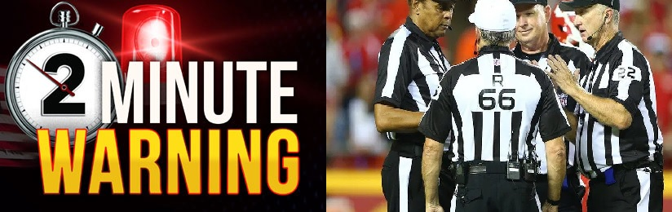

“TWO MINUTE WARNING” April 19, 2020 During a Trump Conference the Intro by a White House news caster reported right before Trump takes the podium. Said: “The game is a 2 Minute Warning about 6 Minutes ago!” (G & Lightening bolt 2020 https://youtu.be/UygW4f55P4o)
***2 minutes prophetically is 2 year warning. 6 minutes/yrs is the total time of the game; 6 years of the 7 year Tribulation of which we are in.
The warning was launched as the news caster spoke which was April 19, 2020 and the two minutes will end approximately April 2022. Which the 15th – 16th is Passover. We are in the 70th week of Daniel, the 7 years of Messiah (Trump) and just as God created the heavens and the earth he worked for 6 days, and rested on the 7th. We are to work 6 days, and rest the 7th. Is this referring to the RAPTURE of the Great Multitude right at the end of the 6th year, launching the 7th?
Pro 25:2 “It is the glory of God to conceal a thing: but the honour of kings is to search out a matter.” (This is research of a potential to consider)
Two minute warning in a FOOTBALL GAME is the practice of a winning team allowing the clock to expire through a series of pre-selected plays, either to preserve a lead or hasten the end of a one-sided contest (Trump Deliverer/God vs. Satan-No Contest). Near the end of a game, in order to reduce the time available for the opposing team to score; the more neutral term "running out the clock" is more commonly used. 2017-2020 is 4 year, April 19, 2020 was the launch of the last 2 year warning, 2022 on April will end the warning approximately to the people now to prepare to meet their maker. Either as a friend or enemy?
Mark 13:32 Day nor the hour. Day means: G2250 the time space between day or dark, time or season, 12th part of the day, point of time or moment G5610 root; steadfast/immovable. Hour means: day, instant (twinkling of an eye, instantaneous, to sustain) season, short, definite precise, time or season fixed by natural law, seat, chair firm and fixed in purpose G1476, etc. Be grounded in the hope of the gospel.
Note: Holocausts Memorial Day (Rabbinic Holiday) is at the end of Nissan [April] to 2021] following Passover, and this intended Holocaust was and is the Shadow Governments with Biden, Pelosi, Obama, and World Leaders to destroy Gods ecclesia/congregation/church and people in general. (www.blueletterbible.com/org)

