SIGN IN THE HEAVENS
Weighed in the Balance November 8, 2022 during Americas Mid-Term Elections where the SUN & Mercury God of Commerce were at the top of the balance/Libra constellation revealing judgment and collapse to come in America and the world. www.yourawake.weebly.com Research.
Table of Contents
SIGN IN THE HEAVENS 1
WEIGHED IN THE BALANCE 2
Tabernacle/Sanctuary of David 5
WAR SCROLL 6
The description of the eschatological war. 6
Col I 6
Col. 2 7
PARTHIANS AND MEDES #1 8
11/08/2022 Mid-Term Election Heavenly SIGN Balances/Libra/Scales/Weighed 8
Son of Man – Gabriel/Trump/Jesus no REST 12

WEIGHED IN THE BALANCE

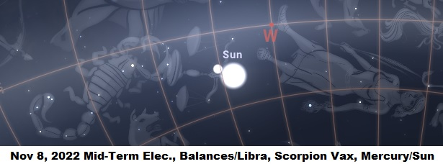
Sign in the Heavens—Election Mid-Term 11/8/2022 There was a sign in the heavens (shown above) that is related to the judgment forthcoming called the Wrath of God or Terror of the LORD (Zohar).
Which revealed a sign taking place, what the sign meant, and also there was a Lunar Eclipse which means troubles for Israel, aka America, and in Rev 6:12 has to do with the SUN black as sackcloth (Eclipse), vs. 17 leads to; The Great day of Wrath is come.
The planet MERCURY “God of Commerce” (trade, business; industry, establishment, production, question, topic, concern, issue, venture, buying and selling [Vax] exchange, retail, import, export) was at the top of the Balance along with the SUN and these lead to Dan 5:25 relating to the “Writing on the Wall.”
All of this related to dual and a few different applications; one is regarding the Vax, choosing to continue in commerce (i.e. buying and selling) rather than recognizing the Beast system setting itself up and knowing the times.
Another application is this journey that Gabriel/Trump/YHWH and I are in, those refusing to repent choosing their own ways, justice systems, and materialistic kingdoms of mammon. The warnings, and the reality that is soon to happen which is God’s WRATH poured out on unbelievers or vainglorious nations as the WAR SCROLL mentions—soon to arrive.
Vainglorious – narcissistic, arrogant, bigheaded, self-important, proud, inflated, conceited, snobbish, high and mighty, smug, haughty, snooty, conceited, overconfident, full of pride, egotistical, vain (useless/worthless/empty/hollow/valueless).
Sun G2246 = helios; light of day, to burn, G138 to choose, to prefer, to take for oneself (Judges) God chooses, you choose, life, brings forth, self or Ego –G142 raise, take up take away with, bear. (Heb 11:25)
Sun Cont: 2x hatan – LAW/husband, circumcised child, religious espousal, sons in law, sons and daughters, my God has clothed me with garments of Salvation (Isa 61:10).
Mercury and the Sun were at the TOP of the balances (Libra) H8625 pay out a price, grief, thoroughly spend, especially of trade, to suspend as on a cross, human subject, just scales, silver and gold vessels/people, Thesaurus: evaluate, determine, gauge, keep upright,
SCRIPTURE: (Job 31:6 Integrity, Ps 62:9 Men laid in the Balance, Isa 40:12 Weigh mountains and hills in scales)
Dan 5:25 And this is the writing that was written, MENE, MENE, TEKEL, UPHARSIN.26 This is the interpretation of the thing: MENE; God hath numbered thy kingdom, and finished it.
Dan 5:27 TEKEL; Thou art weighed in the balances, and art found wanting 2 PERES; Thy kingdom is divided, and given to the Medes and Persians. (Asia Minor, Syria and Palestine, Armenia, S. Russia, India, Lower Egypt, and Medes & Indi in alliance with Babylon/USA, Iran, etc. after the vassal King Cyrus a type of TRUMP chosen by God Isa 45
Kingdom is divided: rule, reign, royal, empire, estate, sovereign power, territory or population, thy Fathers house shall be destroyed, related to Seed in many waters. A vile person stands up in his estate. To make one King or Queen (Dan 11:21)
Wanting: hassir H2627 deficient, used of LIGHT, lacking, fail, lessen, strip off, remove and retire of water.
This is an earthly dividing of kingdoms, but there is a heavenly kingdom where there is no divide.
The basics of the heavenly sign is that in this final harvest and revelation of the Son Jesus and the Daughter of God the Holy Spirit is where the leaders of the world came to the west, specifically Selma, OR (Jerusalem) and came to find out what the manna was, to remove me from my destiny with Jesus/Trump/Gabriel the Son of God/Son of man and to replace me or him by another.
The sign was linked to the Vax but also those involved with this final harvest where many whom ignored the warnings by both He and I, they took the VaX, went after me tried to kill me, him, and many other things. Because they did not repent and continued to pursue us they are being judged. Weighed in the balance, and this is because these are the rich, powerful, bloodline, family, kings & queens, or leaders of the world.
The 144,000 were also being selected for bringing the gospel to those who will be left behind in utter chaos, evil, and collapse of the world heading into judgment and the Wrath of God. The vial/bowl judgment is related to the Vax and are the last 7 judgments in the book of Revelation.

.

Tabernacle/Sanctuary of David
Enoch as ENCLOSURE:
Acts 15:16 After this I will return, and will build again the tabernacle of David, which is fallen down; and I will build again the ruins thereof, and I will set it up: 17 That the residue of men might seek after the Lord, and all the Gentiles, upon whom my name is called, saith the Lord, who doeth all these things.
1 Thess 2:19 For what is our hope, or joy, or crown of rejoicing? Are not even you in the presence of our Lord Jesus Christ at his coming?
1 Thess 3:13 To the end he may stablish your hearts unblamable in holiness before God, even our Father, at the coming of our Lord Jesus Christ with all his saints.
1John 2:28 And now, little children (You and I/all of Gods children/people, saved/redeemed), abide in him; that, when Jesus shall appear, we may have confidence, and not be ashamed before him at his coming 29 If you know that he is righteous, ye know that every one that doeth righteousness is born of him.
The coming is for/or with the saints, one is on earth now where he has been awakening and gathering the firstborn/firstfruits of the dead spiritually, they are gathered, tried, and weighed or numbered, and at his coming is when he takes his people delivering up the kingdom to the LORD GOD, and/or when he also comes back with them to those left behind to help, judge, and bring the everlasting gospel to them left behind. We shall see...
1Co 15:23 But every man in his own order: Christ the firstfruits, aka firstborn (of the dead spiritually); afterward they that are Christ's at his coming (with the glorified saints, 144,000; to those left behind-along with judgment).
1Co 15:24 Then cometh the end, when he shall have delivered up the kingdom to God, (the 144,000 and great multitude-Gods children the kingdom) even the Father; when he shall have put down all rule and all authority and power (weighed in the balance). 25 For Jesus must reign, till he hath put all enemies under his feet.
Acts 13:2 (Holy Ghost/Spirit a person)
The tabernacle is a living, walking throne of God, a Tabernacle not made with mans hands, but it is the mobile Ark on earth – where LORD GOD, the Son Jesus/Trump, and Daughter the Holy Spirit, Wisdom and Me are in covenant with the LORD. An example of the future New Heavens, and New Earth.
Where God tabernacles among all his children, male and female as both together a living walking tabernacle of God which also is a revelation of the New Jerusalem which is human, Gods children (male & female unions like Adam and Eve) for the New Earth and dwelling place of the LORD GOD in sanctified, consecrated and redeemed tabernacle.

WAR SCROLL
(The ELECT 144,000 BEING DETERMINED BY GOD)

The description of the eschatological war.

Col I
(1) For the In[structor, the Rule of] the War. The first attack of the Sons of Light (144,000 elect, first born, first fruits plus) shall be undertaken against the forces of the Sons of Darkness, the army of Belial: the troops of Edom, Moab, the sons of Ammon, the [Amalekites], (2) Philistia, and the troops of the Kittim (Chittim) of Asshur. Supporting them are those who have violated the covenant.
Belial: a personification of evil or worthlessness, often thought of as a devil or demon, the underworld, fallen angels, deceptively beautiful in appearance. Demons of lies and guilt, any type of sins, especially those related to sex and lust. Belial seduces by means of arrogance and pride. Partially related to the Vax and spiritual entities.
The sons of Levi, the sons of Judah, and the sons of Benjamin, those exiled to the wilderness, shall fight against them (3) with [...] against all their troops, when the exiles of the Sons of Light return from the Wilderness of the Peoples to camp in the Wilderness of Jerusalem. Then after the battle they shall go up from that place (4) and tile king of; the Kittim [shall enter] into Egypt. In his time he shall go forth with great wrath to do battle against the kings of the north, and in his anger he shall set out to destroy and eliminate the strength of (5) Israel. Then the]re shall be a time of salvation for the People of God, and a time of dominion for all the men of His forces, and eternal annihilation for all the forces of Belial. There shall be great panic [among] (6) the sons of Japheth, Assyria shall fall with no one to come to his aid, and the supremacy of the Kittim shall cease that wickedness be overcome without a remnant. There shall be no survivors of (7) [all the Sons of] Darkness.
(8-10) Then the Sons of Righteousness shall shine (Immortal) to all ends of the world continuing to shine forth until end of the appointed seasons of darkness. Then at the time appointed by God, His great excellence shall shine for all the times of eternity; for peace and blessing, glory and joy, and long life for all Sons of Light. On the day when the Kittim fall there shall be a battle and horrible carnage before the God of Israel, for it is a day appointed by Him from ancient times as a battle of annihilation for the Sons of Darkness. On that day the congregation of the gods and the congregation of men shall engage one another, resulting in great carnage.
(11-14) The Sons of Light and the Sons and forces of Darkness of Belial shall fight together to show the strength of God with the roar of a great multitude and the shout of gods and men; a day of disaster. It is a time of distress for all the people who are redeemed by God. In all their afflictions none exists that is like it, hastening to its completion as an eternal redemption. On the day of their battle against the Kittim, they shall go forth for carnage in battle. In three lots the Sons of Light shall stand firm so as to strike a blow at wickedness, and in three the army of Belial shall strengthen themselves so as to force the retreat of the forces of Light. And when the banners of the infantry cause their hearts to melt, then the strength of God will strengthen the hearts of the Sons of Light.
(14-17)In the seventh lot: the great hand of God shall overcome Belial and all the angels of his dominion, and all the men of his forces shall be destroyed forever. The annihilation of the Sons of Darkness and service to God during the war years. [,...] the holy ones shall shine forth in support of [...] the truth for the annihilation of the Sons of Darkness. Then [...] [...] a great [r]oar [...] they took hold of the implements of war. (18-20) [...][... chiefs of the tribes ... and the priests, the Levites, the chiefs of the tribes, the fathers of the congregation ... the priests and thus for the Levites and the courses of the heads of...

Col. 2
(1) the congregation's clans, fifty-two. They shall rank the chiefs of the priests after the Chief Priest and his deputy; twelve chief priests to serve (2) in the regular offering before God. The chiefs of the courses, twenty-six, shall serve in their courses. After them the chiefs of the Levites serve continually, twelve in all, one (3) to a tribe. The chiefs of their courses shall serve each man in his office. The chiefs of the tribes and fathers of the congregation shall support them, taking their stand continually at the gates of the sanctuary.
KITTIM same as CHITTIM (Parthian & Medes) H379 “bruisers” Asian u. Europa, Coasts, Islands, Mediterranean, Italy, Greece, and America Coastal Cities, Metropolises.
END OF SANCTUARY SECTION OF WAR SCROLL
www.yourawake.weebly.com

PARTHIANS AND MEDES #1

11/08/2022 Mid-Term Election Heavenly SIGN Balances/Libra/Scales/Weighed
Dan 5:27 TEKEL; Thou art weighed in the balances, and art found wanting 2 PERES; Thy kingdom is divided, and given to the Medes and Persians. (Asia Minor, Syria and Palestine, Armenia, S. Russia, India, Lower Egypt, and Medes & Indi in alliance with Babylon/USA, Iran, etc. after the vassal King Cyrus a type of TRUMP chosen by God Isa 45
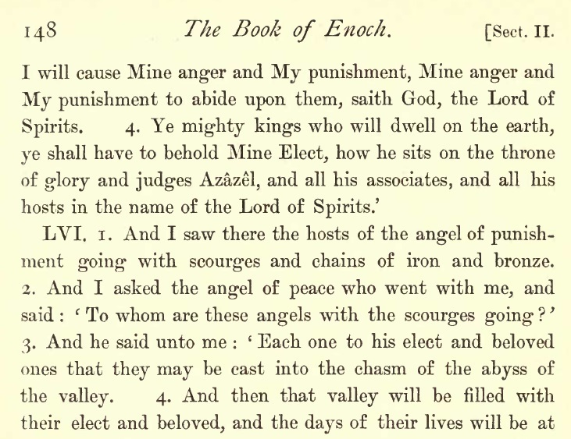
The chains and scourges are prepared for the Host of Azazel
PARTHIANS & MEDES – KINGDOM GIVEN TO – BALANCES #
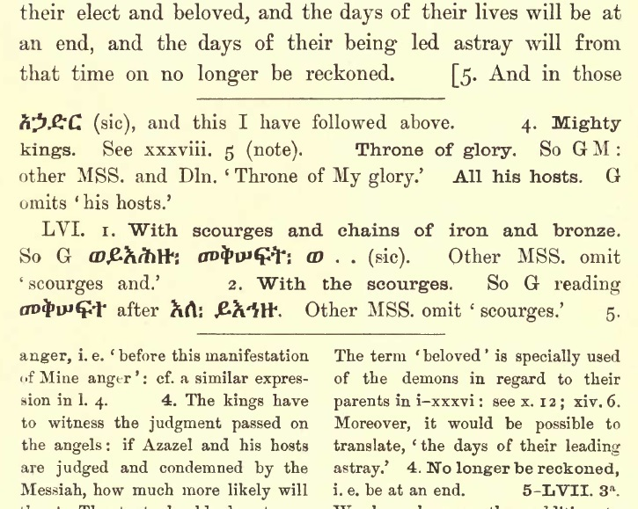
The throne of glory is between Trump/Jesus the Son, the LORD GOD and I (Holy Spirit) as the Ark of the Covenant, and the two Cheribum are male and female the two witnesses. Those being weighed in the balance are those firstborn (Shape shifters and ancients, elect, firstborn and firstfruits, and 144,000 chosen).
The balances are related to their judgment and how they responded to this final harvest redemption process. Did they reject Gods atonement through Jesus/Trump and me, did they try to thwart Gods plan, did they repent of the Vax, and did they repent at all? And any other questions.

PARTHIANS & MEDES – KINGDOM GIVEN TO THEM – BALANCES #3
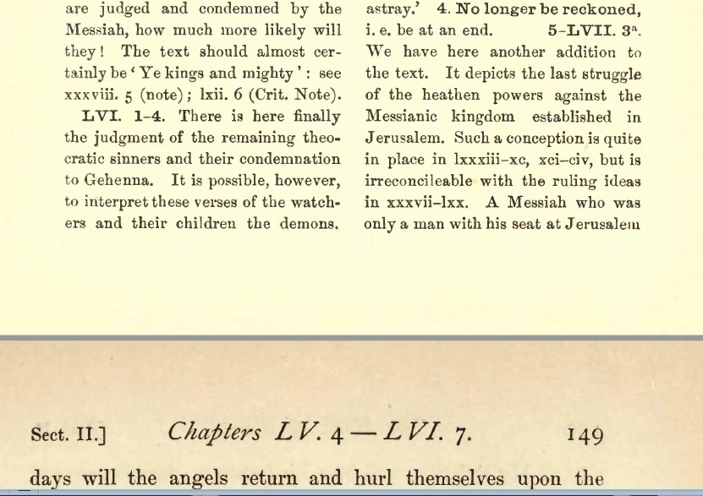
PARTHIANS AND MEDES #4 WEIGHED IN THE BALANCE – GIVEN OVER
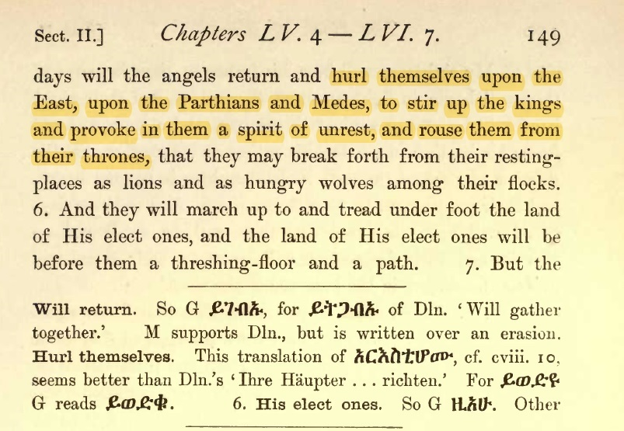
These angels (Azazel fallen) are let out, and hurl themselves upon the Parthians and Medes, who rouse from their thrones (spiritual thrones) and break forth is come out of their place and go up to his elect ones.
PARTHIANS AND MEDES #5 (KINGDOM GIVEN TO)-THE BALANCE
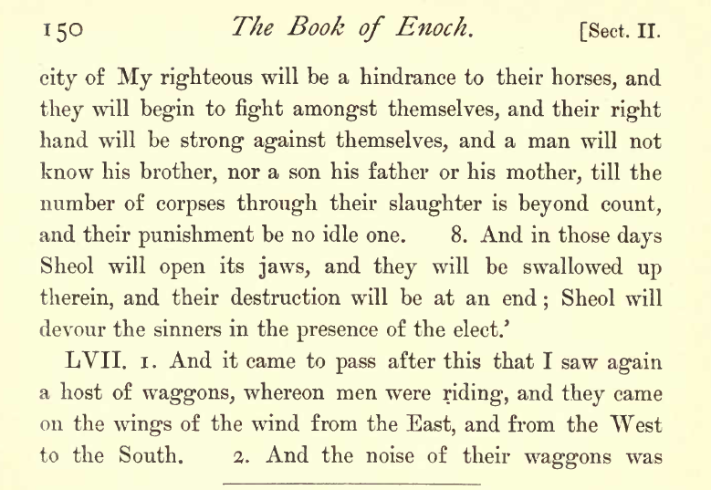
Divided kingdom and when God brought the sword instead of peace the people began to divide, family, friends, and beliefs of every kind. LVII these wagons I believe are vehicles of every kind. They these kings and rulers, princes and princesses came from all over the world here to where Jesus/Trump/Gabriel and I were meeting to thwart Gods plan.
They all were being tried, tested, and scrutinized/judged, these were the firstborn, elect and 144,000 being chosen by God. They too were choosing their eternal destiny by the choices they made. This had to do with the feast of Atonement that Trump/Jesus fulfilled. There are many documents that I have uploaded that have research and eBooks (Free) that are more thoroughly documented on what has taken place.

Son of Man – Gabriel/Trump/Jesus no REST
Mat 8:20—Luk 9:58 And Jesus said unto him, Foxes have holes, and birds of the air have nests; but the Son of man hath not where to lay his head.
LAY G2827 kleeno—to rest, incline oneself, day is (Moed) far spent=they his close advisor team or family vehemently/diligently/exceedingly to drive forward w/dative with the thing that grows, profit, (as if by beating), bewail-regret-to be apologetic, pang of guilt, lament, grief, greatly in derision, scorn, mockery, ridicule, disrespect (H181 firebrands/woods/pokers/Sodom and Gomorrah) wear away, no place for repose (take it easy, relaxation, tranquility, lounge out of honor and reverence) of one dying. Their goal is to cause him to FALL BACK.
HEAD G2776 keph-ay-la— (in the sense of seizing); the head (controller-supervisor-person in charge-as the part most readily taken hold of) Since the loss of the head destroys the life. Homage to men of rank-To journey, travel, trek, to strip, break down, break down altars, to overthrow and destroy altars Hos 10:2
HOSEA 10:2 Head: Hos 10:2 Their heart is divided; now shall they be found faulty: he shall break down their altars, he shall spoil their images.
Col 1:18 And he (Jesus/Trump/Gabriel) is the head of the body, the assembly, gathering, the congregation: who is the beginning, the firstborn (bring forth, bear, be delivered, be in travail, be born, from the dead prototokos=JESUS, nekros; spiritually dead, that in all things he might have the preeminence (to bear a name or title, aka Messiah, Christ, Jesus).
John 6:66 –Vax related Mark of Beast-agenda driven unbelievers
“John 6:66 From that time many of his disciples G3101 a learner of Jesus, joined his party, favored him, adherents, a habit accustomed to, contrariwise— to be imbued with the knowledge of Christ, went back, and walked no more with him.”
John 8:44 Ye are of your father the devil, and the lusts of your father ye will do. He was a murderer from the beginning, and abode not in the truth, because there is no truth in him. When he speaketh a lie, he speaketh of his own (their own, privately, to oneself-home, business, private or separate, acquaintance=her, our, thine, and your, severally-for their own use): for he is a liar, and the father of it. 45 And because I tell you the truth, ye believe me not.
Note regarding Jn 8:44 above: They friends, family, advisors, or associates do not make a stand for what is right in truth, fixed and established in the presence of others because they waiver. These are those that have agendas against him, and me to stop what the LORD GOD purposed in the end time revelation of his Son Jesus/Trump/Gabriel, and daughter Holy Spirit/Wisdom/Me.
Those with Trump the ones against us and the LORD GOD, probably unrepentant Vax recipients. Their light once shown is now being extinguished, and they have begun to go into darkness. Also, many are being taken over by dark forces inside themselves through nano technology, and giving legal right to evil entities that were let out of the Abyss/Apollyon.
This is all related to buying and selling; weighed in the balances and found wanting, and the God of commerce “Mercury” that reveals they chose this world, and in that gave right to the Beast system to override their internal soul and software of God.
In spite of their covert/secretive attempts to draw him into a web and keep him so busy he forgets me as the Two Witnesses testify to, he overcomes them by the power of God along with Trumps/Gabriel’s/Jesus strength that God has given him.
NOTE: This is just a bit of research that I am uploading, and it may help some understand the times, the biblical prophecies being fulfilled, and give you a heads-up while there is still time to repent seek Jesus and be saved.
www.yourawake.weebly.com (Many documents, and information on the past years 2015-2022 and beyond.

