Wisdom is Holy Spirit-the Son are the Two Witnesses
Gabriel/Jesus/Trump the SON
WISDOM/HOLY SPIRIT/ME
Part of the 144,000 leaders WORD STUDY

Word Study HOLY SPIRIT
Contents
Word Study HOLY SPIRIT 1
HOLY SPIRIT 1
WIND = SPIRIT ruah 2
HOLY GHOST 2
SPIRIT=RUAH (H7303/7306) WIND, breath, mind, anger, cool, courage 3
WISDOM 4
THE WORD OF THE LORD 5
Image #2 WORD 7
SON H1121/1129 9
SON ROOT: 9
BENJAMIN EMAIL & TEXT 10
7/27/2022 Word Study 11
EARTH—Related Scripture: 11
WEALTH H2428 hayil: 11
Men of valour, strength, force, virtue, pain, bring forth, travail (laid up for the JUST) God being a just God for reward or punishment 11
The small >>> gods H430 11
BLACK 11
I BARE H5375 12
SHOULDER H3802 12
Blaspheme G987 Holy Spirit >against 12
Two Witnesses STRIKE 13

Daughter of Zion, Daughter of God, Wisdom (Her), and other Word Interpretations—Blueletterbible words study in Hebrew and Greek.

HOLY SPIRIT
Illustrated Dictionary & Concordance of the Bible, pg 453.
Feminine aspect of the Sprit of God, that manifestation of the one God working in creation and especially in human beings. Ps 104:30 Active in the creation, In eschatological prophecies the Holy Spirit is associated with divine judgment (Isa 4:4), the ideal ruler (Isa 11:2), the renewal of the COVENANT with Israel (Isa 32:15, Ezek 11:19,; 36:26, Joel 2:29) and repentance (Zech 12:10).

WIND = SPIRIT ruah
HOLY GHOST G4151; he third person of the triune God, the Holy Spirit, coequal, coeternal with the Father and the Son, sometimes referred to in a way which emphasizes his personality and character (the "Holy" Spirit)
sometimes referred to in a way which emphasizes his work and power (the Spirit of "Truth") never referred to as a depersonalized force, the spirit, i.e. the vital principal by which the body is animated, the rational spirit, the power by which the human being feels, thinks, decides, the soul
a spirit, i.e. a simple essence, devoid of all or at least all grosser matter, and possessed of the power of knowing, desiring, deciding, and acting, a life giving spirit, a human soul that has left the body
A spirit higher than man but lower than God, i.e. an angel, the spiritual nature of Christ, higher than the highest angels and equal to God, the divine nature of Christ
The disposition or influence which fills and governs the soul of any one, the efficient source of any power, affection, emotion, desire, etc. a movement of air (a gentle blast),
Of the wind, or a breeze, hence the wind itself, breath of nostrils or mouth ROOT: wind, to blow,
Eph 4:30 And grieve not the holy G40 (most holy thing, a saint, sacred—physically, pure, morally blameless or religious, ceremonially, consecrated):—(most) holy one, thing.G53 exciting reverence, venerable, sacred, pure from carnality, chaste, modest, pure from every fault, immaculate, clean; H2822 feast (56x), sacrifice, feast days, solemnity, victim.) Spirit of God, whereby ye are sealed unto the day of redemption.
Holy Cont:
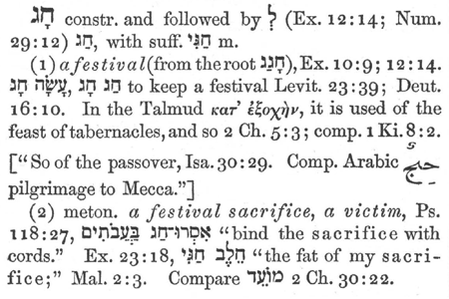
H2287 holy: to move in a circle, i.e. (specifically) to march, walk, tread, crush, protest, move about, travel, be in motion, reposition, transfer, redistribute, progression, evolution (related to manna, the war, and the Army of Justice go round) in a sacred procession, to observe a festival—shall become to Egypt a terror, reeling and fear in the site of it; to be excited at.
Holy root H2283/2328They the opposition and enemy: to encircle, encompass/surround, describe a circle, draw round, make a circle, (Qal) to encircle. We are holding the Feast of Atonement, and Gabriel and I are the victim or sacrifice the two Goats one female and one male in scripture.

SPIRIT=RUAH (H7303/7306) WIND, breath, mind, anger, cool, courage
- Spirit (as that which breathes quickly in animation or agitation), disposition (of various kinds), unaccountable or uncontrollable impulse (God speaks) prophetic spirit,
- (as seat of emotion), desire, sorrow, trouble, spirit, as seat (headquarters, center, base, chair, hold and sit, place, aka place prepared by God) or organ (branch, bough, member [loins]-area office of God the Father most High) of mental acts, as seat especially of moral character...
- Spirit of God, the third person of the triune God, the Holy Spirit, coequal, coeternal with the Father and the Son, (daughter of Zion, aka Me) as inspiring ecstatic state of prophecy, as impelling (urging, coercing, throwing darts/arrows, compelling)prophet to utter instruction or warning.
- Imparting warlike energy and executive and administrative power, as endowing men with various gifts, as energy of life, as manifest in the Shekinah glory, never referred to as a depersonalized force.
- H7306 (Hiphil) to smell, scent, perceive odour, accept, of horse, of delight (metaph)
- Of Quick/Swift understanding.
- WAR SCROLL (By Gabriel) about Horse: The horsemen with the cavalry of the men of the entire army, will be six thousand; five hundred to a tribe. All the cavalry that go out (12)to battle with the infantry shall ride stallions; swift (quick), responsive, unrelenting, mature, trained for battle,
WISDOM בִּינָה bînâ understanding, wisdom, knowledge, meaning, perfectly, understand
H2449 חָכַם ḥāḵam wise, wiser, wisely, teach wisdom, exceeding, understanding, discernment, act, faculty, object personified
H6195 עָרְמָה ʿārmâ guile, wilily, subtilty=cleverly, ingeniously, shrewdly, wisdom, prudence
H2449 חָכַם ḥāḵam wise, wiser, wisely, teach wisdom, exceeding
H998 בִּינָה bînâ understanding, wisdom, knowledge, meaning, perfectly, understand—H2449 חָכַם ḥāḵam wise, wiser, wisely, teach wisdom, exceeding, understanding, discernment act, faculty, object personified
H2451 חָכְמָה ḥāḵmâ wisdom, wisely, skilful man, wits; skill (in war), (In administration), shrewdness, prudence (in religious affairs), (ethical and religious)
READ SCRIPTURES IN THE IMAGE BELOW:
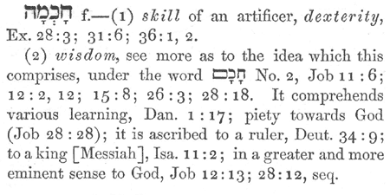
H2454 חָכְמוֹת ḥāḵmôṯ wisdom, every wise
H2942 טְעֵם ṭᵊʿēm decree, chancellor, commanded, regarded, commandment, regard, tasted, wisdom—H3820 לֵב lēḇ heart, mind, midst, understanding, hearted, wisdom, comfortably, well, considered, friendly, kindly, stouthearted, care, misc
H7922 שֵׂכֶל śēḵel understanding, wisdom, wise, prudence, knowledge, sense, discretion, policy—H8454 תּוּשִׁיָּה tûšîyâ wisdom, enterprise, thing as it is, that which is, substance, working
New Testament (Greek) for "Wisdom" Strongs # Greek Transliterated English Equivalent
G4678 σοφία sophia wisdom: wisdom, broad and full of intelligence; used of the knowledge of very diverse matters, the wisdom which belongs to men, spec. the varied knowledge of things human and divine, acquired by acuteness and experience, and summed up in maxims and proverbs
the science and learning the act of interpreting dreams and always giving the sagest advice, the intelligence evinced in discovering the meaning of some mysterious number or vision, skill in the management of affairs, devout and proper prudence in intercourse with men not disciples of Christ, skill and discretion in imparting Christian truth, the knowledge and practice of the requisites for godly and upright living, supreme intelligence, such as belongs to God, to Christ, the wisdom of God as evinced in forming and executing counsels in the formation and government of the world and the scriptures (Lk 2:40, 52)
G4680 Sophia cont:—wise (WISDOM), clear, skilled, expert: of artificers, skilled in letters, cultivated, learned, of the Greek philosophers and orators, of Jewish theologians, of Christian teachers, forming the best plans and using the best means for their execution
G5428 φρόνησις phronēsis wisdom, prudence

THE WORD OF THE LORD
Gen 15:1 “After these things the word of the LORD came unto Abram in a vision, saying, Fear not, Abram: I am thy shield, and thy exceeding great reward.
Word H6197 speech, word, speaking, thing, speech, saying, utterance, word, words, business, occupation, acts, matter, case, something, manner (by extension), commandment; (Image #1)
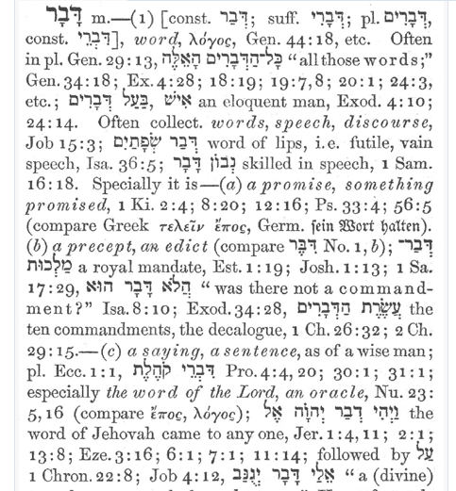

Image #2 WORD
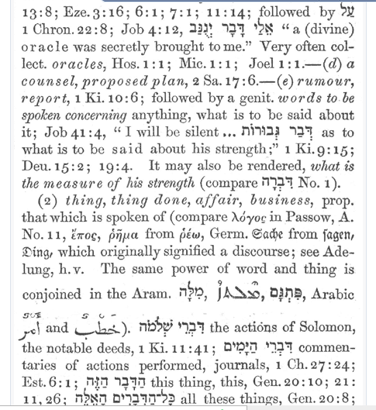
IMAGE #3 WORD
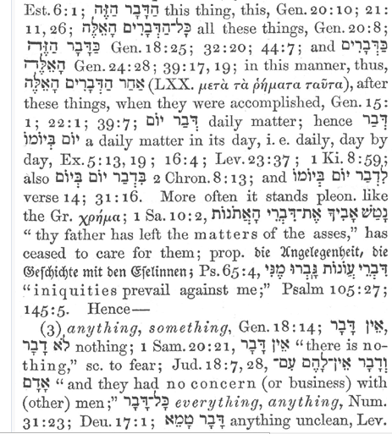
IMAGE #4
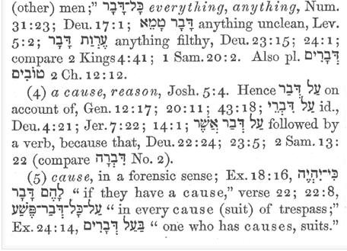

SON H1121/1129
grandson, child, member of a group, son, male child, Grandson, children (pl. - male and female), youth, young men (pl.), young (of animals), sons (as characterization=description/type/portrayal/style/manner/brand/nature/caring/sympathetic/considerate, portrayal, depiction, i.e. sons of injustice [for unrighteous men] or sons of God [for angels—we become the Sons of God in the manifestation of Gods glory as immortals] people (of a nation) (pl.), of lifeless things, i.e. sparks, stars, arrows (fig.), a member of a guild, order, class—We are all the Children of God.

SON ROOT:
to build, rebuild, establish, cause to continue, to build a house (i.e., establish a family), (Niphal) to be built, to be rebuilt, established (of restored exiles), to be built up (of childless wife becoming the mother of a family through the children of a concubine)

BENJAMIN EMAIL & TEXT
BENJAMIN IS?
Oct 20, 2018 IP
Name
Benjamin S
Email
(...)@aol.com
Comment
I would like to ask you questions about the Messiah to come. I didn't read your books yet but you nailed it with your wisdom. I think you want to speak with me so i can fill you in on missing wisdom. I was never religious till 1/20/17 Trump inauguration day. There been crazy things happening to me since that day that I can't explain. All I can say every time I take a pictures or videos there rainbows around me with faces looking down upon me. If you're serious about Trump who I believe has a biblical link to me let's speak,asap. My email is benarm40@aol.com. My grammar isn't good so hard for my to express my points by emails. I'm 50yrs old now but wasn't till turn 48yrs old that Holy Spirit had filled my soul with knowledge of the scripture. The book of Revelation is my life. The scriptures are talking about me. Everything in the first 4-chapters is about me and what happening to me last 2-yrs also book of Daniel from chapter 7 to 11 is me. Let me prove to you who I'am and if i don't hear from you then I know the holy spirit will not allowed you to contact me. Please reach out to me and I won't disappoint you. Thanks Benjamin, Rev 4:2-3 talks about a person sitting on the throne appearance of Jasper(which is stone of Benjamin)then is mentions about rainbow encircled the throne shone like Emerald.(Emerald means tribe of Judah,also stone for Month of May,also stone for Gemini. I'm born on May 26,1968,70-week of Daniel,which started the day Trump sworn into office bc Trump was 70 yrs,7-months and 7-days old on Jan 20,2017 in Hebrew yr 5777. The 70-weeks is about atonement to end sins for the Messiah which would end on last day his turns 49 yrs old. Do the math 70th week of Trump's presidency was Friday May 25th 2018. The next day I turned 50 and that's when all of sudden the pictures inside my phone,I saw these heavenly lights around me. I would love to speak to you bc I have no one who can understand me about this. Btw,my mother was 16yrs of age when she conceived me and was virgin and not married yet. She was married by the time of my birth. I hope to hear from you this is my cell phone number 718-930-2119
My Note: The flow or punctuation etc is like Woody Cambel who gave me info about Trump for book. Also seemed to claim to be God.

7/27/2022 Word Study

EARTH—Related Scripture:
Act 16:26 “And suddenly there was a great earthquake commotion, to rock (vibrate, properly, sideways or to and fro), i.e. (generally) to agitate in any direction; stirring, cause to tremble (of the air) a gale, so that the foundations the institution or system of truth, the building in the SOUL, laid aside, carried no longer, to eat or drink; explained by discourse of the prison place of bondage, to tie, shackle, bind, held fast by bond [unclean spirits, demons-union] were shaken overthrown, to disturb: and immediately passing by, on the wayside, walking by, wealth, riches, money all the doors were opened, and every one's bands were loosed.

WEALTH H2428 hayil:

Men of valour, strength, force, virtue, pain, bring forth, travail (laid up for the JUST) God being a just God for reward or punishment

The small >>> gods H430
Majesty, goddesses, obstinate self confident man, “whose own strength is as his god” confides in his/her own strong hand and sword, “who bears his god in his hand” gods of the Egyptians “Strange Gods” applied to kings, denoting angels and judges, understood of higher powers, whom anyone worships, godlike in appearance or form, H433 a heathen god, whose power is their god. Can be for YHWH as a positive.

BLACK
H 7838/7836 horses, wild asses, used of hair, skin, idea of the duskiness of early dawn, grow black COAL, sahar-to seek early or look diligently, early in the morning, seek early for their food, seek God (Hosea 6:3), look for dawn (AM), Prov 7 related to WISDOM.
Black scripture: Hos 6: 3 then shall we know, if we follow on to know the LORD: his going forth is prepared as the morning; and he shall come unto us as the rain, as the latter and former rain unto the earth.
CROWN G4735 (Rev 12 Woman has a crown of 12 stars) a mark of royal or (in general) exalted rank, the wreath or garland which was given as a prize to victors in public games, metaph. the eternal blessedness which will be given as a prize to the genuine servants of God and Christ: the crown (wreath) which is the reward of the righteousness, that which is an ornament and honour to one.

I BARE H5375

SHOULDER H3802
kâthêph, kaw-thafe'; from an unused root meaning to clothe; the shoulder (proper, i.e. upper end of the arm; as being the spot where the garments hang); figuratively, side-piece or lateral projection of anything:—arm, corner, shoulder(-piece), side, (like the Ark)

Blaspheme G987 Holy Spirit >against
Mar 3:29 but whosoever shall blaspheme against the Holy Spirit (Wisdom, daughter of Zion, tree of life, daughter of God=Me) hath never forgiveness, but is guilty of an eternal sin:
I. to speak reproachfully, disapprovingly, witheringly, censoriously, rail-bar-fence, barrier at, revile, calumniate, blaspheme (linked to Barak)
II. to be evil spoken of, reviled=hated, unloved, out of favor, ostracized, not accepted, disliked, disgraced, in trouble, in a predicament, struggling, in difficulty, railed at. Pierce, strike through, speak, tell, advise, report, say to, pass on, report, and communicate, put into words evil of, common, evil spirits, carnally minded.
Common=ordinary, everyday, nothing special, ordinary, unexceptional
Against G1519: to or into (indicating the point reached or entered), of place, time, or (figuratively) purpose (result, etc.); I. of place, after verbs of going, coming, sailing, flying, falling, living, leading, carrying, throwing, sending, etc.;
of a place entered, or of entrance into a place, into; and a. it stands before nouns designating an open place, a hollow.

Two Witnesses STRIKE
Rev 11:5And if any man will hurt them, fire proceedeth out of their
mouth (stoma-part of body, face, heart and soul, edge of sword; also tomoteros: sharper, decisive single stroke,root: kopto=to beat ones breast for grief, lament, mourn[Rev 1:7/Rev 18:9 , cut down),
and devoureth their enemies: and if any man will hurt them, he must in this manner be killed.6 These (two) have power to shut heaven, that it
rain (brekho; water, moisten, drought, no water; waves be stayed)
not (H3361 me-denial according to judgment, apprehension, send evil that good might come, because of sin, those who trust in riches), in the days of their prophecy: and have power over waters to turn them
to blood (haima-refers to the seat of life, mans living body, of those things that resemble blood, grape juice, the atoning blood of Christ-also regarding the VAX-price of blood for murder, to slay, of innocents, the guilt and punishment for bloodshed, slaying of the righteous person, beasts blood brought into the sanctuary, i.e. their body tabernacle; no redemption?)
and to smite (patasso-to strike gently: as a part or a member of the body to stroke, smite: with the sword, to afflict, to visit with evils, etc. as with a deadly disease, to slay-chains fall off, light shines in the prison-G3817 paio; WOUND WITH A STING as a SCORPION-Vax related, typdo: wound with a STAFF, punitive evil-disquiet ones conscience-as if an accidental collision[Acts 23:3 because of injustice])
the earth with all plagues (all manner, whomever, all things, daily, some of all types/of people or means;G4127 plege: a public calamity, heavy affliction, plague, deprived of light and hidden in darkness, used of a potter to the clay to form and mould a living soul), as often as they will.
7And when they shall have finished their testimony,
END OF TWO WITNESSES SMITE THE EARTH

